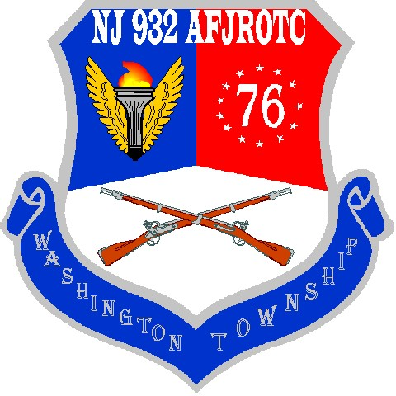

NJ-932
CADET GUIDE
2019-20

TABLE OF CONTENTS

CHAPTER 1 – MISSION AND OBJECTIVES
  - BASIC CONCERNS …………………………………….….………………………. 5
  - AFJROTC MISSION ……………………………………………………………… 8
  - INSTRUCTIONAL OBJECTIVES ………………………………………………. 8
  - PHYSICAL DISCIPLINE & HAZING …………………………………………... 8
  - GRADING POLICY ……………………………………………………………….. 9
  - HONOR FLIGHT RECOGNITION ……………………………………………… 10
  - AFJROTC RELATED CLUBS/ACTIVITIES ……………………….………….. 11
  - DISCIPLINARY ACTION/AF FORM 341………………………………………. 12
  - NOTE ON CONTACTING INSTRUCTORS…………………………………….. 14

CHAPTER 2 – STANDARDS
2.1 CADET PLEDGE ……………………………………………….…………………. 14
2.2 CADET HONOR CODE …………………………………………………………... 15
2.3 CADET OFFICER/SENIOR NCO PLEDGE ……………………………………. 15
2.4 STANDARDS OF CONDUCT …….….……….………………………………….. 15
2.4a STANARDS OF CONDUCT – EVENTS………………………………………... 17
2.5 SALUTING PRIVILEDGES ……………………………………..……………….. 18
2.6 THE AFJROTC UNIFORM……………………………………………………….. 19
2.7 SPECIFIC CADET UNIFORM WEAR GUIDELINES……………………………28

CHAPTER 3 – GROOMING AND APPEARANCE
3.1 GROOMING AND APPEARANCE STANDARDS……………………………... 29
3.2 MALE GROOMING STANDARDS (ALSO SEE 7.10) ………………………… 30
3.3 FEMALE GROOMING STANDARDS (ALSO SEE 7.9) ………………….…… 31
3.4 UNIFORM INSPECTION POINTS ……………………………………………… 32

CHAPTER 4 – CADET CORPS ORGANIZATION (COMMAND STAFF)
4.1 CADET COMMANDER …………………………………………………………... 37
4.2 CADET VICE COMMANDER ………………………………………………….... 38
4.3 CADET CHIEF OF STAFF …………………………………………………….…. 38
4.4 CADET COMMANDER EMERITUS ……………………………………………. 38
4.5 CADET VICE COMMANDER EMERITUS …………………………………….. 39
4.6 EXECUTIVE OFFICER …………………………………………………………... 39
4.7 COMMAND CHIEF MASTER SERGEANT …..………………………………... 39
4.8 DEPUTY COMMANDER, OPERATIONS …………………………………….... 40
4.9 DEPUTY COMMANDER, WINGS……………………………………………….. 40
4.10 DEPUTY COMMANDER, PERSONNEL ……………………………………….. 40
4.11 DEPUTY COMMANDER, INFORMATION …………………………………... 41
4.12 DEPUTY COMMANDER, PUBLIC AFFAIRS ………………………………… 41
4.13 DEPUTY COMMANDER, SYSTEMS ADMINISTRATION………………….. 42
4.14 DEPUTY COMMANDER, LOGISTICS ………………………………………... 42
4.15 DEPUTY COMMANDER, FINANCE………………………..………………….. 42
4.16 DEPUTY COMMANDER, TRAINING ………………………………………… 42
4.17 DEPUTY COMMANDER, RECOGNITION …………………………………... 43
4.18 INSPECTOR GENERAL ………………………………………………………… 43
4.19 JUDGE ADVOCATE ……………………………………………………………. 43
4.20 DRILL TEAM/COLOR GUARD COMMANDER……………………………... 44
4.21 DIRECTOR OF CEREMONIAL PROTOCOL ……………………………….. 44
4.22 PLANS OFFICER ………………………………………………………………... 44
4.23 DIRECTOR, SUMMER LEADERSHIP SCHOOL……………………………. 44
4.24 ATHLETIC OFFICER …………………………………………………………... 45
4.25 ENGINEERING OFFICER ……………………………………………………... 45
4.26 MODEL CLUB …………………………………………………………………... 45
4.27 AWARENESS PRESENTATION OFFICER………………………………….. 45
4.28 COMMANDER KITTY HAWK AIR SOCIETY………………………………... 45
4.29 DRILL COMPETITION DIRECTOR …………………………………………. 46
4.30 SENIOR, JUNIOR, SOPHOMORE, HOMEROOM COMMANDERS ……... 46
4.31 FLIGHT COMMANDER ……………………………………………………….. 46
4.32 FLIGHT FIRST SERGEANT …………………………………………………... 47
4.33 ELEMENT LEADER …………………………………………………………..... 47
4.34 GUIDES AND GUIDON BEARERS …………………………………………… 47
4.35 CADET EVALUATION BOARD ………………………………………………. 47
4.36 CADET PERFORMANCE REPORT ………………………………………….. 48
4.37 UNIT MANNING DOCUMENT ………………………………………………... 48
4.38 UNIT MANNING DOCUMENT (EXPANDED) ………………………………. 48
4.39 OTHER HELPFUL ABBREVIATIONS ……………………………………….. 53
4.40 PROMOTION …………………………………………………………………….. 55
4.41 ROTATION POLICY ……………………………………………………………. 58
4.42 TRANSFER CADETS …………………………………………………………… 59

CHAPTER 5 – PROPER PROCEDURES
5.1 FLIGHT REPORTING IN ………………………………………………………... 59

CHAPTER 6 – FIRST AID
6.1 FIRST AID AS AN AFJROTC CADET…………………………………………... 60

CHAPTER 7—UNIFORM AND AWARDS
7.1 INSIGNIA PLACEMENT …………………………………………………………. 63
7.2 BADGES……………………………………………………………………………... 63
7.3 SHOULDER PATCHES ………………………………………………………….... 66
7.4 SHOULDER CORDS ………………………………………………………………. 66
7.5 SHOULDER TABS ………………………………………………………………… 67
7.6 AWARDS AND DECORATIONS ……………………………………………….... 67
7.7 DESCRIPTIONS AND CRITERIA ………………………………………………. 71
7.8 APPEARANCE AND GROOMING………………………………………………. 88
7.9 SPECIFIC UNIFORM AND APPEARANCE RULES……………………………..89
7.10 SPECIFIC FEMALE CADET GROOMING GUIDELINES …………………... 89
7.11 SPECIFIC MALE CADET GROOMING GUIDELINES ……………………... 90

FIGURES
  - FEMALE CADET GROOMING GUIDELINES………………………………... 95
  - FEMALE HAIR STANDARDS/EXAMPLE AUTHORIZED SCRUNCHIE… 96
  - AUTHORIZED BRAIDS/UNAUTHORIZED FEMALE HAIRSTYLES……... 97
2-1 MALE CADET GROOMING GUIDELINES…………………………………… 98

ATTACHMENTS
AFJROTC RIBBON CHART ………………………………………………………… 87
7.1 AUTHORIZED AIR FORCE JROTC BADGES/INSIGNIA................................ 99
7.1 AUTHORIZED AIR FORCE JROTC BADGES/INSIGNIA…………………… 100
7.2 AIR FORCE JROTC RANK INSIGNIA ………………………………………… 101
7.3 CADET MALE HEADGEAR……………………………………………………... 102
7.4 CADET FEMALE HEADGEAR…………………………………………….......... 103
7.5 CADET BERET HEADGEAR………………………………………………….. 104
7.6 CADET ABU ........................................................................................................... 105
7.7 CADET ABU HEADGEAR....................................................................................... 106
7.8 CADET LIGHTWEIGHT BLUE JACKET…………………………………....... 107
7.9 CADET MALE SERVICE DRESS……………………………………………….. 108
7.10 CADET FEMALE SERVICE DRESS…………………………………………...... 109
7.11 CADET MALE BLUE SHIRT………………………………………………........ 110
7.12 CADET FEMALE BLUE SHIRT……………………………………………....... 111
7-13 FLIGHT SUIT (MALE AND FEMALE)……………………………………....... 104
7-14 SEMI-FORMAL DRESS UNIFORM.................................................................... 113
7-15 SAMPLE EXHIBITION UNIFORM..................................................................... 114
7-15 SAMPLE EXHIBITION UNIFORM..................................................................... 115
7-16 SAMPLE UNIFORM PICTURES......................................................................... 116
7-16 SAMPLE UNIFORM PICTURES......................................................................... 117
7-16 SAMPLE UNIFORM PICTURES......................................................................... 118
7-17 NATIONAL LEVEL AWARD CONTACTS........................................................ 119
7-17 NATIONAL LEVEL AWARD CONTACTS………………………………….... 120
7-17 NATIONAL LEVEL AWARD CONTACTS………………………………….... 121
7-17 NATIONAL LEVEL AWARD CONTACTS………………………………….... 122
8 -1 THE PHONETIC ALPHABET.............................................................................. 123
9 -1 AIR FORCE OFFICIAL MEMORANDUM........................................................ 124
10 -1 MILITARY TIME………………………………………………………………… 125
1 1-1 SUMMARY OF CHANGES……………………………………………………… 126

- MISSION AND OBJECTIVES

JUNIOR AIR FORCE RESERVE OFFICERS’ TRAINING CORPS (AFJROTC) MISSION STATEMENT: TO DEVELOP CITIZENS OF CHARACTER DEDICATED TO SERVING THEIR NATION AND COMMUNITY.

1.1 BASIC CONCERNS

1.1.1 Aerospace Science is a “Life Skills” course, classified as a Practical Art, a graduation requirement in the state of New Jersey. Aerospace Science also introduces the historical, scientific and technical aspects of aerospace. Leadership Education provides experiences to develop discipline, responsibility, communication skills, citizenship, and diplomacy. We encourage our cadets to utilize these traits when interacting with each other to ensure a smooth running, competent corps and most of all, to prepare them for life experiences in the real world. Leadership Education also includes wearing the Air Force uniform and meeting the AFJROTC grooming standards while in uniform, the proper use of Air Force customs and courtesies, participating in drills and ceremonies, giving and receiving instructions, and acting as leaders and members of the NJ-932nd Group. This course meets graduation requirements in Family and Consumer Sciences. One does not incur a service obligation by participating in the program.

We DO NOT ENCOURAGE our cadets to join any branch of the military service upon graduation from high school. We DO ENCOURAGE our cadets to attend college and earn a Bachelor’s or Associate’s Degree in the career of their choice.

1.1.2 LEGAL AND REGULATORY BASIS

1.1.2.1 PUBLIC LAW 88-647: The Reserve Officers’ Training Corps (ROTC) Vitalization Act of October 13, 1964, is the authority to operate Air Force Junior Reserve Officers’ Training Corps (AFJROTC) program. It states that cadets must be physically fit, United States of America citizens.

1.1.2.2 AFJROTCI 36-2010: Air Force Junior ROTC (AFJROTC) Curriculum, describes the curriculum of the AFJROTC program and policies and procedures for AFJROTC units. It gives guidance for organizing the cadet corps and provides other direction in the operation of the NJ-932nd AFJROTC Group.
Air Force Consolidated Operational Supplement (3 August 2019) is the primary reference for this guide.

BACKGROUND

We are designated NJ 932 because we were the second JROTC unit formed in New Jersey in the calendar year 1993. First-year cadets are designated Air Science I (AS I) cadets; second-year cadets are AS II, third-year cadets AS III, and fourth-year cadets are designated AS IV.

A unique aspect of Junior ROTC is that the cadets run the program. The SASI and ASI’s guide and mentor students as they run the program. Recommendations made by senior staff are not implemented until approved by SASI and/or ASI’s.
1.1.3 VOLUNTARY ENROLLMENT OF CADETS

1.1.3.1 All AFJROTC students must be enrolled voluntarily and participate in the full program to include taking AFJROTC academic courses, participate in the cadet corps, and wear the prescribed uniform. The SASI must approve all enrollment and disenrollment initiatives. The instructors will ensure all students adhere to the minimum acceptable standards of conduct and personal appearance as required by the Air Force. Reserve cadets may be able to participate in AFJROTC functions based upon ASI concurrence.

1.1.4 To be eligible for membership in the NJ-932nd AFJROTC program you must be:

1.1.4.1 Enrolled in and attending a regular course of instruction at Washington Township High School.
1.1.4.2 In a grade above the 8th grade.
1.1.4.3 A citizen or national of the United States or an alien admitted for permanent residence.
1.1.4.4 Physically fit to participate in AFJRTOC training (you are considered physically fit if you are qualified for the Washington Township High School physical education program). (Note: Handicapped students, with the concurrence of the principal, may participate.)

1.1.5 Students may transfer from Army, Navy, Marines, or other AFJROTC units with full credit for training already received

1.1.6 STUDENTS MAY BE INVOLUNTARILY DISENROLLED from the program at SASI discretion with collaboration of Washington Township Aerospace Science Guidance Department for:

1.1.6.1 Continued failure to adhere to JROTC rules and regulations as mandated by the Cadet Guide and student handbook (CADETS MUST BEHAVE).
1.1.6.2 Continued failure to maintain acceptable course standards and grades (CADETS MUST PARTICIPATE IN CLASS).
1.1.6.3 Continued unacceptable grooming CADETS MUST MEET GROOMING STANDARDS), incorrect uniform wear (CADETS MUST WEAR THE UNIFORM PROPERLY), failure to wear the uniform when required, etc.
1.1.6.4 Continued inaptitude, indifference to training, disciplinary problems, or undesirable traits of character.
1.1.6.5 Failing to remain enrolled in school.

1.1.7 CERTIFICATE OF COMPLETION (AFJROTC Form 310) is presented to a student in good standing who has successfully completed at least three years of the AFJROTC program. Passing grades in every credit-granting academic period constitutes successful completion of the AJROTC program and makes the cadet eligible by law for a Certificate of Completion. A cadet should have this certificate in his/her possession when enrolling in a college level ROTC program, or when enlisting in the armed forces, in order to gain the benefits of successfully completing the AFJROTC program.

1.1.7.1 If the AFJROTC cadet elects to enlist in the Armed Forces, the Certificate of Completion MAY allow enlistment in pay grade E2 in the Army, Navy, Marine Corps, or Air Force. This provides for immediate monetary ($200/month) benefit. It also places the cadet ahead of other personnel enlisting at the same time, and, theoretically, makes the cadet eligible for promotion ahead of other enlistees who enter at the same time

1.1.8 CERTIFICATE OF TRAINING (AFJROTC Form 1256) is presented to a senior cadet in good standing who completes two years of the AFJROTC program.

1.1.9 CERTIFICATE OF RECOGNITION (AFJROTC FORM 308) is used to recognize AFJROTC cadets and organizations (units) for outstanding support and achievement. The SASI presents this certificate.

1.1.10 ROTC COURSE CREDIT. A student completing at least two years of JROTC may be entitled to credit in the Senior ROTC program. See AFJROTC 36-2001, Cadet Operations, for specifics.

1.1.11 SERVICE ACADEMY NOMINATIONS: U.S.C Title 10 sets aside up to 20 nominations per Service Academy for “honor graduates of JROTC honor schools.”

1.2 AFJROTC MISSION- Develop citizens of character dedicated to serving their
nation and community.
The AFJROTC program has been designed to help you develop:

1.2.1 An appreciation of the basic elements of, and requirements for, national security.
1.2.2 Patriotism and an understanding of your personal obligations to contribute toward national security
1.2.3 Respect for, and an understanding of, the need for constituted authority in a democratic society.
1.2.4 Habits of orderliness and precision.
1.2.5 A degree of personal honor, esprit de corps, self-reliance, and leadership.
1.2.6 A knowledge of fundamental aerospace doctrine
1.2.7 Basic military skills.
1.2.8 A knowledge of, and appreciation for, the traditions of the Air Force.
1.2.9 A knowledge of career opportunities in the Air Force and the aerospace community.
1.2.10 Life skills: budgeting and financial management, leadership, respect, teamwork, responsibility, careers, college applications, problem solving, etc.

1.3 INSTRUCTIONAL OBJECTIVES/GOALS
1.3.1 Instill in high school students the value of citizenship, service to the United States, personal responsibility, and a sense of accomplishment.
1.3.2 Develop respect for and obedience to proper authority and understand and accept military courtesy.
1.3.3 Provide an environment for experience and growth in the attitudes, disciplines, and techniques of effective leadership.
1.3.4 Understand the United States organization for national defense, including the history and structure of military and civil aerospace technology and programs.
1.3.5 Understand the structure of the universe, the solar system, atmosphere of the earth, principles and theory of flight in air and space, propulsion systems and instruments
1.3.6 Develop good personal appearance, including neat military grooming, cleanliness, and proper wear of a military uniform.
1.3.7 Develop qualities of honorable behavior, high ideals, self-confidence, and responsibility for the consequences of one’s actions
1.3.8 Teach Life Skills: Attitude, Behavior, Conduct, Discipline, Ethnics…etc.

1.4 PHYSICAL DISCIPLINE & HAZING

In accordance with AFJROTCI36-2010 and Washington Township High School standards,
any form of hazing, whether verbal or physical will not be tolerated within an AFJROTC unit
or activity. Requiring cadets to perform a physical action as a reprimand, punishment, or
failure to perform, will not be tolerated within any AFJROTC unit or activity.

1.4.1 Examples of prohibited physical activities include, but are not limited to: push-ups, running laps, or any inappropriate physical contact such as shoving, pulling, or grabbing.
1.4.2 Any form of bullying, discriminatory harassment, sexual harassment, cyber bullying, verbal abuse, teasing, public rebuke or any attempt to otherwise humiliate a cadet is prohibited.
1.4.3 This prohibition is applicable to all AFJROTC unit activities including: instructors, cadets, or any personnel involved with or participation in an AFJROTC unit or activity.
1.4.4 Unauthorized Clubs: no unit may encourage, facilitate, or otherwise condone secret societies or private clubs as part of the AFJROTC program.

1.5 GRADING POLICY

1.5.1 You are graded in three areas in AFJROTC: Aerospace Science (AS) and Leadership Education (LE) and Wellness. AS or LE academic instruction is normally conducted two days per school week. LE grades will count for uniform wear and AS evaluation grades will account for 30% of your grade for each marking period. 10% of your grade is based upon performance (ie, drill/wellness/flickerball or job). Proper wear of the uniform and personal appearance in uniform are the largest part (50%) of your **leadership grade. Grades are used to determine eligibility for field trips. Cadets are required to be passing all classes (current Marking Period and/or Year Grade) at the time of determination for the field trip. Cadets must also be in good standing at that time.

93-100% EXCELLENT PROGRESS

85-92% GOOD PROGRESS

77-84% SATISFACTORY PROGRESS

70-76% FAIR PROGESS

0-69% FAILING

1.5.2 Grades for homework, test, quizzes, reports, projects, and presentations are averaged for a numerical grade for AS. Grades for classroom conduct and uniform inspections are averaged for a numerical grade for LE. We do not round grades (i.e. a grade of 92.9 is recorded as a 92.0).
1.5.3 You are encouraged to understand the importance of your grades. Aerospace Science Instructors (ASIs) will discuss your grades upon request.
1.5.4 Performance grades are determined partly by efforts toward promotion. You are expected to accomplish requirements for promotion to the next highest grade from Cadet Airman Basic through Cadet Colonel, every marking period. If you do not qualify for promotion, you are still graded on your efforts toward promotion.
1.5.5 Senior, 4th year cadets are graded on uniform wear, LE 400 curriculum, and job performance (AS 400) and Wellness.
1.5.5.1 All AS IV cadets are required to turn in a weekly performance report to their respective ASI or Command Staff Rep. no later than close of business (NLT COB) the 1st school day of the week.
1.5.6 All cadets must meet the requirement of passing all classes at the time of the trip
or event in order to be given any consideration. The cadet must also be in good
standing. There will be no exceptions! In other words, “no pass, no play”.
1.5.7 AS IV status: Only cadets who attain officer status by end of Junior year
are considered 12-IVs. 12-IIIs may be elevated to 12-IV status based upon
performance and ASI concurrence.
1.5.8 Cadets must pass their first three years of AFJROTC to be eligible for 12-IV and
Command Staff status their senior year.
1.5.9 Any student with a final grade of less than 70% in any single year will be ineligible for
12-IV and command staff status.
1.5.9.1 Cadets are granted 12/4 status no earlier than the first day of their senior
year of high school. The requirements for 12/4 status are passing the JROTC
course for all 3 years prior AND passing the Officer Qualification Test. The
Officer Qualification Test (OQT) is a 100-question test on JROTC general
knowledge found in this cadet guide and AFMAN 36-2203, Personnel Drill
and Ceremonies. Cadets must achieve at least the minimum score of 50 to
pass the OQT.
1.5.10 12/4 seniors lead by example and are charged with upholding the highest standards. They lead in and out of the classroom, and are responsible to know each member of their flight by name. 12/4’s must be approachable and make new students feel welcome. If a new student has a question or an issue, 12/4’s and officers are their first points of contact. If the officer cannot help, they should ask another officer, and then the ASI. This gives the officers and 12/4’s an opportunity to lead in a cadet-run corps.

1.6 HONOR FLIGHT RECOGNITION

The flight to which you are assigned is evaluated as a team for this award. The award
(The Outstanding Flight Ribbon) is presented at the end of each semester. At the end of
each semester, the slate is wiped clean, and each flight starts again in each of the
categories/areas of input. This is a “teamwork” award and each flight has an equal
opportunity to earn this award. It is possible for one flight to earn this award both
semesters, as it is possible for a different flight to earn this award each semester.

The categories and specific areas, which will serve as criteria for Honors Flight distinction, are as
follows:

Drill Evaluations Leadership Lab Competition (Flickerball)

Service Credit ASI Flight Leadership/Followership evaluation

Academic Wellness

Participation

Teamwork

Total number of service credits accumulated by the flight

Average number of service credits per flight member

Flight Uniform Inspection Grade average
Percent of flight members who wear uniforms each week

Flight academic average (homework, quizzes, tests, etc.)

1.7 AFJROTC RELATED CLUBS/ACTIVITES

1.7.1 Model Rocketry/Model Airplane Club
1.7.2 Drill Team/Color Guard
1.7.2.1The team consists of Color Guard, Armed and Unarmed Exhibition, Armed and Unarmed Regulation, Armed and Unarmed Inspection, New Cadet Basic Drill.
1.7.2.2Refer to 4.20 Note.
1.7.3 Awareness Presentation Team
1.7.3.1 Led by the Awareness Presentation Team Officer (Refer to 4.26), cadets will travel to the middle schools and educate 8th graders on the program in hopes of recruiting new members to the program.
1.7.4 AFJROTC Honors Club (Kitty Hawk Air Society)
1.7.4.1 Led by the Kitty Hawk Commander (Refer to 4.27), cadets who are members of the society must have a 93% in the AFJROTC class and at least an 85% in every other course. Cadets will tutor fellow cadets when requested.
1.7.5 AFJROTC sponsored functions
1.7.6 Fund-raising activities
1.7.7 Service projects (approximately 200)
1.7.7.1 Counts towards service ribbons and awards (Refer to 5.4.12)
1.7.7.2 Cadets that fail to attend events which they signed up for will be evaluated by the JA (Refer to 4.19) and IG (Refer to 4.18) for possible disciplinary action.
1.7.8 Cadet Command and Staff School (CCSS)
1.7.8.1 Command Staff members are required to meet as designated by the Cadet
Corps Commander, typically once a week.
1.7.9 Military Aircraft Orientation Flights
1.7.10 Military Base Field Trips
1.7.11 Aerospace Museums

You are highly encouraged to attend the following curricular activities:

Military Ball

Dining-In

Final Awards Ceremony

Commander’s Call

Annual Drill Competition

1.8 DISCIPLINARY ACTION AND AF FORM 341 (EXCELLENCE/DISCREPANCY
REPORT)

You will be held accountable for infractions of school rules or policies, as well as NJ-932nd
regulations. According to the severity of the infraction, you may be removed from your
position, demoted, receive a suspended reduction in grade and/or be placed on probation.
Further any disciplinary action, if deemed necessary, may be recommended. The Cadet
Judge Advocate General (JAG, refer to para 4.19) will deal with any disciplinary problems
that may arise. His/her recommendations will be forwarded to the ASIs, the final authority
for any disciplinary action recommended, for review. ASI’s (ONLY) may complete the
AETC Form 341 for ANY infraction by a cadet. This form may also be used to document a
positive contribution that a cadet makes. All 341’s are kept on file for all cadets for the
duration of their time in JROTC. This documentation may be used as consideration for end-
of-year awards as well as negative actions (demotion, non-consideration for promotion,
suspended reduction in grade, removal from command staff, and if severe enough, removal
from the corps with coordination from school officials).

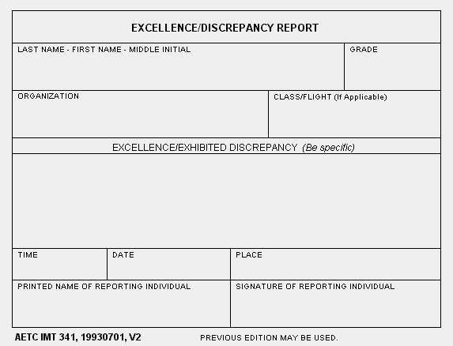

1.8.1 PROBATION (Usual length of nine weeks (one marking period))
1.8.1.1 You will be counseled by the ASI.
1.8.1.2 You may not participate in any extracurricular activity.
1.8.1.3 You will not be considered for promotion during this time or probation.
1.8.2 UNEXCUSED ABSENSE POLICY
1.8.2.1 First offense results in one week probation.
1.8.2.2 Second offense results in one marking period probation.
1.8.2.3 Third offense results in two marking periods of probation.
1.8.3 SUSPENSION POLICY (Internal or External Suspension/Alternative Education.)
1.8.3.1 First Suspension
1.8.3.1.1 One week probation per day of suspension.
1.8.3.1.2 Loss of leadership position for one marking period.
1.8.3.2 Second Suspension
1.8.3.2.1 One marking period probation.
1.8.3.2.2 Revert to permanent grade.
1.8.3.2.3 Loss of leadership position for one semester.
1.8.3.3 Third Suspension
1.8.3.3.1 One school year probation.
1.8.3.3.2 Revert to grade of Airman Basic.
1.8.3.3.3 Loss of leadership position for one year.
1.8.3.4 One internal suspension generally removes a cadet from promotion
eligibility for the marking period in which the incident occurred.
1.8.3.5 Three detentions during a single marking period will generally remove
a cadet from promotion eligibility.
1.8.3.6 All incidents which bring discredit on the program will be reviewed by
SASI for demotion or removal of promotion eligibility.
1.8.3.7 Two missed uniform inspections during a marking period will render a
cadet ineligible for promotion during a marking period.
1.8.3.8 Cadets must turn in at least one homework assignment during a marking
period in order to be considered for promotion.
1.8.3.9 Three negative 341’s during a marking period will result in a review of a
cadet’s promotion eligibility for the marking period. Reviews are done by
ASI’s, the Corps Commander, JA, and additional command staff deemed
necessary by SASI. Reviews are completed on a case by case basis. 12/4’s
and officer cases will be reviewed and held to a higher standard since they
are charged to set the example. If the 341 actions are severe enough, cadets
may be ineligible to promote.
1.8.3.10 Four negative 341’s during a marking period will result in a review with
the above personnel for demotion action.

1.9 NOTE ON CONTACTING INSTRUCTORS

ASIs can always be contacted via email or work phone or The REMIND app, but cadets are
prohibited from contacting instructors via social media (i.e. Facebook, etc) or by cell phone.
Lt Col Lumpkin (SASI) blumpkin@wtp.org 856-589-8500 x7265
MSgt Richard Harris (ASI) rharris@wtps.org 856-589-8500 x7247
MSgt Jeff Hood (ASI) jhood@wtps.org 856-589-8500 x7266

- STANDARDS
2.1 CADET PLEDGE

I HAVE CHOSEN TO BE A CADET IN THE UNITED STATES AIR FORCE JUNIOR ROTC. IN DOING SO, I PLEDGE ALLEGIANCE TO THE UNITED STATES OF AMERICA AND TO THE CADET HONOR CODE, WHICH STATES,

“I WILL NOT LIE, CHEAT, OR STEAL NOR WILL I CONDONE THOSE WHO DO.”

I WILL STRIVE TO BE A PRODUCTIVE CITIZEN OF THIS COUNTRY FOR I KNOW THAT IN FUTURE YEARS I WILL BE ONE OF AMERICA’S LEADERS WORKING TO UPHOLD THE CONSTITUTION AND OUR WAY OF LIFE.

I WILL ALWAYS REMEMBER THAT THIS GREAT NATION WAS BUILT WITH THE COURAGE AND STRENGTH OF MANY OF OUR FOREFATHERS.

THEREFORE, I PROMISE TO WORK HARD AND DILIGENTLY TO EDUCATE MY MIND AND BODY SO I CAN ACCOMPLISH THIS FOREVER CHALLENGING TASK.

SIGNED: ________________________________________

2.2 CADET HONOR CODE

“I WILL NOT LIE, CHEAT, OR STEAL, NOR WILL I CONDONE THOSE WHO DO.”

2.2.1These simple words provide the basis for a personal code of honesty which will sustain you for the rest of your life. The Honor Code is specific and clear in what it demands. You are expected to have complete integrity and honesty in both word and deed; you avoid evasive or misleading statements. You will do your own work on anything which is to be graded. The Honor Code belongs to you.
2.2.2 Maintaining the high standards of trustworthiness is your responsibility. This requires self-control and a conscious effort at all times.
2.2.3 The purpose of the code goes beyond the part of your life which involves AFJROTC training. It should become your ethical code and lifestyle.
2.2.4 If you become aware of lying, stealing, or cheating, report the episode to an ASI. The Judge Advocate (JA, refer to 4.19) and/or the Inspector General (IG, refer to 4.18) will investigate the charges and recommend appropriate action to the ASI. The ASI will take action deemed appropriate in each case.

2.3 CADET OFFICER/SENIOR NCO PLEDGE

In accepting officer/senior NCO rank in the AFJROTC program, I understand and accept the fact that my duties and responsibilities are significantly more demanding and that standards of performance upon which I will be judged in leadership are more exacting as my rank increases.

I recognize that a very important part of my job as an officer/senior NCO is to serve as a model of behavior, performance, bearing, appearance, and self-discipline.

I accept all of these duties and responsibilities without reservation, and promise to honor my obligations at all times. By my example and by my energetic efforts, I pledge to bring credit and honor to the cadet corps, and never by word or deed bring discredit or dishonor to it.

SIGNED: ___________________________________

2.4 STANDARDS OF CONDUCT

2.4.1 You become a leader by exhibiting qualities of intelligence, good judgment, decisiveness and initiative. You inspire others to follow you by setting examples of confidence and maturity. In order to realize your highest potential, you must maintain high standards of self-discipline, high ideals, good manners, social grace, appropriate dress (in or out of uniform), and good grooming.
2.4.2 You will display friendliness and respect to other students, Washington Township High School faculty, Aerospace Science instructors, and other AFJROTC cadets. You will greet other cadets and Aerospace Science instructors in a pleasant manner, regardless of location.
2.4.3 Cadet Officers will exercise discretion in enforcing military courtesy. Cadets will not be placed in an embarrassing situation by a public reprimand. However, cadet officers have the authority and the responsibility to deal with violations of military customs or courtesies.
All decisions regarding the corps/cadets made by cadet officers will not be implemented until approved by an ASI.
2.4.4 You will show your respect for Aerospace Science instructors and any guest speakers by addressing them as "Sir" or "Ma'am" and by responding to them in the same manner.
2.4.5 Enlisted cadets show their respect for cadet officers by addressing and responding to them as “Sir" or "Ma'am". CADET OFFICERS ARE AN EXTENSION OF SASI’S AUTHORITY. ANY INSUBORDINATION AGAINST STUDENT LEADERS WILL BE TREATED AS AN OFFENSE AGAINST THE TEACHER.
2.4.6 You will not wear hats (uniform or civilian) indoors unless permission is obtained from the ASI. When you are in uniform and carrying ceremonial weapons you will wear the correct headgear outdoors and indoors.
2.4.7 You will follow procedures outlined in this cadet guide and will obey reasonable orders from all senior cadets, regardless of position or rank.
2.4.8 You will come to the AFJROTC classroom prepared to engage in AS/LE/Wellness activities. Preparation includes completed assignments, proper textbooks, proper attire, note paper, pen/pencil, and an attitude conducive to learning.
2.4.9 You will not litter the classroom or leave study materials or personal items in the AFJROTC office, classroom, or logistics room. You will put your trash in the trash cans and leave tables and/or chairs correctly place. Classes will not be dismissed until the room is neat and orderly.
2.4.10 You will not mark, scratch, or otherwise deface Air Force or Washington Township High School property.
2.4.11 You MAY chew gum in the classroom, but NOT while in uniform.
2.4.11.1 Cadets may NEVER smoke/vape/or use tobacco products while in uniform regardless of location/time.
2.4.12 You will not wear hats in the classroom (exception: valid religious head cover).
2.4.13 You will not (while in class or at an event) use your cell phones or any other electronic device unless given expressed permission by an ASI. Cadets who violate this rule will be asked to surrender their cell phone. Continued usage of cell phone will result in disciplinary action. THIS APPLIES TO ALL JROTC STUDENTS.
2.4.14 Cadets who violate standards of conduct can and will be demoted, ineligible for promotion, or considered for removal from the class/program.
2.4.15 Cadets are free to exercise their right to peacefully protest/demonstrate, but not in their uniform. Cadets who are wearing their uniforms during student protests/demonstrations must change out of their uniforms to participate. It is appreciated, as a courtesy, that you inform ASI’s when this occurs.
2.4.16 Cadets who use social media must respect the flag and uniform. They must not portray the Air Force or JROTC in a negative light. Cadets must exercise good judgment when posting ROTC activities to social media.
2.4.17 Cadets must not cut through the classroom during the ASI’s instruction. If a cadet is visiting during their lunch period, they must enter through the LG room door. Cadets MUST bring a signed pass if they come to ROTC (unless it’s their flight). Cadets who come to ROTC and are disruptive or violate these rules will not be allowed to come back (exception, their own flight). Cadets who are failing any class are not permitted to come to ROTC except for their flight.

2.4a STANDARDS OF CONDUCT – EVENTS

The Washington Township AFJROTC is a highly visible program which generates pride for the Air Force, the unit, and the school district. Cadets will be asked to participate in events to include community service. Examples of events are theater works, animal aid, home drill competition, Memorial Day parade, posting colors at football games, graduation, and the Fourth of July parade. When volunteering for events such as these, you MUST abide by the following rules:
1. The detail will be led by the OIC (Officer in Charge). This is a cadet officer who is responsible for directing the activity. The cadet officer will direct cadets, and will provide a list of cadet names to the ASI’s the following day as verification of all who attended, time attended, anyone who was a no-show, and report any negative incidents as well. This list will be used to record uniform passes and service hours. This list will be provided to an ASI each time a detail is completed.
2. The NCOIC (Noncommissioned Officer in Charge) will assist the OIC in directing the event. If there is an incident at the event, the NCOIC will accompany the OIC in reporting it to ASI’s.
3. Cadets participating in events MUST conduct themselves with the highest degree of tact and accountability. They MUST exercise their core values (integrity, service, excellence) when representing the JROTC program at school district or community events. The uniform MUST be worn proudly and properly and be in inspection order at all times. Cadets will exercise diplomacy at all times when interacting with the school and community officials, OIC, NCOIC, all fellow cadets, to include anyone one else not previously mentioned. Cadets will display a positive and helpful attitude. They will be mindful of what they do and say while representing the program in and out of uniform. Cadets will ALWAYS be respectful. This includes standing during the entire event, refraining from using handheld devices (unless in performance of their OIC, NCOIC duties), using appropriate language and manners.
4. If a cadet has signed up for an event but cannot attend for a valid reason, it is the cadet’s responsibility to find suitable replacement if one is required. Signing up for events and not attending is unacceptable, and will be dealt with accordingly.

2.5 SALUTING PRIVILEGES

Saluting has always been a privilege enjoyed by military personnel of honorable standing. Not only was it used in the early days of recorded history as a greeting, but also to express mutual trust and respect. Today the salute is a respectful greeting exchanged between military personnel not withstanding differences in military grade. Listed are several of the more important saluting rules. Your instructors will teach you the proper manner of saluting and the rules which govern its use among the military services. They will also teach you the special rules on saluting at Washington Township High School.

2.5.1 Cadet officers are saluted by all cadets with lesser rank while in uniform. Cadet junior grade officers will salute officers of higher rank while in uniform. Enlisted cadets are not required to salute each other however, they are required to salute all cadet officers while in uniform.
2.5.2 The Flight Sergeant (acting Flight Sergeant) will salute the Flight Commander (acting Flight Commander) after taking attendance prior to the beginning of class. The Flight Commander (acting Flight Commander) will salute the instructor when reporting the class ready for instruction.
2.5.3 Salute, in or out of uniform, whenever you are required to report to an ASI in the AFJROTC office.
2.5.4 Do not salute while running. Come to a walk, salute the senior ranking cadet officer, and continue running if necessary.
2.5.5 Salute an inspecting cadet officer when reporting for uniform inspection on Thursday.
2.5.6 When you are in uniform and outdoors, salute all military officers in uniform.
2.5.7 Begin the salute in time to allow the senior cadet/military officer to return it. If you are carrying articles in both hands you do not need to salute, although you will be saluted if recognized as an officer. The person being saluted should nod in return or verbally acknowledge the salute.
2.5.8 Except for formal reporting, you are not required to salute indoors.
2.5.9 When you are outdoors in uniform and the National Anthem is being played, come to attention, face the music and salute. If the flag is being raised or lowered, face the flag and salute. Hold the salute until the flag has stopped moving or the music stops playing. Anytime you are in uniform and observe the American flag moving up or down the flag pole, you will halt, come to attention and salute until the flag stops moving.
2.5.10 Pledge of Allegiance to the United States of America flag.
2.5.10.1 When you are in uniform, outdoors, stand at attention and render the hand salute while reciting the pledge.
2.5.10.2 When you are in uniform, indoors, stand at attention facing the flag and salute the flag. Do not recite the pledge.
2.5.10.3 When you are in civilian attire, stand at attention place the right hand over the heart, face the flag and recite the pledge.
2.5.11 Cadet Officers and NCOs should correct saluting violations by cadets junior to them in a courteous and helpful manner. You are expected to accept these corrections in the same spirit. 2.5.12 ALWAYS include a verbal greeting when rendering a salute (example “Good morning/afternoon sir /ma’am”).
2.6 THE AFJROTC UNIFORM

The AFJROTC cadet uniform is, with certain exceptions, the same as that worn by active duty military personnel. The reputation of the United States Air Force, as a professional military organization, is known worldwide and has no equal. The uniform you wear is a symbol of that reputation. WEAR THE UNIFORM CORRECTLY AND PROUDLY IN ORDER TO PROTECT AND GUARD THAT REPUTATION! You must keep your uniform clean, neat, correct in design and specifications, and in good condition. Maintain badges, insignia, and other metallic devices in proper luster condition. The NJ-932nd weekly uniform day is Thursday. Exceptions to this policy will be announced in advance by the instructors. You are required to wear your uniform to school and remain in uniform the entire school day, unless excused by the ASIs. YOU ARE EXPECTED TO MAKE NECESSARY ADJUSTMENTS TO THE UNIFORM STANDARDS WHEN CHANGES ARE MADE BY HEADQUARTERS EACH YEAR. THIS IS A REFLECTION OF YOUR LEADERSHIP ABILITIES. IF A CHANGE IN POLICY IS MADE, YOU ARE REQUIRED TO MAKE THE ADJUSTMENT.

Your uniform (with the exception of shoes, socks and undershirts) and equipment items are loaned to you and remain the property of the United States Air Force. You must be able to account for all items at all times. If you lose or willfully destroy a uniform or equipment item, you will be required to pay for it at the cost in effect when the account is scheduled to be cleared. Uniforms must be returned cleaned, pressed, on hangers, and in the dry cleaner’s plastic bag. Grades will not be released and the AFJROTC Certificate of Training or Certificate of Completion will not be awarded until all uniform and equipment items have been returned or paid for.

2.6.1. Uniform items not issued by the ASIs are considered optional items. Wear them only when authorized by an ASI.
2.6.2 You will be required to reimburse the Air Force for any lost or willfully damaged uniform item(s).
2.6.3 After being issued the AFJROTC uniform, you will acknowledge receipt for items by signing a male or female uniform initial issue form. By signing the form, you agree to exercise all reasonable caution and care to assure that items of Air Force property are cared for and not damaged due to carelessness, neglect, improper cleaning and/or laundering methods. Further, you are required to return all uniform items, cleaned and laundered, to the ASI upon demand or at which time you are no longer enrolled in the AFJROTC program at Washington Township High School.
2.6.4 Wear the uniform as prescribed in AFJROTC Consolidated Operations Supplement Chapter 7 (3 August 2019) and AFI 36-2903. Attachments to this guide outline authorized uniform combinations. When participating in orientation flights or field trips, you are required to wear the uniform combination prescribed by the Senior Aerospace Science Instructor (SASI).
2.6.5 If you are currently an active member of the Drill Team or Color Guard, you are authorized to wear team cords (yellow/royal blue) as an addition to the regular uniform worn on normal inspection days. Drill Team Commanders have a royal blue cord. (See paragraph 2.6.22.1) The SASI must approve all special uniform items before wear.
2.6.6 Active member of the Kitty Hawk Air Society and cadets who maintain perfect uniform grades are also authorized to wear the corresponding cord (light blue) with their uniform.
2.6.7 Cadet Command and Staff Officers are authorized to wear a dark red shoulder cord while serving in their Command/Staff position. Cadets may only wear one cord. Command staff cords take precedence over all others.
2.6.8 Your issued service dress uniform must be worn when directed by the ASI. On other uniform days, you may wear any authorized combination as prescribed in Chapter 7 Ops Supplement and the attachments to this guide. You will be graded on your appearance on all inspection days. Categories will include uniform appearance and condition, placement of insignia, condition of shoes, military bearing, hair, and grooming. Each inspection will be worth 100 points.
2.6.9 It is your responsibility to ensure that your uniform is available and in inspection condition on Thursdays or the designated uniform day. You will receive a lowered grade or a ‘0’ for not wearing the uniform when required. If you continually fail to wear the uniform when required, you will jeopardize your leadership grade and may be dismissed from the AFJROTC program. If you are absent from school on uniform day, you may make-up your uniform wear grade by wearing your uniform the next day, (Friday)or the Monday or Tuesday following your absence.
2.6.10 You will not wear a mix of cadet uniform and civilian clothing items. If you have a valid reason (medical) for not wearing certain uniforms item(s), shoes for example, you must produce a note from a parent, guardian, or valid medical authority to have an ASI waiver uniform requirement(s).
2.6.11 NJ-932nd cadets must wear the standard USAF, blue, clutch-design nametag on their blue uniform shirts. Cadets must also wear the silver name tag on their service dress uniform coat.
2.6.12 You must dry clean or launder, as applicable, all uniform items you exchange or turn in at the end of the school year.
2.6.13 Ribbons must be worn on the service dress uniform coat; they are optional on all other uniform combinations.
2.6.14 Do not carry bulky items or put your hands in the uniform pockets. Do not place articles under the epaulet of the shirt. Carry books and other objects in your left hand to free the right arm for saluting.
2.6.14.1 Back Packs. Cadets may wear a back pack on the left shoulder or both shoulders (not to interfere with rendering the proper salute).
2.6.15 Wear/use of an earpiece, any blue tooth technology or headphones, while in uniform, indoors or outdoors, is prohibited, unless specifically authorized for the execution of official duties. EXCEPTION: During lunch in the cafeteria, while in uniform, cadets may wear headphones or earbuds. They are also allowed use of electronic devices which include cellphones, iPods, MP3-type players, etc; including any blue tooth technology. Once lunch has concluded and upon exiting the cafeteria, headphones and earbuds will be immediately removed, all electronic devices turned off, and all items put away. Headphones and earphones [iPods, MP3-type players, etc.] are authorized during travel on public transportation i.e., bus, train, or air travel.
2.6.16 You may not perform hard labor, or engage in sports activities while wearing the uniform.
2.6.17 Because you wear the official United States Air Force uniform, objectionable behavior in public can create unfavorable reaction by the public toward the AFJROTC program and the United States Air Force. Conversely, proper conduct, actions and attitude can create and sustain favorable public reactions that will enhance the corps image.
2.6.18 Religious headgear is permitted and able to be worn while in uniform. If possible, conservative design/color is preferred. Consult as ASI for uniform waiver criteria.
2.6.19 As an AFJROTC cadet, you must constantly strive to present a neat, clean, and well-groomed appearance. You will comply with the following standards of appearance
2.6.20 Physical Training Gear (PTG) and Physical Fitness Training (PFT) gear.
2.6.20.1 Physical Training Gear (PTG). PTG refers to the Air Force Physical Training Uniform that may ordered through FEDMALL.
2.6.20.2 Units may locally design and purchase Physical Fitness Training (PFT) gear and sweat pants/shirts that is customized for esprit-de-corps within a unit (usually school colors). Air Force PTG may not be mixed with local purchased PFT gear within a unit. During a Cadet Leadership Course (CLC) cadets may wear Air Force PT shorts with CLC specific t-shirts – this is only for during the duration of the CLC course and cadets may not wear these outside of the CLC. Units may use MilPer funds to locally purchase PFT gear. See Chapter 8 – Finance Guide for additional information.
2.6.20. 3 Physical Training Gear (PTG) and Physical Fitness Training (PFT) gear. Physical Training Gear (PTG). PTG refers to the Air Force Physical Training Uniform that may be ordered through FEDMALL. Physical Fitness Training gear (PFT). PFT gear refers to gear that is locally designed and purchased and customized for esprit-de-corps within a unit. Air Force PTG may not be mixed with local purchased PT gear within a unit. Units may use MilPer funds to locally purchase PFT gear. Cadets will be issued physical training gear (PTG), which consists of a sweatshirt, pt shirt and sweat pants. Cadets will be issued physical fitness training gear (PFT) which consists of a sweat shirt, pt shirt and sweat pants. Both PTG and PFT gear will be issued by the ASIs. Wear of the physical training gear and the physical fitness training gear will be during wellness days or other activities deemed appropriate by the SASI. Cadets are required to wear PT Gear or PFT Gear for Wellness Wednesday. Proper athletic style shoes must be worn. Improper athletic style shoes include slides, sandals, and boots. If slides, sandals or boots are worn, cadet will receive an automatic “0”. Wellness is conducted every Wednesday and WILL include a participation grade. PTG/PFT gear with athletic style shoes + participation = 100 points; Participation + athletic style shoes with NO PTG or PFT Gear = 50 points; NO participation (with or without PTG/PFT Gear = 0. Cadets will change into PTG or PFT gear every Wellness day immediately after the bell rings.
2.6.20.4 Short-sleeved PTG and PFT gear shirt. The short-sleeve shirt will be tucked into the shorts at all times. Do not remove or cut sleeves. PTG undershirts, short and long-sleeved solid white, black or light gray form fitting undershirts, (i.e., Spandex, Lycra or elastic material) may be worn and visible under the short-sleeved PTG shirt. Undershirt must be tucked in. There is no color restriction on the form fitting undershirt; undershirt may have visible small trademark logo.
2.6.20.5 The PTG/PFT shorts waistband will rest at or within two inches of the natural waistline. The lining in the PTG shorts may be removed.
2.6.20.6 Socks. Socks are mandatory. Socks will be white or black and may have small trademark logos.
2.6.21 Footwear. Cadets must wear appropriate athletic style shoes while engaging in physical fitness activities/wellness.
2.6.21.1 Athletic style shoes. Athletic style shoes are mandatory. There are no restrictions on the color of the athletic shoes.
2.6.22 Headgear. The SASI may authorize wear of an optional solid color, that is conservative and in good taste, baseball/sport cap with the PTG/PTF uniform. If authorized, caps are to be worn outdoors only and cadet officer rank will be worn. Enlisted cadets will not have any rank on their headgear.
2.6.23 Drill Team, Color Guard, and Exhibition Uniforms – these uniforms WILL NOT be worn on regular uniform days. It is important that AFJROTC cadets properly represent the Air Force during events and competitions. All drill team, color guard and exhibition uniforms must be a distinctive Air Force dress uniform. This means 1) a combination of the normal Air Force blue pants/skirts, light blue shirt, blue service dress coat or light weight blue jacket or, 2) the Airman Battle Uniform (ABU). Normal blue or ABU uniforms are visually depicted in Attachment 7-16 of this publication.
2.6.24 Units may accessorize their blue drill team, color guard or exhibition uniforms with the following items only. No waiver is needed for any of the items listed below. Additionally, NO WAIVER will be granted for any items not listed below.
2.6.24.1 Berets may be worn. Solid color white, dark blue or black ONLY, with AFJROTC officer or minim-Hap Arnold Insignia pin. The former officer/enlisted flight cap emblems will not be worn on the beret. The wear of a “Beret Flash” or mini unit patch is not authorized. Berets may be worn on regular uniform days. No other color berets may be worn and no waiver will be granted for any other color OR insignias other than listed above. Berets may be purchased from a vendor using MilPer funds.
2.6.24.2 Cadets may only wear one shoulder cord (double knot, single cord, without metal tips, no more than 1-inch wide.
2.6.24.3 Shoulder Cord. One “infantry” style shoulder cord may be worn. Cords will be worn on the left shoulder, grounded to the shoulder seam, with no metal tips, and no wider than 1-inch. Colors are locally determined, (does not have to be a solid color, may be multi-color), must be conservative, in good taste, and defined in Cadet Guide. Shoulder cord may be worn on regular uniform days. Shoulder cords may be purchased from a vendor using MilPer funds. NOTE: Units will have until 1 August 2019 to comply with this change.
2.6.25 Service Caps (wheel and bucket hats, dark Air Force blue color only) may be worn. Females are authorized to wear the male Service Cap. Silver braid headband straps may only be worn on the Service Cap while the cadet is performing in a color guard or drill team competition ONLY. Cadets will wear the black headband strap during regular uniform days.
2.6.25.1 Service Caps (wheel and bucket hats) will be a solid color, dark Air Force blue color only and free of any embroidery. No waiver will be granted to change the color or authorize the use of embroidery on the Service Cap.
2.6.25.2 Service Cap insignia. Cadet officers may wear the highly polished/chrome Hap Arnold Wings or the large highly polished/chrome Cadet Officer insignia on the Service Cap (wheel and bucket hats). Enlisted cadets may only wear the highly polished/chrome Hap Arnold Wings. These items may be purchased from a vendor using MilPer funds.
2.6.26 Chrome helmets are no longer authorized for wear and are to be removed from inventory.
2.6.27 Blue pants may be modified to have a ¾ inch stripe (braid) on the outside length of the pants, sliver, dark blue, and/or black only. These items will not be worn on regular uniform days. No Air Force funds may be used. NOTE: Units will have until 1 August 2019 to comply with this change.
2.6.28 Service Dress Jacket may be modified to have a 1/2 -inch braid, silver, dark blue, and/or black only braid sewn 3 inches from bottom of sleeve. These items will not be worn on regular uniform days. No Air Force funds may be used. NOTE: Units will have until 1 August 2019 to comply with this change.
2.6.29 Wear of Color Guard and Saber harnesses, i.e., Sam Brown belt with shoulder strap is authorized only when performing color guards or commanding during drill segment. Harness and color guard web/parade belts may be black, dark blue, white and black/white clarion (high gloss). USAF Honor Guard Ceremonial Belt (Hap Arnold insignia may also be worn). Harness and web/parade/ceremonial belts must be removed when not performing a color guard or a segment of drill and cannot be worn at awards ceremonies.
2.6.30 Belts for trousers must be blue in color only. (No waiver will be granted for wear any other color.)
2.6.31 Units may wear the USAF Honor Guard Ceremonial Belt, with the Hap Arnold Wings and heavy/medium weight (pistol, military police) web belts during performances of drill and color guard events only. These items will not be worn on regular uniform days. No Air Force funds may be used to purchase these belts.
2.6.32 Wing and Star Buttons on the Service Dress uniforms may NOT be highly polished (chrome). Buttons will have the standard satin finish only. No waiver will be granted for wear of any other style and/or finish on the buttons. NOTE: Units will have until 1 August 2019 to comply with this change.
2.6.33 Solid color ascots may be worn (units may embroider a logo/team name/mascot or place a unit patch of the ascot), colors may be locally-determined, but must be one solid color, conservative, and in good taste, and defined in the Cadet Guide or Unit Operations Instruction. Ascots will not be worn on regular uniform days.
2.6.34 Items NOT to be worn on Drill Team, Color Guard, and Exhibition Uniforms. (No waivers will be granted for such items listed below.
2.6.34.1 Embroidery on the Air Force blue drill team uniform is not authorized, i.e., on the back of the blue shirt collar or shoulder yoke. No waiver will be granted for wear of such items.
2.6.34.2 Specialized unit rank, stars or other unit made rank/shoulder boards are not authorized. Example: Team or school name on shoulder boards, or a custom unit rank for drill team members. No waiver will be granted for wear of such items.
2.6.34.3 Arm wrist/sweat bands are not authorized. No waiver will be granted for wear of such items.
2.6.34.4 Spats (shoe covers) will not be worn with any uniform combinations, drill, color guard or any type of ceremonial uniform. No waiver will be granted for wear of such items.
2.6.34.5 Service Caps (wheel and bucket hats) will be a solid color. No embroidery on the service cap is authorized. Additionally, no “thunder and lightning” on the hat brim is authorized for wear by cadets. No waiver will be granted for wear of such items.
2.6.34.6 Military Training Instructor (MTI) style head gear (Aussie Outback/Slouch and Smokey the bear hats) are prohibited for wear by cadets. No waiver will be granted for wear of such items.
2.6.34.7 Black Boots/corfams may be issued on an as required basis to the Color Guard or Drill Team. This is for restricted use and is not intended for use across unit’s entire cadet corps. Black boots/corfams may be reissued to cadets. Spray boots/corfams with disinfectant spray/before reissuing. This rule does not apply to standard issue of cadet foot ware. All new cadets enrolling in AFJROTC are to be issued a pair of “NEW” oxford (leather) shoes. Corfams are not to be considered an initial issue of AFJROTC foot ware.
2.6.35 Airman Battle Uniform (ABU)
2.6.35.1 ABUs may be worn as Drill Team, Color Guard, and Exhibition Uniform. Berets, shoulder cords, ascots and gloves will not be worn with the ABU uniform, waivers will not be authorized.
2.6.35.2 ABUs will be worn only with the garrison ABU cap and sage green boots. ABU pants must always be properly bloused over the sage green boots. ABU sage green boots may be reissued to cadets. Spray boots with disinfectant spray before reissuing ABU boots. NO berets, shoulder cords, ascots and gloves will be worn with the ABU uniform.
2.6.35.3 ABUs are authorized for wear by 12-4 cadets, command staff personnel, LG technicians and cadets who have successfully completed the Cadet Leadership Course (CLC).
2.6.35.4 OCP uniforms are not authorized for wear by AFJROTC cadets at any time.
2.6.36 Semi-Formal Dress Uniform. Cadets may wear medals with the semi-formal uniform at events such as dining in/outs, military ball, awards ceremonies, picture day or other formal events as specified by the SASI. Large medals will be worn on the semi-formal uniform ½ inch below the top of the welt of the pocket, centered on the pocket. Additionally, AFJROTC ribbons may be worn on the semi-formal uniform, however, if medals are worn, ribbons will not be worn (no mixing).
2.6.36.1 The semi-formal dress uniform coat is the service dress uniform coat without a name tag.
2.6.36.2 Cadets may wear either the blue or white Long Sleeve Shirt. The blue or white long-sleeve shirt will be plain, knit or woven, commercial type with a short or medium point collar, with button or French cuffs. Shirts will be tucked into the trousers. Female cadets may wear a white long-sleeved blouse similar in style to the men’s long-sleeved shirt.
2.6.36.3 Tie/Tab. Either a blue polyester or silk, herringbone twill tie/tab or may be worn with either the blue or white long-sleeved shirt. Men may wear a plain black or dark blue bow tie with the long-sleeve shirt, with the semi-formal dress uniform only.
2.6.36.4 Trousers or skirts. The semi-formal dress uniform trousers and/or skirt are the same as the service dress trousers and/or skirt. No stripes (braiding) on the outside length of the trousers is authorized for wear on the semi-formal dress uniform.
2.6.36.5 Belt and Buckle. The semi-formal dress uniform belt and buckle are the same as the service dress belt and buckle.
2.6.36.6 Cadets will not wear headgear with the semi-formal dress uniform.
2.6.36.7 Mess Dress Uniforms are not authorized for wear by AFJROTC cadets.
2.6.37 Attachment 7-1. Authorized Air Force JROTC Badges and Insignia. Hap Arnold insignia is authorized for wear on the service cap for enlisted/officer and pins removed.
2.6.38 Attachment 7-3. Male Service Cap Insignia - Cadet officers may wear the AFJROTC officer hat insignia or the large Hap Arnold Wings insignia. Enlisted cadets may only wear the large Hap Arnold Wings insignia.
2.6.39 Attachment 7-4. Female Service Cap Insignia - Cadet officers may wear the AFJROTC officer hat insignia or the large Hap Arnold Wings insignia. Enlisted cadets may only wear the large Hap Arnold Wings insignia.
2.6.40 Attachment 7-6. Cadet ABU Headgear – Officers will wear rank insignia on the ABU cap. Note: Enlisted ranks will have no insignia on the ABU cap.
2.6.41 Attachment 7-7. Note 3- Grade insignia (officer and enlisted) will be worn on both lapels, mandatory. For placement see Note 7. Note 7 – Center insignia horizontally on collar. Place 1 inch from bottom of collar and parallel to the outer edge of the collar. Note 9 – Ascots and shoulder cords will not be worn on this uniform.
2.6.42 Attachment 7-8. Cadet Male Service Dress Uniform. Shoulder Cord, no wider than 1 inch and will be grounded to the seam of the left shoulder. Ribbons are mandatory and are centered, on but not over the edge of the pocket. Wear 3 or 4 in a row. Wear all or some ribbons earned. Medals are not authorized for wear on this uniform with ribbons. Ribbons and medals may not be mixed.
2.6.43 Attachment 7-9. Cadet Female Service Dress Uniform. Shoulder Cord, no wider than 1 inch and will be grounded to the seam of the left shoulder. Ribbons are mandatory and are centered, on but not over the edge of the pocket. Wear 3 or 4 in a row. Wear all or some ribbons earned. Medals are not authorized for wear on this uniform with ribbons. Ribbons and medals may not be mixed.
2.6.44 Attachment 7-10. Cadet Male Blue Shirt. Ribbons are optional, wear all, or some ribbons earned. If worn, ribbons will be centered, resting on, but not over the edge of the pleated pocket on the wearers left. Shoulder Cord, no wider than 1 inch and will be grounded to the seam of the left shoulder under epaulet. Medals (regardless of what type) are not authorized for wear on this uniform.
2.6.45 Attachment 7-11. Cadet Female Blue Shirt. Ribbons are optional, wear all, or some ribbons earned. If worn, ribbons will be centered, resting on, but not over the edge of the pleated pocket on the wearers left. Shoulder Cord, no wider than 1 inch and will be grounded to the seam of the left shoulder under epaulet. Medals (regardless of what type) are not authorized for wear on this uniform.
2.6.46 Attachment 7-12. Flight Suit – Note 2 – The unit patch will be worn on the right sleeve (shoulder) of the Flight Suit, if the unit patch is unavailable then the white, Lamp of Knowledge, AFJROTC Patch will be worn Velcro attached. Note 4 - *Cadet Name Patch (mandatory). Velcro attached. Black background with silver border (if unit has a unit patch, units may substitute background color/border with unit patch colors). Cadet Name Badge – Top line will be Cadet Name and second line will be “CADET AFJROTC”.
2.6.47 Attachment 7-13. Semi-Formal Dress Uniform. Black or blue bow tie may be worn. Ribbons will not be worn on the semi-formal uniform. Large medals may be worn on the Service Dress coat only, directly under ribbon rack. Authorized badges may be worn on the semi-formal dress uniform. If medals are worn, badges that are normally worn directly under the ribbon rack will not be worn. Note 5 – Large medals will be worn on the semi-formal uniform coat ½ inch below the top of the welt of the pocket, centered on the pocket. If medals are worn, ribbons will not be worn (no mixing). Note 6 – AFJROTC ribbons may be worn on the semi-formal uniform. If ribbons are worn, medals will not be worn (no mixing).
2.6.48 Attachment 7-14. Sample Exhibition Uniform. Berets, solid Color, white dark blue and/or black ONLY, with AFJROTC officer and/or enlisted rank insignia and mini-Hap Arnold Insignia. The former officer flight cap emblem will not be worn on the beret. Shoulder Cords, cadets are authorized to wear one shoulder cord on the left shoulder. This will be a single “infantry” style cord, without metal tips, no more than 1-inch wide. On the blue shirt the cord will be under the epaulet, grounded to the left shoulder seam and pinned to the shoulder with the pin hidden beneath the cord. Blue/Silver Name Tags and ribbon may be omitted on uniforms where a drill rifle or other equipment may damage the item or injure the performing member. This does not apply to uniforms worn during regular uniform days. Blue pants may be modified to have a ¾ inch stripe on the outside length of the pants. Silver dark blue, and/or black only. These items will not be worn on regular uniform days. Solid color ascots may be worn, colors may be locally-determined (school colors), but must be conservative and in good taste, and defined in the Cadet Guide or Unit Operations Instruction. Ascots will not be worn on regular uniform days. Embroidery on the Air Force blue drill team uniforms is not authorized, i.e., on the back of the blue shirt collar or shoulder yoke. Specialized unit rank/shoulder boards are not authorized. Wrist bands are not authorized. Note 5 – Solid color ascots may be worn (embroidery or a unit patch is authorized on the ascot), colors may be locally-determined (school colors), but must be conservative and in good taste, and defined in the Cadet Guide or Unit Operations. Ascots will not be worn on regular uniform days.
2.6.49 Attachment 7-15. Sample Exhibition Uniform. Women’s Service Cap may be worn with the Hap Arnold Wings insignia or Officer Service Cap may also be worn with the large officer service cap insignia large officer’s. Service Caps (wheel and bucket hats) will be solid color and free of any embroidery. Shoulder Cord, cadets are authorized to wear one shoulder cord on the left shoulder. This will be a single “infantry” style cord, without metal tips, no more than 1-inch wide. On the blue shirt the cord will be under the epaulet, grounded to the left shoulder seam and pinned to the shoulder with the pin hidden beneath the cord. Cords may be any color. Blue/Silver Name Tags and ribbons may be omitted on uniforms where a drill rifle or other equipment may damage the item or injure the performing member. This does not apply to uniforms worn during regular uniform days. Blue pants may be modified to have a ¾ inch stripe on the outside length of the pants, sliver, dark blue, and/or black only. These items will not be worn on regular uniform days. Solid color ascots may be worn, color may be locally-determined (school colors), but must be conservative and in good taste, and defined in the Cadet Guide or Unit Operations Instruction. Ascots will not be worn or regular uniform days. Embroidery on the Air Force blue drill team uniform is not authorized, 1.e., on the back of the blue shirt collar or shoulder yoke. Specialized unit rank/shoulder boards are not authorized. Note 1 – Women’s Service Caps may be worn with the Hap Arnold Wings insignia or Officer Service Cap may also be worn with the large officer service cap insignia. Service Caps (wheel and bucket hats) will be a solid color and free of any embroidery. Note 5 – Solid color ascots may be worn (embroidery or a unit patch is authorized on the ascot), colors may be locally-determined (school colors), but must be conservative and in good taste, and defined in the Cadet Guide or Unit Operations Instruction. Ascots will not be worn on regular uniform days. Note 8 – A ½ inch silver sleeve braid, 3 inches from the end of the sleeve may be worn.
2.6.50 Attachment 7-16. Sample Uniform Pictures
2.6.51 Attachment 7-17. Updated – National Level Award Contacts.
2.6.52 Attachment 7-16. Sample Design, Local purchased PFT – Units may locally
design and wear PFT gear that is customized for the unit (see para 2.6.20.2 for additional
information.)
2.7 SPECIFIC CADET UNIFORM WEAR GUIDELINES
2.7.1 Cadet Uniform Wear Guidance for School Hosted JROTC Events:
2.7.1.1 School Sponsored Military Ball with Awards Ceremony: Units have two
options they may choose to utilize.
Option 1: All cadets can wear the AFJROTC Service Dress uniform.
Option 2: Each male and female cadet will be given the individual option to wear
their AFJROTC Service Dress uniform or to wear formal or semi-formal civilian
attire. Any civilian attire worn must be in compliance with any/all school and district
policies.
NOTE: Option 2 would allow block schedule school students to attend who are not
currently in AFJROTC and who may not have uniforms currently issued to them.
2.7.1.2 School Sponsored Dining-Ins/Dining-Outs with Awards Ceremony: All
AFJROTC cadets will wear their AFJROTC Service Dress uniform.
2.7.1.3 For any other event, the SASI, in conjunction with the school Principal will
decide on the appropriate attire for AFJROTC cadets.
2.7.2 Cadet Uniform Wear Guidance for Fundraising:
2.7.2.1 There are no concerns with businesses contributing money to an AFJROTC
booster club or other private clubs associated with AFJROTC that are NOT
established by the Air Force as part of the program.
2.7.2.2 If businesses make a monetary donation, AFJROTC instructors and cadets
may not advertise for the business in return – particularly in uniform. Doing so
would present the “appearance” of an Air Force endorsement of the businesses
making the donation. Such an appearance could be interpreted as a violation of the
Joint Ethics Regulation.
2.7.2.3 AFJROTC personnel/cadets should not solicit donations from local businesses
at any time.
2.7.2.4 Incorporating Corporate Sponsorship/local business donations as a way to
help boost funding for your AFJROTC program are a great way to fund Leadership
Development Requirements (LDR) for your cadets. The key is to contact your district
and follow the above guidance to help keep sponsors and AFJROTC units within the
scope of the Joint Ethics Regulation.

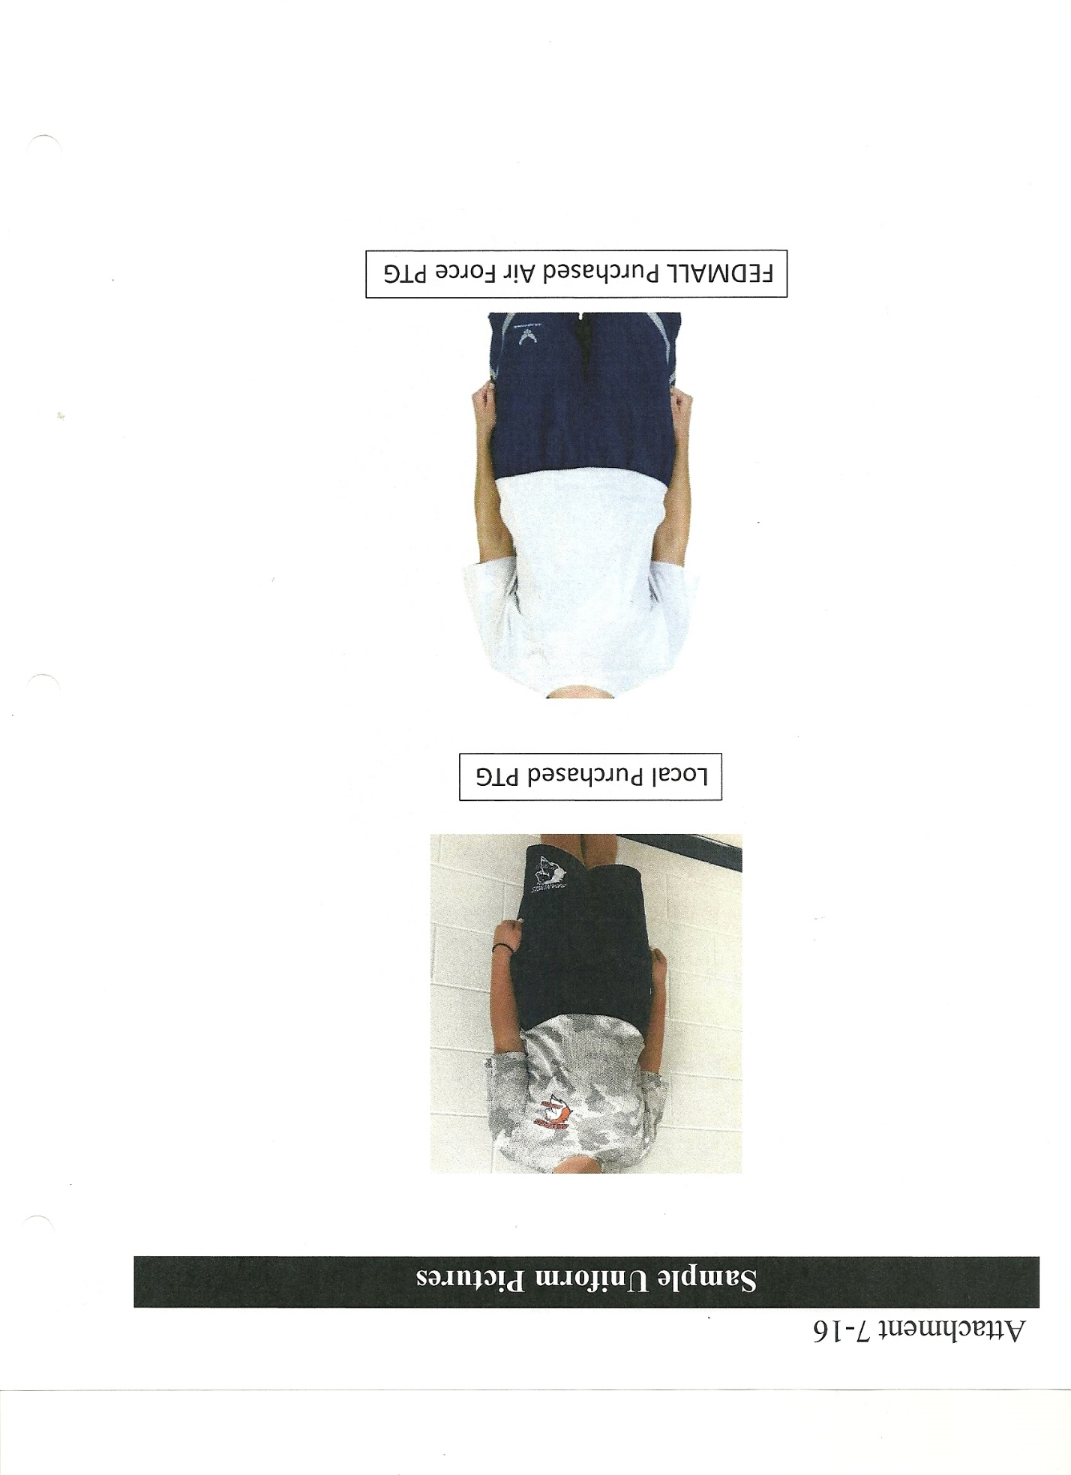

- GROOMING AND APPEARANCE
3.1 GROOMING AND APPEARANCE STANDARDS (ALSO SEE PARA 7.9 & 7.10)
3.1.1. Personal Grooming Standards. This paragraph outlines personal grooming while
wearing the JROTC uniform. The ASI’s discretion may be used to determine if individual’s
personal grooming is within standards of this cadet guide. The personal grooming standards
listed are minimum standards that represent common appearance issues and are not all-inclusive.
Although Cadet’s have the right, within established limits, to express their individuality through
their appearance, Air Force has defined what is and what is not an acceptable professional
military image for cadets. Except for minor variations based on gender differences, all Junior
ROTC cadets must comply with the same personal grooming standards. ASI’s have the
responsibility to determine compliance with the letter and intent of this Cadet Guide and to
correct the obvious violations regardless of whether the situation identified is clearly written in
this Cadet Guide.
3.1.2. Hair-male and female. Will be clean, well-groomed, present a professional appearance,
allow proper wear of headgear, helmet or chemical mask and conform to safety requirements.
Will not contain excessive amounts of grooming aids (e.g. gel, mousse, pomade, and
moisturizer), appear lopsided, touch either eyebrow, or end below an imaginary line across the
forehead at the top of the eyebrows that is parallel to the ground. If applied, dyes, tints, bleaches
and frostings must result in natural hair colors. The hair color must complement the member’s
complexion and skin tone. Examples of natural hair colors are brown, blonde, brunette, natural
red, black or grey. Prohibited examples (not all inclusive) are burgundy, purple, orange,
fluorescent or neon colors. (See Para 7.8.1)

3.2 MALE GROOMING STANDARDS’ (SEE PARA 7.11)
3.2.1. Hair-Male. Military tapered appearance on both sides and the back of the head, both
with and without headgear. A military tapered appearance is one that when viewed from any
angle outlines the member's hair so that it conforms to the shape of the head, curving inward
to the natural termination point without eccentric directional flow, twists or spiking. A block-
cut is permitted with tapered appearance. Hair will not exceed 1¼ inch in bulk, regardless of
length and ¼ inch at natural termination point; allowing only closely cut or shaved hair on the
back of the neck to touch the collar. Hair will not touch the ears or protrude under the front
band of headgear. Cleanly shaven heads, military high-and-tight or flat-top cuts are
authorized. Prohibited examples (not all inclusive) are Mohawk, mullet, cornrows, dreadlocks
or etched design. Males are not authorized hair extensions. See Figure 2-1 for sideburns
and mustache for graphic examples of male hair standards.
3.2.1.1. Sideburns. If worn, sideburns will be straight and even width (not flared),
and will not extend below the bottom of the orifice of the ear opening. Sideburns will
end in a clean-shaven horizontal line. See Figure 2-1, orifice of the ear opening is at
reference point A.
3.1.2.2. Mustaches. Male Cadets may have mustaches; however, they will be
conservative (moderate, being within reasonable limits; not excessive or extreme) and
will not extend downward beyond the lip line of the upper lip or extend sideways
beyond a vertical line drawn upward from both corners of the mouth. See Figure 2-1,
reference points B, C, and D. Any other facial hair is not authorized unless for medical /
religious reasons. Cadet must submit medical /religious facial hair waiver request to SASI
for authorization. SASI will submit waiver request in WINGS for review by HQ AFJROTC
Waiver Review board.
3.1.2.3. Earrings. Male cadets in uniform may not wear earrings or any other type of facial
piercings.
3.2.2 When a physician prescribes that a patient not shave, the beard must be kept trimmed
symmetrically and all beard hairs must be kept trimmed so that they do not protrude more than
one quarter inch from the skin surface of the face.
3.2.3 Your hair must be neat, clean, trimmed, and present a conservative well-groomed
appearance. Male hair will have a military tapered appearance on both sides and the back of the
head. A military tapered appearance is one that when viewed from any angle outlines the
member’s hair so that it conforms to the shape of the head, curving inward to the natural
termination point without eccentric directional flow, twists spiking or duck tails.
3.2.4 You may not wear wigs and hairpieces except for cosmetic reasons to cover natural
baldness or physical disfigurement. When worn, they will conform to 3.2.3. Your hair must
be of a natural color. (See para 7.10.1.6).
3.2.5 You will not wear, or carry, exposed on the service uniform, articles such as
handkerchiefs, pencils and pens, watch chains, pins, jewelry, wallets, combs, cigars, pipes,
cigarettes, earrings, and sunglasses. You may wear wristwatches, identification bracelets, and
no more than three rings, (no thumb rings). You may wear conservative sunglasses outdoors,
(non-mirrored and conservative color) but not in military formations.
3.2.6 Males will wear a plain, white, “V” neck undershirt when in uniform.
3.2.7 Males will keep their finger nails neat, clean, and trimmed.

3.3 FEMALE GROOMING STANDARDS (SEE PARA 7.10)
3.3.1 You will wear appropriate undergarments to present a conservative, feminine appearance. You
will not wear, or carry, exposed on the uniform, pencils, pens, handkerchiefs and jewelry, including
ankle bracelets. You may wear wristwatches, identifications bracelets, small round or square white
diamond, gold, white pearl, or silver earrings, (no more than one per ear, and in the lowest hole of the
earlobe), if a member has multiple holes, only one set of earrings are authorized to be worn in uniform
and will be worn in the lower ear lobes. Cadets are authorized no more than three rings. You may wear
conservative sunglasses, (non-mirrored and conservative color) except in military formations.
3.3.2. Hair-Female. No minimum hair length to a maximum bulk of 3 ½ inches from scalp and allows
proper wear of headgear. Hair will end above the bottom edge of collar and will not extend below an
invisible line drawn parallel to the ground, both front to back and side to side. Bangs, or side-swiped hair
will not touch either eyebrow, to include an invisible line drawn across eyebrows and parallel to the
ground. See Figure 1.2. When in doubt, assess correct length of hair with Cadet standing in the
position of attention. Exception: While wearing the Physical Training Uniform (PTU), long hair
will be secured but may have loose ends and may extend below the bottom edge of the collar.
3.3.2.1. The intent is for pinned-up hair to be styled in a manner that prevents loose ends from
extending upward on the head. For example, when using a clip or hairpins, hair will not present
the appearance of a ―rooster tail. When hair is in a bun, the bun must be a single bun; no wider
than the width of the head and all loose ends must be tucked in and secured. When hair is in a
ponytail, it must be a single ponytail; that does not exceed bulk and length standards and does not
extend below the bottom of the collar. As with all hairstyles, a neat and professional image is
essential.
3.3.2.2 Hair accessories. If worn, black hair accessories ( e.g. fabric scrunchies, hairpins, combs,
clips, headbands, elastic bands and barrettes, etc) are authorized regardless of hair color.
Headbands or fabric scrunchies will not exceed one-inch in width. Ornaments are not authorized
(i.e. ribbons, beads, jeweled pins). See figure 1-2 (photo of scrunchie).
3.3.2.3 Locs, braids, twists, micro-braids, french braids, dutch braids and cornrows are
authorized. Locs are defined as portions of hair that have been intentionally or
unintentionally fused together to form a loc or locs. A braid or twist is two or more
portions of interwoven hair. If adding additional hair, it must be a natural-looking color,
similar to the individual's hair color. It must be conservative (moderate, being within
reasonable limits; not excessive or extreme) and not present a faddish appearance. Hair
must not exceed bulk and length standards and must not extend below the bottom of the
collar. Headgear must fit properly.
3.3.2.4 All locs, braids, and twists, when worn will be of uniform dimension, no wider than one
inch, with natural spacing between the locs, braids, or twists and must be tightly interwoven to
present a neat, professional and well-groomed appearance. When worn, multiple locs, braids, or
twists shall be of uniform dimension, small in diameter (approx. ¼ inches), show no more than ¼
inch of scalp between the locs, braids or twists and must be tightly fused/interwoven to present a
neat, professional appearance. A loc, or braid must continue to the end of the hair without design
and following the contour of the head, and may be worn loose or in a secured style within hair
standards in paragraph 7.10.1. above. [Exception: Micro-braids or twists are not required to
continue to the end of the hair.]
3.3.2.5 Unauthorized: Shaved heads. Shaved heads are defined as complete removal of all hair
to the skin on the head or portions of the head. See figure 1-1. Hair color, highlights, lowlights,
and frosting will not be faddish or extreme and will be natural looking hair color, similar to the
individual’s hair color (e.g. black, brunette, blond, natural red, and grey).
3.3.2.6 Unauthorized: Mohawk, mullet or etched design.
3.3.3. Body Hair. Female Cadets will remove leg hair that is visibly protruding beyond the
appropriate hosiery or causes a visibly uneven texture under hosiery.
3.3.4 Your hair must be styled to permit proper wear of any military headgear and will not be worn in any style longer than the bottom of the collar edge at the back of the neck. Exaggerated styles with excessive fullness or extreme heights are prohibited. If you wear a hairpiece, it must conform to the same regulations governing natural hairstyles. Hair must be a natural color; bright highlighted hair colors (i.e. pink, blue) are not authorized in uniform. If worn, hair ties and other hair accessories must be black regardless of hair color (black, brown, brunette, blonde, natural red, and grey). (See para 7.10.1.3.1).
3.3.5 Your cosmetics must be conservative and in good taste.
3.3.6 Hosiery must be sheer and in a shade that complements the uniform. (See para 7.10.3.3).
3.3.7 Your fingernails must be kept neat and clean. White tip French manicures are authorized and will not exceed ¼ inch in length beyond the tip of the finger. Nail polish, if worn, must be in good taste and of a conservative color. (See para 7.10.2.1).

3.4 UNIFORM INSPECTION POINTS

Inspections are completed on assigned uniform days (typically Thursday of each week).

ASI’s and 12/4 cadets (with ASI present) conduct all inspections.

A student may wear the uniform PRIOR TO their Thursday inspection, but not on the day when physical training gear/physical fitness training gear (Wednesday) is required. Students CANNOT make up a uniform inspection after the normal Thursday inspection (unless they are absent for the Thursday inspection).

Inspection officers are required to use good judgment when “assessing” points due to infractions.
During all inspections an instructor will be present to ensure points are assessed equitably.
POINT OF EMPHASIS: A REPEAT WRITE-UP FROM THE PREVIOUS WEEK (example grooming standard: haircut, hair dyed unnatural color, not shaving, no tie/tab) WILL RESULT IN DOUBLING THE DEDUCTION (ie, hair touching ear 10 points doubled=20 point deduction). Continued failure to adhere to standards will increase the deduction by ten points each week (ex, 10 points, then 20 points, then 30 points, etc). Cadets can and will be removed from the programs for Failure to Wear the Uniform.

POINT OF EMPHASIS: IF A CADET REMOVES ANY PART OF THE REQUIRED UNIFORM PRIOR TO THE END OF THE SCHOOL DAY, OR VIOLATES GROOMING STANDARDS, THE UNIFORM GRADE WILL BE A ZERO.

If you know you will not be in uniform on uniform day, you can wear your uniform any other school day of the week, except Wednesday with prior notice, with no penalty. Ensure your Instructor or Flight Commander inspects you and records the results in the grade book.

For uniform inspections, points will be deducted for the following infractions:

DISCREPANCY | Maximum  Point  Deduction  ^{1st} Offense | 2nd | 3rd | 4th | 5th | REMARKS
ABU – missing nametape | 10 points | 20 | 30 | 40 | 50
ABU – missing service tape | 10 points | 20 | 30 | 40 | 50
ABU – missing patch | 10 points | 30 | 40 | 50 | 60
ABU – not bloused properly | 10 points | 20 | 30 | 40 | 50
ABU – wrong undershirt | 10 points | 20 | 30 | 40 | 50
Athletic/utility socks - w/flats | 10 points | 20 | 30 | 40 | 50
Badge(s) missing | 10 points | 20 | 30 | 40 | 50
Belt improperly fitted (Class B/C) | 5 points | 10 | 15 | 20 | 25
Belt missing | 10 points | 20 | 30 | 40 | 50
Belt – wrong type* | 10 points | 20 | 30 | 40 | 50 | Not dark blue web
Bracelet - not conservative/ no rubber | 10 points | 20 | 30 | 40 | 50
Button – missing | 10 points | 20 | 30 | 40 | 50
Button – not fastened | 10 points | 20 | 30 | 40 | 50
Button (top) exposed* | 10 points | 20 | 30 | 40 | 50
Cables | 2 points | 2 | 2 | 2 | 2 | Strings
Collar Stained – (ring) | 10 points | 20 | 30 | 40 | 50
Earrings (female) – wrong type | 10 points | 20 | 30 | 40 | 50
Earrings (female) – too many | 20 points | 30 | 40 | 50 | 60
Excessive jewelry | 20 points | 30 | 40 | 50 | 60
Gig line crooked (Class “B”/ “C”) | 2 points | 2 | 2 | 2 | 2
Hair – excessively long | 10 points | 20 | 30 | 40 | 50 | 1 1/4 in./bulk(m) & 3 ½ in. bulk(f)
Hair – (male) not cut | 10 points | 20 | 30 | 40 | 50
Hair – (female) fly-aways | 5 points | 5 | 5 | 5 | 5
Hair – touching eyebrows | 5 points | 10 | 15 | 20 | 25
Hair – wrong color hair-tie/headband | 10 points | 20 | 30 | 40 | 50 | BLACK Only
Hair (female) below bottom of collar | 10 points | 20 | 30 | 40 | 50
Hair (male) touching ears or collar | 10 points | 20 | 30 | 40 | 50
Hair – not natural color | 10 points | 20 | 30 | 40 | 50
Hair – excessive fullness (male/female) | 10 points | 20 | 30 | 40 | 50
Hair – not (military) tapered* | 10 points | 20 | 30 | 40 | 50
Headbands (female) > 1 in. | 10 points | 20 | 30 | 40 | 50
Hosiery – not worn with proper uniform | 20 points | 30 | 40 | 50 | 60
Hosiery – wrong type/color | 10 points | 20 | 30 | 40 | 50
ID – missing | 10 points | 20 | 30 | 40 | 50
Lint | 5 points | 5 | 5 | 5 | 5
Lipstick – wrong color (not conservative) | 5 points | 10 | 15 | 20 | 25
Mustache – out of regulation | 10 points | 20 | 30 | 40 | 50
Necklace – exposed | 10 points | 20 | 30 | 40 | 50
Nails – wrong color | 10 points | 20 | 30 | 40 | 50
Nail Polish/chipped, designs | 10 points | 20 | 30 | 40 | 50
Nametag wrong position on uniform | 5 points | 5 | 5 | 5 | 5
Name tag missing | 10 points | 20 | 30 | 40 | 50
Not wearing hosiery | 10 points | 20 | 30 | 40 | 50
Patches missing or frayed | 10 points | 20 | 30 | 40 | 50
Rank improperly positioned on uniform | 5 points | 10 | 15 | 20 | 25
Rank – missing | 10 points | 20 | 30 | 40 | 50
Ribbons improperly positioned on uniform | 5 points | 10 | 15 | 20 | 25
Ribbons – missing | 10 points | 20 | 30 | 40 | 50
Ribbons – out of order | 10 points | 20 | 30 | 40 | 50
Rings – too many/inappropriate | 10 points | 20 | 30 | 40 | 50 | No thumb rings
Ropes/Excessive Cables | 10 points | 20 | 30 | 40 | 50
Shave required – did not shave | 20 points | 30 | 40 | 50 | 60
Shave required – stubble | 10 points | 20 | 30 | 40 | 50
Shoes – wrong color/type | 15 points | 25 | 35 | 45 | 55
Shoes – not polished/dirty | 10 points | 20 | 30 | 40 | 50
Shoe laces missing | 5 points | 5 | 5 | 5 | 5
Shoes laces – not tied | 5 points | 5 | 5 | 5 | 5
Shoes – scuffed | 5 points | 5 | 5 | 5 | 5
Sideburns – (male) too long | 10 points | 20 | 30 | 40 | 50
Skirt – improper length | 5 points | 10 | 15 | 20 | 25
Socks – wrong color | 10 points | 20 | 30 | 40 | 50
Socks w/logo | 10 points | 20 | 30 | 40 | 50
Stains | 10 points | 20 | 30 | 40 | 50 | Not washable
Talking/moving in formation/classroom | 10 points | 20 | 30 | 40 | 50 | Bearing during inspection
Tie missing | 10 points | 20 | 30 | 40 | 50
Undershirt – wrong type /not “V” neck | 10 points | 20 | 30 | 40 | 50
Undershirt – wrong color | 10 points | 20 | 30 | 40 | 50
Uniform – wrong type | 20 points | 30 | 40 | 50 | 60
Uniform dirty/wrinkled | 20 points | 30 | 40 | 50 | 60

Inspection officers are required to use good judgment when “assessing” points due to infractions. 12/4 seniors are required to be consistent when inspecting. Assess cadets objectively without regard for your personal feelings toward them. The integrity of the inspection depends on your ability to do this.

**During all inspections an instructor (ASI) will be present to ensure points are assessed equitably.

Inspection Deductions 2019-20
A repeat write-up does not necessarily occur in consecutive weeks. A subsequent offense may occur during any inspection following the initial write up. The entire uniform is to be worn all day at school on inspection days. A deduction may occur at any time during the school day. Special consideration will be given if the reason is valid such as a member of an athletic team traveling. This must be presented to ASI’s and not assumed.
CLASS “A” INSPECTIONS – Cadets may be asked to remove service coat after it is inspected to inspect shirt/blouse, pants, belt, nametags, ranks, etc.

CLASS “B” & “C” INSPECTIONS – Cadets will remove windbreakers prior to falling out for inspection. Windbreakers are not a mandatory inspection item & therefore will not be worn in formation
A student may wear the uniform PRIOR TO their Thursday inspection, but not on the day when physical training gear/physical fitness training gear (Wednesday) is required. Students CANNOT make up a uniform inspection after the normal Thursday inspection (unless they are absent for the Thursday inspection). If a student is inspected on a day other than the scheduled uniform inspection, they MUST complete and turn in an Out of Cycle Inspection Form. This will ensure the grade is recorded. Failure to complete this form and turn it in will result in a grade of zero or a repeat of the inspection on another day.
INSPECTION FORM (OUT OF CYCLE)

This form (below) MUST be presented to an ASI & 12/4 inspector if you are inspected
Separate from your regular flight inspection. This will ensure your grade is recorded!

Cadet completes the following (in blue or black ink):

Name:

Flight:

Today’s date:

What is the date of the inspection you are being graded for?:

Uniform Class: (A, B, C)

You must be inspected by a 12/4 with an ASI present! The ASI/12/4 will complete the following:
Inspection Deductions (Discrepancies) (if any): _________________________________

Final grade: _________/(100 possible)
12/4 signature: _____________________________________________
ASI signature: _____________________________________________

Cadet signature: _____________________________________________
The cadet (who was inspected) MUST turn this COMPLETED form in to the ASI in charge of curriculum (MSgt Hood) to ensure this grade is recorded! If any portion of this form is not completed, the inspection may have to be repeated. The cadet may have a copy of this completed form as evidence of the inspection (upon request).
Inspection officers are required to use good judgment when “assessing” points due to infractions. 12/4 seniors are required to be consistent when inspecting. Assess cadets objectively without regard for your personal feelings toward them. The integrity of the inspection depends on your ability to do this.

**During all inspections an instructor (ASI) will be present to ensure points are assessed equitably.
Inspection Deductions 2019-20

A repeat write-up does not necessarily occur in consecutive weeks. A subsequent offense may occur during any inspection following the initial write up. The entire uniform is to be worn all day at school on inspection days. A deduction may occur at any time during the school day. Special consideration will be given if the reason is valid such as a member of an athletic team traveling. This must be presented to ASI’s and not assumed.
CLASS A INSPECTIONS – Cadets will be asked to remove service coat after it is inspected to inspect shirt/blouse, pants, belt, nametags, ranks, etc.

CLASS B & C INSPECTIONS – Cadets will remove windbreakers prior to falling out for inspection. Windbreakers are not a mandatory inspection item & therefore will not be worn in formation.

- CADET CORPS ORGANIZATION (COMMAND STAFF)

DUTIES AND RESONSIBILITIES
TABLE OF CONTENTS
POSITION | PAGE NUMBER
COMMANDER (CC) | 38
VICE COMMANDER (CV) | 38
CHIEF OF STAFF (CS) | 39
COMMANDER EMERITUS (CX) | 39
VICE COMMANDER EMERITUS (VX) | 39
EXECUTIVE OFFICER (CCE) | 39
COMMAND CHIEF MASTER SERGEANT (CMC) | 40
DEPUTY COMMANDER, OPERATIONS (DO) | 40
DEPUTY COMMANDER, WINGS (DW) | 41
DEPUTY COMMANDER, PERSONNEL (DP) | 41
DEPUTY COMMANDER, INFORMATION (IM) | 41
DEPUTY COMMANDER, PUBLIC AFFAIRS (PA) | 42
DEPUTY COMMANDER, LOGISTICS (LG) | 42
DIRECTOR, SYSTEMS ADMINISTRATION (SA) | 42
DEPUTY COMMANDER, FINANCE (FM) | 43
DEPUTY COMMANDER, TRAINING (DT) | 43
DEPUTY COMMANDER, RECOGNITION (RP) | 43
INSPECTOR GENERAL (IG) | 43
JUDGE ADVOCATE GENERAL (JAG) | 44
DRILL TEAM COMMANDER (DOSDT) | 44
COLOR GUARD COMMANDER (DOSCG) | 44
DIRECTOR OF CEREMONIAL PROTOCOL (DOS) | 44
PLANS OFFICER (DOX) | 45
DIRECTOR, SUMMER LEADERSHIP SCHOOL (DL) | 45
ATHLETIC OFFICER (DOA) | 45
ENGINEERING OFFICER (DOE) | 45
MODEL CLUB OFFICER (DOM) | 45
COMMANDER AWARENESS PRESENTATION TEAM (APT) | 46
COMMANDER KITTY HAWK AIR SOCIETY (KH) | 46
DIRECTOR, DRILL COMPETITION (DDC) | 46
HOMEROOM COMMANDERS (HRCC) | 46
FLIGHT COMMANDERS (ACC) | 47
FLIGHT SERGEANT (CCF) | 47

COMMAND STAFF MEMBERS MUST BE HELD TO THE HIGHEST STANDARDS OF LEADERSHIP, UNIFORM WEAR, GROOMING, PARTICIPATION, AND BEHAVIOR. DUE TO THEIR EXPERIENCE, THEY WILL BE EXPECTED TO SET THE EXAMPLE AND MENTOR THE CORPS OF CADETS! Selection for Command Staff positions is based upon: grades, attendance, leadership, uniform wear and service hours with ASI collaboration.
4.1 CADET CORPS COMMANDER (CC)
Reports to: Lt Col Lumpkin
Is responsible for:
4.1.1 The appearance, discipline, efficiency, training, and conduct of the corps.
4.1.2 The accomplishment of the leadership training program and mission under the guidance of the ASI.
4.1.3 Ensuring that all members of the cadet corps have the opportunity to develop leadership/management talents to commensurate with their individual abilities.
4.1.4 Administering cadet corps activities in accordance with the accordance with Air Force and AFJROTC rules, regulations, policies, and procedures.
4.1.5 Briefing the School Board on planned corps activities for the year (October). Briefing the School Board on annual accomplishments (May). Briefing the principal monthly.
4.1.6 Conducting staff meetings weekly and Commander’s Calls every marking period.
4.1.7 Supervise the Vice Commander (CV, refer to 4.2), the Executive Officer (CCE, refer to 4.6), the Chief of Staff (CS, refer to 4.3), and the Judge Advocate (JA, refer to 4.19)
4.1.8 Address the entire corps at Commanders Call.
4.1.9 Attends Drill Competitions
4.1.10 Cadet Commander assumes the rank of Cadet Col. Upon assumption of command.
4.1.11 The office of Cadet Corps Commander is typically held by three different 12/4 cadets during the year, dividing the school year in three.
4.1.12 Selects his/her command staff with SASI approval.

4.2 CADET CORPS VICE COMMANDER (CV)
Reports to: CC and Lt Col Lumpkin
Is responsible for:
4.2.1 The Commander of the Corps in absence of the Cadet Commander.
4.2.2 Supervising the Corps staff and ensuring the staff is organized according to regulations.
4.2.3 Administering Corps headquarters in accordance with established guidelines.
4.2.4 Carrying out the orders of the Commander.
4.2.5 Serves as representative for the Parent Booster Club.
4.2.6 Maintaining Military Hall of Honor.
4.2.7 Supervises Executive Officer (CCE, refer to 4.6), Chief of Staff (CS, refer to 4.3), and Judge Advocate (JA, refer to 4.19) during the Commanders absence.
4.2.8 Attends Drill Competitions for the Commander.

4.3 CHIEF OF STAFF (CS)
Reports to: CC and Lt Col Lumpkin
Is responsible for:
4.3.1 Supervising the Command Staff (DO, IM, DP, PA, LG, FM, RP, and DT).
4.3.2 Recording and filing weekly reports of all senior cadets.
4.3.3 Serving as Officer in Charge (OIC) of selected projects/activities.
4.3.4 Maintaining an accurate and up-to-date unit manning document in accordance with regulations.
4.3.5 Ensuring that all senior cadets serve as OIC throughout the year.
4.3.6 Serves as a chair of the Promotion Board.
4.3.7 Maintain an accurate record of OIC and participants in all cadet operations.
4.3.8 Attends Drill Competitions in the absence of CC/CV
4.3.9 Ensures WINGS cadet data is recorded correctly and timely.

4.4 CADET COMMANDER EMERITUS (CX)
Reports to: Lt Col Lumpkin
Is responsible for:
4.4.1 Completing any duty assigned by an SASI.
4.4.2 Assisting any cadet who has difficulties with the AFJROTC program.
4.4.3 Observing and evaluating the progress of the cadet corps in accomplishing its mission.
4.4.4 Attends Drill Competitions in absence of CC
* *4.4.5 During upcoming inspections, individual may serve in the capacity of IG or any other
position
*NOTE: CX position is reserved for former Commanders. This position is NOT part of the Unit Manning Document. A CX may serve in another command staff position after they serve as Corps Commander.

4.5 CADET VICE COMMANDER EMERITUS (VX)
Reports to: MSgt Hood and MSgt Harris
Is responsible for:
4.5.1 Completing any duty assigned by an ASI.
4.5.2 Assisting any cadet who has difficulties with the AFJROTC program.
4.5.3 Observing and evaluating the progress of the cadet corps in accomplishing its mission, advising the Cadet Vice Commander.
4.5.4 Attends Drill Competitions in absence of Cadet Commander.
*NOTE: VX position is reserved for former Vice Commander. This position is NOT a part of the Unit Manning Document.

4.6 EXECUTIVE OFFICER (XO)
Reports to: CC and Lt Col Lumpkin
Is responsible for:
4.6.1 Taking and publishing minutes of staff meetings.
4.6.2 Keeping the Commander informed.
4.6.3 Supervises Commander, APT
4.6.4 Making preparations for Commander’s Calls and staff meetings – Notify Mr. Cordner (scordner@wtps.org and/or call x7015)
4.6.5 Keeping records of attendees at all staff meetings.
4.6.6 Ensuring non-attendees receive a copy of the minutes of the staff meeting and notification of tasks assigned by the Commander.
4.6.7 Serving as OIC of selected projects/activities.

4.7 COMMAND CHIEF MASTER SERGEANT (CMC) (Authorized Rank Cadet Chief Master Sergeant)
Reports to: CC and MSgt Hood
Is responsible for:
4.7.1 Attending cadet staff meeting and assisting the XO in preparing the room for these meetings.
4.7.2 Maintaining discipline, custom, and courtesies at staff meetings and school assemblies as well as supervising lower ranking cadet noncommissioned officers.
4.7.3 Organizing the corps for pass-in-reviews and parades.
4.7.4 Training the Flag detail.
4.7.5 Supervising flag raising and lowering each school day.
4.7.6 Acting as spokesperson for all enlisted personnel.
4.7.7 Serving as a chair of the enlisted promotion board.
4.7.8 Visits Sophomore homeroom at least twice a week. (Ensures HR operations run smoothly)

4.8 DEPUTY COMMANDER, OPERATIONS (DO)
Reports to: CC and Lt Col Lumpkin
Is responsible for:
4.8.1 Planning and coordinating extracurricular and co-curricular activities with other school organizations and Army, Navy, Marine, and other Air Force JROTC units.
4.8.2 Assisting the ASI in scheduling cadets for base visitations and similar activities.
4.8.3Serving as Office of Primary Responsibility (OPR) for ALL Corps activities.
4.8.4 Assigning a Command or Staff member as Officer in Charge (OIC) and Non-Commissioned Officer in Charge (NCOIC) for the activity.
4.8.5 Maintaining a complete record of all events and activities and assisting other staff members in carrying out all events and other activities.
4.8.6 Supervising activities related to the model rocketry, model airplane clubs; drill teams, Color Guard, and physical fitness.
4.8.7 Publishing the weekly operations order.
4.8.8 Selects cadets who volunteer for regulated activities.
4.8.9 Maintains records of all cadets who participate in service activities.
4.8.10 Ensures volunteers’ duties are equitable.
4.8.11 Supervises the DOA, DOE, DOH, DOS, and DOX.

4.9 DEPUTY COMMANDER, WINGS (DW)
Reports to: CC and Lt Col Lumpkin
Is responsible for:
4.9.1 Enters community service hours into WINGS within seven days of event.
4.9.2 Enters fundraisers, drill team events and field trip information into WINGS
4.9.3 Maintains and frequently updates personnel records in WINGS

4.10 DEPUTY COMMANDER, PERSONNEL (DP)
Reports to: CC and MSgt Hood and MSgt Harris
Is responsible for:
4.10.1 Maintaining personnel records on all cadets. (Promotions, ribbons, demographics, etc.)
4.10.2 The compilations, submission, and posting of service credits earned by cadets for co-curricular and extracurricular activities.
4.10.3 Serving as a member of the Promotion Board (enlisted and officer).
4.10.4 Serving as OIC of selected projects/activities.
4.10.5 Issuing the Physical Fitness exam to cadets eligible.
4.10.6 Issuing and maintain Promotion Recommendation Forms (PRF).
4.10.7 Maintaining an accurate and up-to-date unit manning document in accordance with regulations.
4.10.8 Supervises APT Commander (Recruiting Officer).
4.10.9 Provides ASI’s a spreadsheet with all cadet ranks & dates of rank.

4.11 DEPUTY COMMANDER, INFORMATION (IM)
Reports to: CC and MSgt Harris
Is responsible for:
4.11.1 Authenticating, publishing, distributing, and filing all group administrative publications where applicable. This includes maintaining administrative files and correspondence.
4.11.2 Keeping, publishing, and posting minutes of group staff meetings.
4.11.3 Assuming the position of “adjutant” for drill and ceremonies.
4.11.4 Maintaining the official group bulletin board and clip board.
4.11.5 Publishing and posting cadet orders and chain of command board. Collecting and filing Flight Daily Activity Reports.
4.11.6 Maintaining and verifying Flight Commander’s daily attendance report.
4.11.7 Serving as OIC for selected activities/projects.
4.11.8 Supervises Engineering Officer (DOE).
4.11.9 Maintains office calendar.

4.12 DEPUTY COMMANDER, PUBLIC AFFAIRS (PA)
Reports: CC and MSgt Hood
Is responsible for:
4.12.1 Corps public relations and affairs.
4.12.2 Publishing the corps newsletter (three times a year) and maintaining the publicity bulletin board, and other internal information media.
4.12.3 Providing newsworthy items about cadets and cadet activities to the Principal’s Newsletter, school newspaper, and HQ, AFJROTC.
4.12.4 Taking pictures of ALL Corps activities.
4.12.5 Scheduling pictures for the Corps composite.
4.12.6 Maintaining the unit scrapbook, history, and other records reflecting the tradition, accomplishments, and activities of the unit.
4.12.7 Serving as liaison officer between JROTC and the School Yearbook staff.
4.12.8 Serving as liaison officer between JROTC and the School Newspaper staff.
4.12.9 Serving as OIC for selected activities/projects.
4.12.10 Supervises Historian and Photographer (PAP and PAH)
4.12.11 Maintaining the chain of command pictures

4.13 DEPUTY COMMANDER, SYSTEMS ADMINISTRATION (SA)
Reports to Lt Col Lumpkin
Is responsible for:
4.13.1 Maintaining and updating all computer and technology matters, setting up
systems, and advising ASI’s/cadets on the use of technology.
4.13.2 Maintain two-way radios for usage and accountability

4.14 DEPUTY COMMANDER, LOGISTICS (LG)
Reports to: CC and MSgt Harris
Is responsible for:
4.14.1 Keeping CIMS computer program current.
4.14.2 Assisting the ASIs in the inventory of accountable property and maintaining accurate records of all accountable property.
4.14.3 Maintaining an accurate inventory sheet as to the location of supply items.
4.14.4 Maintaining a neat, clean, and functional supply room.
4.14.5 Ensuring only authorized personnel have access to the supply room.
4.14.6 Preparing ranks for promotion ceremonies.
4.14.7 Preparing ribbons for awards ceremonies.
4.14.8 Serving as OIC for selected activities/projects.
4.14.9 Supervises supply officer (LGS) and equipment officer (LGE)
4.14.10 Providing guidance to the cadet staff on proper supply discipline.

4.15 DEPUTY COMMANDER, FINANCE (FM)
Reports to: CC and Lt Col Lumpkin
Is responsible for:
4.15.1 Checking the accuracy of daily flight FMNCO records.
4.15.2 Coordinating requests for expenditure of funds with the Commander.
4.15.3 Assisting the ASIs and cadet staff members in planning, organizing, directing, controlling, and coordinating unit fund drives.
4.15.4 Maintaining an accurate record of all income and expenses. (Keeping the Books)
4.15.5 Maintaining the FM inventory records.
4.15.6 Keeping the FM inventory current.
4.15.7 Serving as OIC for selected activities/projects.
4.15.8 Supervises Accounting Officer (FMA) and Budget Officer (FMB)
4.15.9 Directs financial contribution to sanctioned charities.

4.16 DEPUTY COMMANDER, TRAINING (DT)
Reports to: CC and MSgt Hood
Is responsible for:
4.16.1 Keeping an accurate record (including backup) of the grades of all tests, quizzes, homework and inspections administered to cadets.
4.16.2 Ensuring Flight Training Officers (FTO) turn in grades NLT COB 2 School days after the activity.
4.16.3 Ensuring all cadet grades are accurately logged in the computer NLT COB 3 school days after the activity.
4.16.4 Serving as a member of the promotion board.
4.16.5 Preparing answer keys for all tests, quizzes, and homework. Inputs test data.
4.16.6 Publishing midterm and marking period cadet progress reports.
4.16.7 Serving as OIC for selected Corps activities/projects.
4.16.8 Supervises Flight Training Officers (FTO)

4.17 DEPUTY COMMANDER, RECOGNITION (RP)
Reports to: CC and MSgt Hood
Is responsible for:
4.17.1 Maintaining accurate records of cadet involvement in ALL AFJROTC activities.
4.17.2 Determining cadet eligibility for awards and decorations.
4.17.3 Serving as a member of the Cadet Promotion Board.
4.17.4 Coordinating activities with all award presenting organizations.
4.17.5 Serving as OIC for selected Corps activities/projects.

4.18 INSPECTOR GENERAL (IG)
Reports to: CC and Lt Col Lumpkin
Is responsible for:
4.18.1 Inspecting staff agencies and Group functions as required.
4.18.2 Acting as unit complaints officer.
4.18.3 Ensuring the AFJROTC NJ-932nd cadet staff follows pertinent regulations and policies.
4.18.4 Planning, organizing, directing, coordinating, and controlling all activities related to the Wing’s Annual Inspection. (Briefings, Slides, Itinerary, Invitations, Reports, etc.)
4.18.5 Serving as OIC for selected activities/projects.
*4.18.6 Commander Emeritus may serve in this position when required.

4.19 JUDGE ADVOCATE GENERAL (JAG)
Reports to: CC and MSgt Hood
Is responsible for:
4.19.1 Investigating all violations of NJ-932 and school rules, regulations, policies and procedures.
4.19.2 Recommending disciplinary action to the Commander and the ASI.
4.19.3 Preparing all written disciplinary actions for the Commander’s signature.
4.19.4 Keeping an accurate record of all disciplinary actions, detentions, suspensions, etc. imposed upon cadets.
4.19.5 Maintain all rules, regulations, policies, and procedures pertaining to the Cadet merit/demerit system (if sanctioned by the Commander).
4.19.6 Publishing a Cadet Code of Conduct (CCC)
4.19.7 Serve as a member of cadet promotion board

4.20 DRILL TEAM COMMANDER (DOSDT) / COLOR GUARD COMMANDER (DOSCG)
Reports to: CC and MSgt Hood and MSgt Harris
Is responsible for:
4.20.1 Organizing and training the Drill Teams and Color Guards for performances as directed by the ASIs and/or the Cadet Corps commander.
4.20.2 Competing in approximately six drill competitions a year.
4.20.3 Keeping accurate attendance/performance records.
4.20.4 Provides a flag detail to lower the flags

Note: Active members of the Drill Team and Color Guard will earn a school letter in addition to the Drill Team/Color Guard ribbon if they attend 75% of all scheduled practices and attend at least 50% of all competitions. SASI will decide along with advice of DOSDT/DOSCG which cadets are eligible for the ribbon.

4.21 DIRECTOR OF CEREMONIAL PROTOCOL (DOS)
Reports to: DOSDT and MSgt Harris and MSgt Hood
Is responsible for:
4.21.1 Serving as OIC DOSDT, DOSCG
4.21.2 Preparing all correspondence for Drill Competitions (Transportation, medals, registration, directions, competition procedures, etc.)
4.21.3 Attends all Drill Competitions

4.22 PLANS OFFICER (DOX) (Authorized Rank: Cadet Captain)
Reports to: DO and Lt Col Lumpkin
Is responsible for:
4.22.1 Proper arrangements to be made prior to trips/activities outside of school grounds
4.22.2 Reserves time for future events
4.22.3 Maintains the plans book

4.23 DIRECTOR, SUMMER LEADERSHIP SCHOOL (DL)
Reports to MSgt Harris
Is responsible for:
4.23.1 Working with ASI’s on the planning phases of CLC (Cadet Leadership Course)
4.2432 Recruiting of cadets for CLC
4.23.3 Planning of both interest meetings & athletic meetings prior to selection for CLC

4.24 ATHLETIC OFFICER (DOA)
Reports to: DO and Lt Col Lumpkin
Is responsible for:
4.24.1 Conduct at least two physical fitness tests per school year (Sept/Oct and April)
4.24.2 Maintains records of all cadets participating in the PFT Program
4.24.3 Informs LG, RP, and DP of the names of all cadets selected who earned the PFT ribbon
4.24.4 Maintains records of Flickerball games
4.24.4.1 Will ensure all Health and Wellness waivers completed by cadets prior to
any physical activity.
4.24.5 Tasked to provide ASI’s activities/lesson plans (proposals) for Wellness
Wednesday activities the day prior (Tuesday) for approval.

4.25 ENGINEERING OFFICER (DOE)
Reports to: DO and Lt Col Lumpkin
Is responsible for:
4.25.1 Repairs and replaces equipment as required

4.26 MODEL CLUB (DOM)
Reports to: DO and ASI MSgt Harris
Is responsible for:
4.26.1 Supervises model rocketry and model airplane club
4.26.2 Maintains models in the classroom
4.26.3 Keeps and accurate record of cadets who earn the model rocketry badge

4.27 COMMANDER AWARENESS PRESENTATION TEAM (APT)
Reports to: DP and Lt Col Lumpkin
Is responsible for:
4.27.1 Writing recruiting speeches.
4.27.2 Organizing recruiting trips with middle schools.
4.27.3 Organizing recruiting within the school for freshman.
4.27.4 Organizing and teaching recruiting staff.
4.27.5 Qualifies cadets for recruiting trips by grading performance during practices.
4.27.6 Suggest cadets for recruiting ribbon
4.27.7 Process first year cadets

4.28 COMMANDER KITTY HAWK AIR SOCIETY (KH)
Reports to: CC and Lt Col Lumpkin
Is responsible for:
4.28.1 Inducting new Kitty Hawk members into the society.
4.28.2 Reviewing report cards to ensure all members retain the criteria
4.28.3 To organize and increase participation in scholastic competitions (Voice of Democracy essay)
4.28.4 To prepare a team for and participate in the JROTC Online Academic Competition
4.28.5 To organize teams for academic challenges held at any drill competition for which the drill team participates
4.28.6 To prepare a topic for the academic challenge or the home drill competition
4.28.7 Serve as OIC for selected projects

4.29 DIRECTOR, DRILL COMPETITION (DOSDC) Reports to: CC and MSgt Hood
and MSgt Harris
Is responsible for:
4.29.1 Prepare and organize master schedule for all units attending
4.29.2 Send invitations to potential judges and make follow-ups as needed
4.29.3 Coordinate with Parent Booster Club for food
4.29.4 Prepare all areas for the competition
4.29.5 Manage and solve any unforeseen problems the day of the competition
4.29.6 Provides security, runners, cafeteria, workers, scorekeepers, etc. For the competitions

4.30 SENIOR HOMEROOM COMMANDER (HRCC12)
JUNIOR HOMEROOM COMMANDER (HRCC11)
SOPHOMORE HOMEROOM COMMANDER (HRCC10)
Reports to: SASI Lt Col Lumpkin & MSgt Hood
Is responsible for:
4.30.1 Taking attendance and maintaining attendance records
4.30.2 Sends late students to Attendance Office
4.30.3 Responsible for classroom conduct
4.30.4 Keeping cadets silent during video and overhead announcements
4.30.5 Selecting a team to raise the flag each morning (HRCC10 only)

4.31 FLIGHT COMMANDER (FCC)
Reports to: CS and Lt Col Lumpkin, MSgt Hood, MSgt Harris. The flight commander SHOULD BE a cadet officer 11/3 if at all possible, but this is not a requirement. An enlisted cadet may serve as flight commander if the situation requires it.
Is responsible for:
4.31.1 Providing drill and ceremonies training to element leaders and flight members as outlined in AFMAN 36-2203.
4.31.2 Reporting attendance to the ASIs and maintaining an accurate attendance record.
4.31.3 Motivating cadets to excel in uniform wear, academics, service, homework and teamwork.
4.31.4 Inspecting cadets, posting and maintaining uniform inspection records.
4.31.5 Completing daily flight activity reports.
4.31.6 Collecting and maintaining Promotion Recommendation Forms (PRFs)
4.31.7 Placing disruptive/disobedient cadets on Report.
4.31.8 Teaching cadets how to wear the uniform properly and proudly.
4.32.9 Teaching the Cadet Guide.
4.31.10 Preparing to teach class every uniform day.
4.31.11 Selecting a flag detail to take down the flags at the end of the day. (Hotel Flight)

4.32 FLIGHT SERGEANT (CCF)
Reports to: Lt Col Lumpkin, MSgt Hood, MSgt Harris
Is responsible for:
4.32.1 Preparing the flight for inspection and assisting the Flight Commander in teaching drill and ceremonies.
4.32.2 Training the right guide and guidon bearer in correct drill and ceremonies.
4.32.3 Taking attendance and reporting to the Flight Commander.
4.32.4 Assisting the Flight Commander in maintaining order and discipline in the flight.
4.32.5 Serving as Flight NCOIC during the Flight Commander’s absence.

4.33 ELEMENT LEADER
Is responsible for:
4.33.1 Leading elements in drill and ceremonies and learning the manual of the guidon.
4.33.2 Taking attendance of elements when in flight formation and assisting the Flight Commander and Flight Sergeant.
4.33.3 Ensuring that all members of that element are familiar with AFMAN 36-2203.

4.34 GUIDES AND GUIDON BEARERS
Are responsible for:
4.34.1 Leading the flight in the direction and cadence of march.
4.34.2 Learning the manual of the guidon.

4.35 CADET EVALUATION BOARD

The Cadet Evaluation Board (CEB) is convened at the discretion of the JAG to assist him/her in evaluating the positive or negative actions of a Cadet Corps. The CEB consists of the CV (Chair), CS, JA, and RP.
4.35.1 Meets as required by the ASIs to evaluate cadets with discipline problems and to recommending cadets for promotion, awards and special recognition.
4.35.2 Overseeing all cadet evaluations to insure a correct and true record of cadet performance.

4.36 CADET PERFORMANCE REPORT

The Cadet Performance report will be used to evaluate officers and enlisted cadets. AS-IVs evaluate AS-IIIs, AS-IIIs evaluate AS-IIs and AS-IIs will evaluate AS-I. ASIs will evaluate the AS-IVs. The evaluation will be conducted while an ASI is present.

4.37 UNIT MANNING DOCUMENT

The Unit Manning Document is a record of authorized positions. It not only outlines authorized positions, but also authorized grades and the number authorized to hold that position. An asterisk (*) denotes the number is determined by unit strength.

4.37.1Statement of Authorized Officer Grades

C/Col 3 | C/Lt Col 11 | C/Maj 17
C/Capt. * | C/1st Lt * | C/2nd Lt *

*There can be up to three cadet colonels. The other two positions are reserved for previous corps commanders (Assistants to the ASIs) and are not counted against the UMD.

4.37.2 Statement of Authorized Enlisted Grades:

C/CMSgt 1 | C/SMSgt 4 | C/MSgt 9 | C/TSgt 22
C/SSgt *  C/AB * | C/SrA * | C/A1C * | C/Amn *
4.38 UNIT MANNING DOCUMENT (Expanded)

The NJ-932nd Air Force JROTC Group/Expanded Staff Unit Manning Document is as follows:

NJ-932 AFJROTC UNIT MANNING DOCUMENT
TITLE | SYMBOL | Auth Rank
Commander, NJ-932 AFJROTC | CC | Cadet Colonel
Vice Commander, NJ-932 AFJROTC | CV | Cadet Colonel
Chief of Staff | CS | Cadet Lieutenant Colonel
Executive Officer | CCE | Cadet Major
Command Chief Master Sergeant | CMC | Cadet Chief Master Sergeant
Judge Advocate General | JAG | Cadet Lieutenant Colonel
Inspector General | IG | Cadet Colonel
Total Quality NCO | IGQM | Cadet Senior Master Sergeant
Security NCO | IGSE | Cadet Senior Master Sergeant
Safety NCO | IGSA | Cadet Senior Master Sergeant
Deputy Commander, Systems Administration | DSA | Cadet Captain
Commander, Kitty Hawk Air Society | KH | Cadet Lieutenant Colonel
Commander, Awareness Presentation Team | KHAPT | Cadet Captain
Deputy Commander, Operations | DO | Cadet Lieutenant Colonel
Athletics NCO | DOA | Cadet Master Sergeant
Engineering NCO | DOE | Cadet Master Sergeant
Commander, Model Club | DOM | Cadet Second Lieutenant
Director, Ceremonial Protocol | DOS | Cadet Captain
Color Guard Commander | DOSDT | Cadet Captain
Director, Drill Competition | DDC | Cadet Captain
Drill Team Commander | DOSCG | Cadet Captain
Director, Summer Leadership School | DL | Cadet First Lieutenant
Plans Officer | DOX | Cadet Captain
Director, Volunteer Activities | DOV | Cadet Captain
Commander, Senior Homeroom | HRCC12 | Cadet Captain
Commander, Junior Homeroom | HRCC11 | Cadet Captain
Flight Sergeant, Junior Homeroom | HRCCF11 | Cadet Master Sergeant
Superintendent, Sophomore Homeroom | HRCCF10 | Cadet Chief Master Sergeant
Flight Sergeant, Sophomore Homeroom | HRCCF10 | Cadet Staff Sergeant
Commander, Alpha Flight | ACC | Cadet Captain
Flight Sergeant, Alpha Flight | ACCF | Cadet Master Sergeant
Commander, Bravo Flight | BCC | Cadet Captain
Flight Sergeant, Bravo Flight | BCCF | Cadet Master Sergeant
Commander, Charlie Flight | CCC | Cadet Captain
Flight Sergeant, Charlie Flight | CCCF | Cadet Master Sergeant
Commander, Delta Flight | DCC | Cadet Captain
Flight Sergeant, Delta Flight | DCCF | Cadet Master Sergeant
Commander, Echo Flight | ECC | Cadet Captain
Flight Sergeant, Echo Flight | ECCF | Cadet Master Sergeant
Commander, Foxtrot Flight | FCC | Cadet Captain
Flight Sergeant, Foxtrot Flight | FCCF | Cadet Master Sergeant
Commander, Golf Flight | GCC | Cadet Captain
Flight Sergeant, Golf Flight | GCCF | Cadet Master Sergeant
Commander, Hotel Flight | HCC | Cadet Captain
Flight Sergeant, Hotel Flight | HCCF | Cadet Master Sergeant
Deputy Commander, Logistics | LG | Cadet Lieutenant Colonel
Equipment Officer | LGE | Cadet Captain
Supply Officer | LGS | Cadet Captain
Logistics Technician, Alpha Flight | LGAA | Cadet Staff Sergeant
Logistics Technician, Bravo Flight | LGAB | Cadet Staff Sergeant
Logistics Technician, Charlie Flight | LGAC | Cadet Staff Sergeant
Logistics Technician, Delta Flight | LGAD | Cadet Staff Sergeant
Logistics Technician, Echo Flight | LGAE | Cadet Staff Sergeant
Logistics Technician, Foxtrot Flight | LGAF | Cadet Staff Sergeant
Logistics Technician, Golf Flight | LGAG | Cadet Staff Sergeant
Logistics Technician, Hotel Flight | LGAH | Cadet Staff Sergeant
Deputy Commander, Finance | FM | Cadet Lieutenant Colonel
Accounting Officer | FMA | Cadet Captain
Budget Officer | FMB | Cadet Captain
Accounting Technician, Alpha Flight | FMAA | Cadet Technical Sergeant
Accounting Technician, Bravo Flight | FMAB | Cadet Technical Sergeant
Accounting Technician, Charlie Flight | FMAC | Cadet Technical Sergeant
Accounting Technician, Delta Flight | FMAD | Cadet Technical Sergeant
Accounting Technician, Echo Flight | FMAE | Cadet Technical Sergeant
Accounting Technician, Foxtrot Flight | FMAF | Cadet Technical Sergeant
Accounting Technician, Golf Flight | FMAG | Cadet Technical Sergeant
Accounting Technician, Hotel Flight | FMAH | Cadet Technical Sergeant
Deputy Commander, Personnel | DP | Cadet Lieutenant Colonel
Awards Officer | DPA | Cadet Captain
Accessions Officer | DPR | Cadet Captain
Personnel Technician, Alpha | DPAA | Cadet Staff Sergeant
Personnel Technician, Bravo | DPAB | Cadet Staff Sergeant
Personnel Technician, Charlie | DPAC | Cadet Staff Sergeant
Personnel Technician, Delta | DPAD | Cadet Staff Sergeant
Personnel Technician, Echo | DPAE | Cadet Staff Sergeant
Personnel Technician, Foxtrot | DPAF | Cadet Staff Sergeant
Personnel Technician, Golf | DPAG | Cadet Staff Sergeant
Personnel Technician, Hotel | DPAH | Cadet Staff Sergeant
Deputy Commander, Information | IM | Cadet Lieutenant Colonel
Computer Officer | IMC | Cadet Captain
Deputy Commander, Training | DT | Cadet Lieutenant Colonel
Director, Continuing Education | DTE | Cadet Major
Director, Professional Military Education | DTP | Cadet Major
Director, Training | DTT | Cadet Major
Training Officer, Alpha Flight | DTTA | Cadet Major
Training Officer, Bravo Flight | DTTB | Cadet Major
Training Officer, Charlie Flight | DTTC | Cadet Major
Training Officer, Delta Flight | DTTD | Cadet Major
Training Officer, Echo Flight | DTTE | Cadet Major
Training Officer, Foxtrot Flight | DTTF | Cadet Major
Training Officer, Golf Flight | DTTH | Cadet Major
Training Officer, Hotel Flight | DTTG | Cadet Major
Deputy Commander, Public Affairs | PA | Cadet Lieutenant Colonel
NCOIC, Public Affairs | PAF | Cadet Staff Sergeant
Group Historian | PAH | Cadet First Lieutenant
Group Photographer | PAHP | Cadet Staff Sergeant
Deputy Commander, Recognition | RP | Cadet Lieutenant Colonel
Director, Recognition Management | RPA | Cadet Major
Commander Emeritus** | CX | Cadet Colonel
Vice Commander Emeritus** | VX | Cadet Colonel
Commander Emeritus (CX) and Vice Commander Emeritus (VX) are reserved for former Corps Commanders and Vice Commanders. These individuals will retain their present rank. As needed these individuals may be utilized in other positions. However, they are not counted in the Unit Manning Document (UMD). The UMD is a record of authorized positions. It not only outlines authorized positions, but also authorized grades and the number authorized to hold that position with regard to numbers that are assigned and positions.

4.39 OTHER HELPFUL ABBREVIATIONS

OFFSYM | TITLE
ASI | Aerospace Science Instructor
CCSS | Cadet Command and Staff School
SASI | Senior Aerospace Science Instructor
SOP | Standard Operating Procedures
FLT | Flight
SQ | Squadron
WG | Wing
ASAP | As Soon as Possible
OIC | Officer in Charge
NLT | No Later Than
COB | Close of Business
EOF | End of Flight
AF | Air Force
USN | United States Navy
USMC | Unites States Marine Corps
USA | United States Army
USA | United States of America
AFJROTC | Air Force Junior Reserve Officer Training Corps
PAS | Professor of Aerospace Science
LE | Leadership
AS | Aerospace Science
NCO | Noncommissioned Officer
PRF | Promotion Recommendation Form
UMD | Unit Manning Document
OPR | Office of Primary Responsibility
ETA | Estimated Time of Arrival
ETD | Estimated Time of Departure
NCOIC | Noncommissioned Officer in Charge
CEB | Cadet Evaluation Board
AS1 | Aerospace Science year 1
AS2 | Aerospace Science year 2
AS3 | Aerospace Science year 3
AS4 | Aerospace Science year 4
SLS | Summer Leadership School
GI | Government Issue
SOP | Standard Operating Procedures
AWOL | Absent Without Official Leave
MIA | Missing In Action
CO | Commanding Officer
CP | Command Post

4.40 PROMOTION
4.40.1 All promotions and assignments must be earned and sustained by conscientious work. The surest path to promotion is to volunteer to work hard and effectively on behalf of the cadet corps, and to demonstrate continual, consistent, timely leadership.
4.40.2 Promotion provides constant challenge and motivation to members of the active Air Force and to members of the AFJROTC. This attention and interest is proper since the insignia of promotion reflects visible evidence of progression and standing among fellow cadets. The insignia is also evidence of growing maturity, the ability and willingness to accept additional responsibility and a demonstrated growth of leadership.
4.40.3 Promotions in the NJ-932nd AFJROTC are based on aerospace science and leadership grades and on demonstrated qualities. Our promotion system is patterned after the active Air Force system and conforms to guidance provided by Headquarters AFJROTC. There are two types of grades you may hold, and in some cases, both will be held at the same time.
4.40.3.1 Permanent Grade: This grade is awarded based on years of satisfactory service in AFJROTC. This grade will be awarded not later than the end of the year in which you qualify, providing you have made satisfactory progress. If you have not been assigned a higher temporary grade, you will wear the insignia of the permanent grade.
The permanent grade for the

First year - Cadet Airman Basic
Second year - Cadet Airman 1st Class
Third year- Cadet Senior Airman
Fourth year - Cadet Staff Sergeant

4.40.4 When you are initially assigned to a position, you will not be awarded the highest grade authorized. This will allow you to be promoted based on actual performance in that position.
4.40.5 Promotions are based on the "whole person concept” in the following areas:
4.40.5.1 Academic Leadership: How well do you perform on quizzes and examinations, class projects and presentations and timely assignment completion?
4.40.5.2 Co-curricular Activities: To what degree do you carry interest and enthusiasm beyond the classroom? Do you participate and demonstrate excellence in all activities?
4.40.5.3 Responsibility: How do you accept job assignments and responsibility? Do you volunteer for additional duties? Do you accept responsibility for the proper care of your uniform? Are you always on time? Are you always prepared for class? Do you meet your financial obligations in a timely manner?
4.40.5.4 Service: To what degree do you serve the cadet corps, school, and community?
4.40.5.5 Organizational Support: Do you perform above and beyond normal duties? To what degree do you participate in drill team, color guard, model clubs, parades, fund drives, etc.?
4.40.6 The ASIs will select the Cadet Corps Commander. The cadet corps commander will recommend cadets to the SASI for their approval for additional leadership positions. All command and staff positions will normally be rotated approximately every three months (1 March, 1 September, and 1 December) to ensure maximum opportunity for all qualified cadets to exercise their leadership potential.
4.40.7 There are four enlisted promotion cycles and three officer promotion cycles per school year. Eligible First year cadets can expect to be promoted to Cadet Staff Sergeant. Second year cadets will compete for promotion to Cadet Chief Master Sergeant. Third year cadets will compete for promotion to Cadet Captain. Fourth year cadets will compete for promotion to Cadet Colonel. Cadets scheduled for promotion to the next higher rank are not authorized to wear the new rank UNTIL the Promotion Order is published and signed by the SASI.
4.40.8 Promotion boards meet to recommend cadets to the ASI’s for promotion. The enlisted promotion board consists of the Deputy Commander, Personnel (DP), Deputy Commander, Training (DT), Deputy Commander, Finance (FM), Deputy Commander Operations (DO) and The Command Chief Master Sergeant (CMC). The officer promotion board consists of cadets selected by the ASI’s.

PROMOTION TO CADET AIRMAN: (One Chevron)
- Nine weeks time in grade (TIG) as Cadet Airman Basic.
- A 78% grade in Aerospace Science and Leadership.
- Know the Corps chain of command.
- Identify all AFJROTC rank insignia and their proper placement on the uniform.
- Perform all facing movements properly.
- Demonstrate how to report properly.
- Pledge and understand the cadet pledge and honor code.
- Turn in Promotion Recommendation Form (PRF) complete and on time.
- Have no financial obligations to the Corps.
- Have no JROTC detentions or school suspensions

PROMOTION TO CADET AIRMAN FIRST CLASS: (Two Chevrons)
- Nine weeks time in grade (TIG) as a Cadet Airman.
- A 78% grade in Aerospace Science and Leadership.
- Identify all Air Force rank insignia.
- Demonstrate knowledge of, and proper respect for, the U.S. flag.
- Demonstrate knowledge of proper handling of the U.S. flag.
- Perform all facing, flanking and column movements properly.
- Have no financial obligations to the Corps
- Turn in Promotion Recommendation Form (PRF) complete and on time.
- Have no AFJROTC detentions or suspensions

PROMOTION TO CADET SENIOR AIRMAN: (Three Chevrons)
- Nine weeks time in grade (TIG) as Cadet Airman First Class.
- A 78% grade in Aerospace Science and Leadership.
- Explain the purpose of all cadet Command and Staff functions.
- Give proper stationary commands to another cadet.
- Have no financial obligations to the Corps
- Turn in Promotion Recommendation Form (PRF) on time.
- Have no AFJROTC detentions or school suspensions.

PROMOTION TO CADET STAFF SERGEANT: (Four Chevrons)
- Nine weeks time in grade (TIG) as a Cadet Senior Airman.
- An 80% in Aerospace Science and Leadership.
- Give proper marching commands to a cadet.
- Perform open ranks inspection of a flight.
- Have no financial obligations to the Corps.
- Give a five minute briefing to your flight on a topic selected by the SASI/ASI.
- Turn in promotion recommendation form (PRF) on time.
- Have no JROTC detentions or school suspensions.

PROMOTION TO CADET TECHNICAL SERGEANT: (Five Chevrons)
- Nine weeks time in grade (TIG) as a Cadet Staff Sergeant.
- An 80% in Aerospace Science and Leadership.
- Drill a flight properly.
- Perform open ranks inspection of a flight.
- Have no financial obligations to the Corps.
- Turn in Promotion Recommendation Form (PRF) on time.
- Have no JROTC detentions of school suspensions.

PROMOTION TO CADET TOP THREE: (Six, Seven, Eight Chevrons)
Promotion to cadet "top three" (Master Sergeant, Senior Master Sergeant, and Chief Master Sergeant) will be made on the basis of merit. Those cadets eligible for promotion into the top three enlisted grades must meet the following standards.
- Recommendation by either Cadet Group Commander or Commander Emeritus.
- Selected by the Cadet Evaluation/Promotion Board.
- Maintain an 85% average in AFJROTC.
- Have no financial obligations to the Corps.
- Have no JROTC detentions or school suspensions.
- Pledge, understand, and accept the responsibilities of the cadet officer/senior NCO pledge.
- Pass the Top Three Promotion Fitness Test with a grade of 85% or higher. (Retakes must span two weeks apart.)
- Turn in Promotion Recommendation Form (PRF) on time.

PROMOTION TO CADET OFFICER: (2nd Lt, 1st Lt, Capt., Major, Lt Col, Col)
Promotion to cadet officer grades will be made on the basis of merit. All cadet officer grades, unless otherwise stated, are temporary and retention of these positions is contingent upon satisfactory performance and behavior. Those cadets eligible for promotion into the officer ranks must meet the following standards.
- Satisfactory job performance during the promotion cycle.
- Selection by the Cadet Evaluation/Promotion Board.
- Maintain an 85% average in AFJROTC.
- Pass the Officer Qualification Test with a grade of 50% or better. (Retakes must span two weeks apart.)
- Pledge, understand, and accept the responsibilities of the cadet officer/senior NCO pledge.
- Have no JROTC or school disciplinary actions.
- Have no financial obligations to the Corps.
- Twelve weeks time in Grade (TIG) as a Technical Sergeant, Master Sergeant, Senior Master Sergeant, or Chief Master Sergeant to 2nd Lt.
- Turn in Promotion Recommendation Form (PRF) completed and on time.
- Be recommended for promotion by the Promotion Board.
- ASI’s make the final decision

SPOT PROMOTIONS
- A cadet who serves with distinction on the cadet staff and whose rank is below that authorized for the position (see Unit Manning Document), may be promoted temporarily (spot) to any rank up to and including the authorized grade. Such performance must continue for at least ten weeks.
- "Spot" promoted cadets wear the insignia of the temporary rank and are due all of the courtesies and respect of cadets with equal rank.
- In order to retain spot rank, cadets must complete all requirements for that grade, including those bypassed. A cadet who fails to do so will lose that rank. A cadet failing to complete promotion requirements for the next higher rank may not be able to advance during the next promotion cycle.
ADMINISTRATIVE DEMOTIONS/SUSPENDED REDUCTIONS
- Cadets are subject to administrative demotion/suspended reduction in rank for a variety of reasons. These include disciplinary issues, violation of the school’s code of conduct, failure to attend events the cadet volunteered for, violations of the cadet code of conduct, or any reason deemed appropriate by SASI.
- 12-4’s and Command Staff are considered for administrative demotion/suspended reduction when they fail to execute their command staff duties in a reasonable manner, for failing AFJROTC during any marking period their senior year, or for any of the reasons cited in the above paragraph.
- Reporting violations is a mandatory Command Staff duty, but any cadet may report a violation.
4.41 ROTATION POLICY
Cadet Officer Leadership positions are normally rotated every three months (1 September, 1 December and 1 March) to give as many cadets as possible a chance to hold a leadership or management staff position. Cadet non-commissioned officer positions are normally rotated four times a year (1 September, 15 November, 1 February and 15 April).
4.42 TRANSFER CADETS
4.42.1 Cadets transferring to the NJ-932nd will hold the same permanent rank held when
departing the previous JROTC unit, regardless of branch of service. Cadets transferring from
other than Air Force JROTC units will convert their rank to AFJROTC cadet rank of equal
value. If the other school’s promotion standards are different than Washington Township, the
SASI/ASI’s will decide on the cadet’s appropriate grade after consulting with the cadet’s
previous SASI.
4.42.2 Rank must be verified in writing by the previous JROTC unit.
4.42.3 All cadets transferring from other JROTC units must complete all NJ 932nd promotion requirements for the rank held before becoming eligible for promotion. This policy applies to cadet officers as well as enlisted cadets.
4.42.4 AFJROTC cadets are not authorized to wear ribbons/medals earned/issued from Army, Navy, Marine Corps, or Coast Guard Junior ROTC Programs. Cadets will be given equivalent AFJROTC ribbons to wear in lieu of Army, Navy, Marine Corps or Coast Guard Junior ROTC ribbons/medals the cadet earned while serving in sister-service JROTC program. It is up to the SASI to make the best determination as to what equivalent AFJROTC ribbon to issue.
4.42.5 These ribbons may be worn by cadets during regular uniform days and will be worn
in the precedence listed below following the Patriotic Flag Ribbon.
59. General Carl Spaatz Award
60. General Ira C. Eaker Award
61. Amelia Earhart Award
62. General Billy Mitchell Award
63. General J.F. Curry Achievement Award

5. PROPER PROCEDURES

5.1 FLIGHT(S) REPORTING IN

The following are the proper procedures for reporting in.
When the late bell rings, the Flight First Sergeant (CCF) will command: FLIGHT, FALL IN.
When the flight has formed, the CCF will face the Flight Commander (FCC), salute and
state, SIR (MA’AM) THE FLIGHT IS FORMED.
The FCC will return the salute and command, RECEIVE THE REPORT.
The CCF will command, REPORT.
The 1st Element Leader will perform the proper facing maneuver, salute the CCF and report, ALL PRESENT AND/OR ACCOUNTED FOR, SGT, or Cadet _______ UNACCOUNTED FOR, SGT.
CCF will return the elements leader’s salute.
Element Leader will perform the proper facing movement to return to his original position.
All remaining elements will report in the same manner as above.
FLT SGT will face the FLT CC and report. “Sir (Ma’am) all present and/or accounted for.” Or “Sir (Ma’am), cadets _____________ unaccounted for.”
FLT CC returns FLT SGT salute, and commands, READ THE ANNOUNCEMENTS.
FLT SGT then commands AT EASE and reads all necessary announcements.
FLT SGT then commands FLIGHT, ATTENTION the salutes FLT CC and states THE FLIGHT IS PREPARED FOR INSTRUCTION, SIR (MA’AM).
FLT CC in turn, salutes the ASI and states THE FLIGHT IS PREPARED FOR INSTRUCTIONS, SIR (SGT).
The SASI/ASI returns the FLT CC salute and announces “Carry on.”
After the ASI orders the FLT CC to carry on, the FLT CC commands SEATS.
Recommendations when entering the AFJROTC classroom:
Deposit Gum in wastebasket if in uniform
Check bulletin board either before or after every class
Check Weekly Operations Order
Check Weekly Lesson Plan

6 FIRST AID

6.1 FIRST AID AS AN AFJROTC CADET*
As a cadet who is enrolled in this “life skills” course, it is essential for you to be able to perform first aid in case of an emergency. A first aid kit is located in the front of the class on top dresser near D-12 doorway. Inform an ASI as soon as possible if an emergency occurs.

6.1.1 CPR
6.1.1.1 Cardiopulmonary Resuscitation (CPR) is the most important part of first aid. It is used if victim is not breathing. CPR is comprised of chest compressions at about a rate of 100 per minute and rescue breaths. If you are not trained in CPR, perform hands-only CPR (no rescue breaths) until help arrives. If you are trained in CPR, perform 30 chest compressions; check the victim’s airway and 5 breathes. Repeat until help arrives.
6.1.2 BLEEDING
6.1.2.1 If a victim is bleeding, apply pressure to the wound and wrap gauze around the wound. If the bleeding is severe, use a tourniquet.
6.1.3 HEAT STROKE
6.1.3.1 Symptoms of heat stroke include dizziness, headache, muscle weakness or cramps, nausea and vomiting, rapid breathing, seizures and unconsciousness. If someone is suffering a heat stroke, take the person into a cooler location, lie them down, remove any unnecessary clothing and cool them down with cool water, an ice pack or by fanning them.
6.1.4 SHOCK
6.1.4.1 Symptoms of shock include pale skin, rapid pulse, rapid breathing, nausea, dizziness and a sudden change in behavior. If someone is experiencing shock, lay the person down, perform CPR (if necessary) and cover the person with a blanket. Make sure to keep the person still and to reassure the person.
6.1.5 BURNS
6.1.5.1 If someone has a burn, cool the burn with cool (not cold) running water for 10 to 15 minutes. Cover the burn with sterile, non-adhesive bandages. Do not apply butter or ointments, which can cause infections.
6.1.6 FAINTING
6.1.6.1 If a cadet faints or feels faint, allow them to have space, but assure they are well and remove neck tab/tie. If you see the cadet falling, assist or catch them to ensure their safety. Locate water and food for the cadet and report to an OIC immediately.

*Information derived from Mayo Clinic.
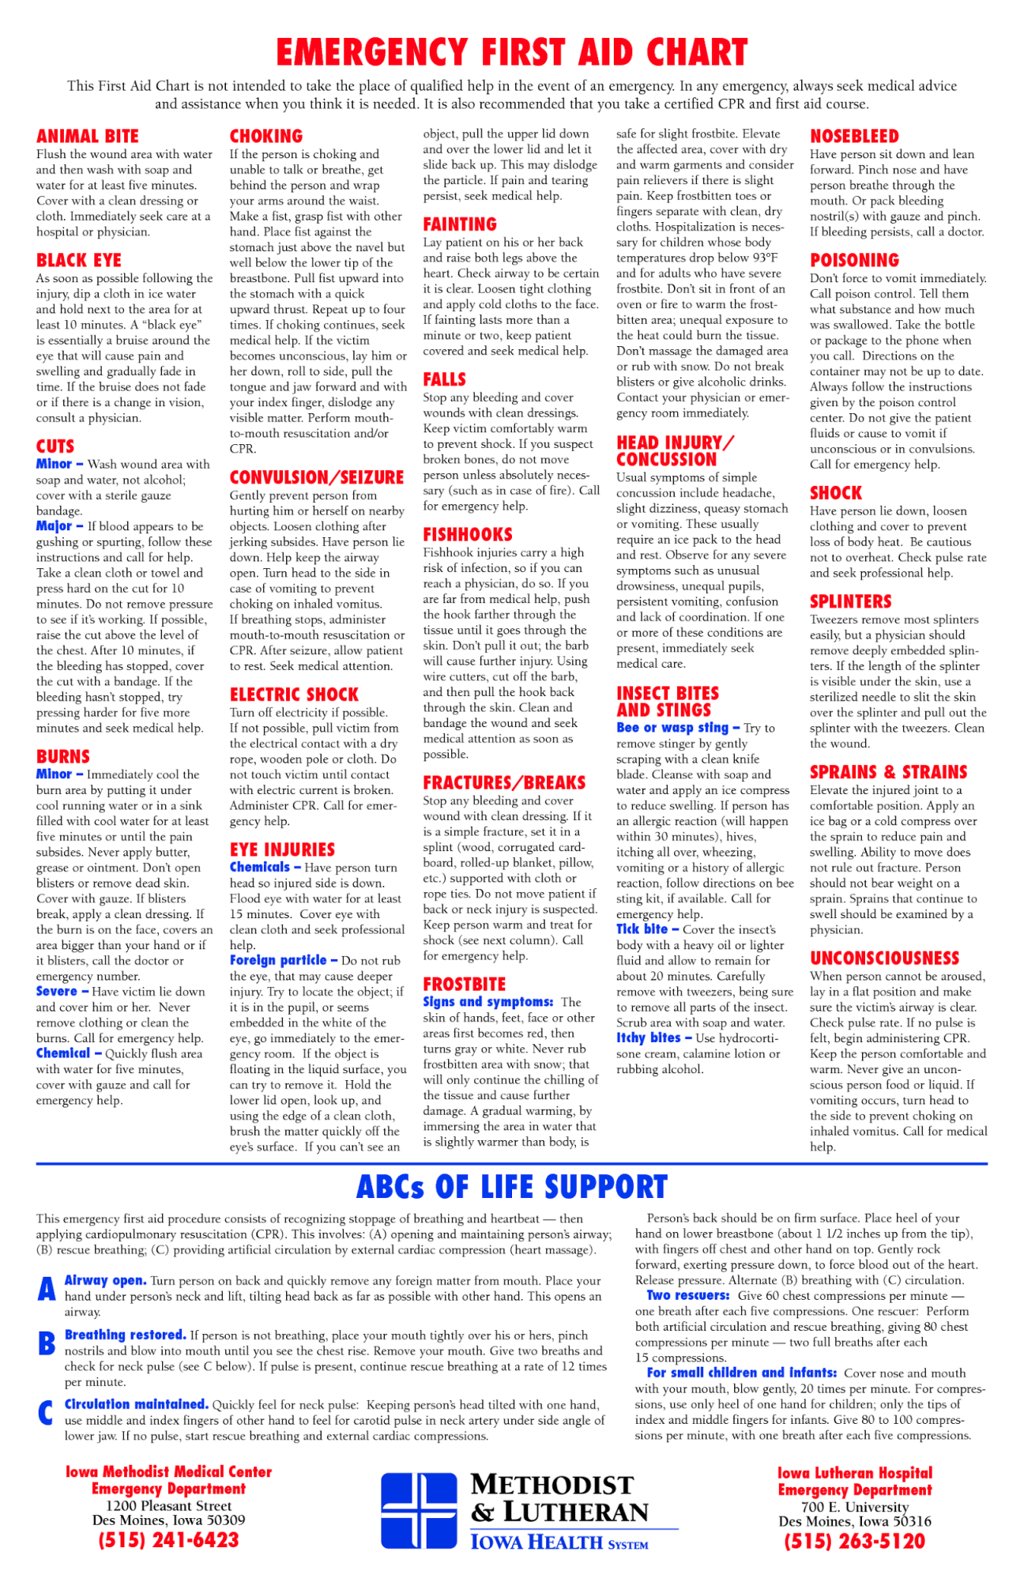

7 UNIFORM AND AWARDS
Foreword

AFJROTC cadets wear the same basic uniform as the active duty Air Force, and they are expected to honor and wear the uniform properly and with pride. This chapter provides the latest guidance and clarification on AFJROTC uniform wear for instructors and cadets. It also provides guidelines for cadet appearance and grooming.

The AFJROTC Awards and Decorations Program recognizes the achievements of AFJROTC cadets and foster increased morale and spirit de corps. This chapter outlines the proper execution of a successful unit Awards and Decorations Program.

7.1 INSIGNIA PLACEMENT
Insignia Placement. Insignia on the AFJROTC uniform will be worn according to attachments 7-3, 7-4, 7-5, 7-6, 7-7, 7-8, 7-9, 7-10 ,7-1, 7-12 and 7-14 contained in this guide. Flight Suits are authorized for those cadets that are currently enrolled in or that have successfully completed AFJROTC aviation honors ground school, have been awarded the aviation ground school/unmanned aircraft badge, flight solo badge, flight certificate badge or have successfully completed the AFJROTC Flight Academy program. Purchase flight suits through WINGS/FEDMALL. (See Atch 7-13).

7.2 BADGES (SEE ATTACHMENT 7-1)
7.2.1 Cadets will only wear one of the following badges, Aviation Ground
School/Unmanned Aircraft Badge, Flight Solo Badge and/or Flight Certificate Badge.
7.2.2 GROUND SCHOOL BADGE
7.2.2.1 Aviation Ground School/Unmanned Aircraft Badge. Awarded for successful completion of the FAA Private Pilot Practical Test (Powered or Glider) or the Remote Pilot Certification Test. Email HQ-Logistics@afjrotc.com a copy of the cadet’s FAA Certificate, and then go to WINGS | Logistics | Create Display Orders and order the applicable badge. Ground School Badge. Flight suits are authorized for cadets who are enrolled in or who have completed AFJROTC aviation honors ground school and have successfully completed the requirements for the Aviation Ground School/Unmanned Aircraft Badge. (See Atch 7-1).
7.2.3 FLIGHT SOLO BADGE
7.2.3.1 Awarded to any cadet possessing a solo flight certificate signed by a FAA certified flight instructor for either powered or non-powered aircraft. Email HQLogistics@afjrotc.com a copy of the cadet’s Flight Solo Certificate, and then go to WINGS | Logistics | Create Display Orders and order the Flight Solo Badge. Flight suits are authorized for those cadets that have received their flight solo badge and have emailed a successful FAA test certificate. (See Atch 7-1).
7.2.4 FLIGHT CERTIFICATE BADGE
7.2.4.1 Awarded to any cadet who possesses a valid FAA pilot’s certificate for either powered or non-powered aircraft. Once earned, this badge will be worn in place of the Flight Solo Badge. Email HQ-Logistics@afjrotc.com a copy of the cadet’s Flight Certificate, and then go to WINGS | Logistics | Create Display Orders and order the Pilot Certificate Badge. Flight suits are authorized for those cadets that have received their flight certificate badge (See Atch 7-1).
7.2.5 AWARENESS PRESENTATION TEAM BADGE
7.2.5.1 Awarded for participation on an Awareness Presentation Team. Criteria for becoming a member of the team includes: selection by ASIs based upon oral presentation and must have been a student at one of the three WTPS middle schools (BHMS, CRMS, or OVMS)
7.2.6 KITTY HAWK AIR SOCIETY BADGE
7.2.6.1 Awarded to cadets who are members of the Kitty Hawk Air Society. 7.2.6.2 Criteria for becoming a member includes:
7.2.6.2.1 A minimum 93 average in AFJROTC for the previous semester.
7.2.6.2.2 Be in good standing within the AFJROTC program.
7.2.6.2.3 Have at least and 85 or above weighted average in all other academic classes for the previous semester.
7.2.6.2.4 Have no school suspensions.
7.2.6.2.5 Be willing to tutor other cadets when requested
7.2.6.2.6 Be an AS-II or higher.
7.2.7 DISTINGUISHED CADET BADGE
7.2.7.1 This annual award consists of a certificate and the Distinguished Cadet badge. The award recognizes one outstanding third-year cadet selected at the end of each school year. This allows the recipient to wear the award their final year in the AFJROTC program. The recipient must be of high moral character, demonstrate positive personal attributes, display outstanding military potential, and maintain consistent academic and military excellence
7.2.7.2 The SASI, in coordination with the ASI and with the concurrence of the principal, selects the recipient of this award.
7.2.7.3 The recipient should hold the following awards prior to selection:
7.2.7.3.1 Leadership Ribbon
7.2.7.3.2 Superior Performance Ribbon
7.2.7.3.3 Achievement Ribbon
7.2.7.3.4 Academic Ribbon
7.2.7.3.4 Leadership Development Requirement
7.2.7.3.6 Service Ribbon

7.2.8 AEROSPACE EDUCATION FOUNDATION (AEF) ACADEMIC CADET BADGE
7.2.8.1 Awarded to rising Junior and Senior cadets for academic excellence as signified by attaining an overall 3.3 grade point average (GPA) with no grade below 2.0 GPA on their transcript. Individuals must be recommended by SASI.
7.2.9 MODEL ROCKETRY BADGE
7.2.9.1 Awarded to cadets who have fulfilled model rocketry program requirements
7.2.10 OTHER BADGES OR PINS
7.2.10.1 Any badge or pin not specifically authorized by HQ AFJROTC will not be worn on any AFJROTC uniform combination. Pins given to CyberPatriot and Stellar Explorer cadets will not be worn on the AFJROTC uniforms. Only cadets who receive the National Finalist CyberPatriot badge may wear this badge on their uniforms. (See Attachment 7-1)
7.2.10.2 Marksmanship Awards. Marksmanship competition awards/badges may be worn on the AFJROTC uniform. Males and females will wear the badge (may only wear one) below the ribbons on the blue shirt or service dress uniform. Marksmanship badges will not be worn with medals.
7.2.10.3 Each Marksmanship athlete may earn one of the three marksmanship badges. They may only wear one of the badges on the uniform, not more than one at a time. These badges are earned by scores obtained in competitions, not practices. These badges are awarded by the unit’s SASI.
7.2.10.4 The basic marksmanship badge - requires a combined score of 170 or above, fired in the prone, standing, and kneeling 3x10 positions.
7.2.10.5 The sharpshooter badge - requires a combined score of 220 or above, fired in the prone, standing, and kneeling 3x10 positions.
7.2.10.6 The expert badge - requires a combined score of 250 or above, fired in the prone, standing, and kneeling 3x10 positions.
7.2.10.7 The Civilian Marksmanship Program’s (CMP) Junior Distinguished Badges (Gold, Silver and Bronze) are awarded to cadets who distinguish themselves by attaining a series of high rankings in designated major junior air rifle championships that include State Junior Olympic Qualifiers, CMP Cup Matches, the National Junior Olympic Championships and other National Council Three-Position Air Rifle Championships.
7.2.10.8 Badges are earned through CMP and units can visit www.thecmp.org for additional information on how to qualify for the badges.
7.2.10.9 Junior Distinguished Badges are provided, at no cost, by the CMP and cannot be purchased through local vendors or HQ AFJROTC.
7.2.10.10 Badges or insignia from Active Duty, Guard, Reserve, or nay other non-AFJROTC group are not authorized on the AFJROTC uniform. Badges, ribbons or insignia from middle school programs such as Youth Leadership Corps are not authorized on the AFJROTC uniform.
7.2.10.11 Base Honor Guard (BHG) Breast Badge (BHG cookie) is prohibited for wear by cadets. No waiver will be granted for wear of such items.
7.3 SHOULDER PATCHES
7.3.1 AFJROTC PATCH
7.3.1.1 Wear of the AFJROTC official shoulder patch is mandatory on the left sleeve (shoulder) of all uniforms except the raincoat, overcoat, and all-weather coat, ABU (front left pocket only). Cadets enrolled in Civil Air Patrol (CAP) and AFJROTC who use the same uniform for both activities may wear the CAP wing patch on the right shoulder sleeve. “Flight Suit – the white, Lamp of Knowledge, AFJROTC Patch will be worn (if no unit patch is available) on the right sleeve (shoulder) (see Attachment 7-12, Note 2).
7.3.2 UNIT PATCH
7.3.2.1 Optional. If worn, must be on the right shoulder only (ABU on front right pocket only). Flight Suit – the unit patch will be worn on the right sleeve (shoulder) of the Flight Suit, if no unit patch is available the white, Lamp of Knowledge, AFJROTC Patch will be worn (see Attachment 12, note 2). Unit patches are paid for the non-Air Force Funds and must be approved by HQ AFJROTC via the waivers module in WINGS prior to purchase or use.
7.4 SHOULDER CORDS
Cadets are authorized to wear one shoulder cord (double knot, single cord “infantry” style shoulder cord. Cords will be worn on the left shoulder, grounded to the shoulder seam, with no metal tips, and no wider than 1-inch (no aiguillettes or citation cords). Colors are locally-determined (does not have to be solid color, may be multi-color), must be conservative, in good taste, and defined in the Cadet Guide or Unit Operations Instruction. Shoulder cord may be worn on regular uniform days. Shoulder cords may be purchased from a vendor using MilPer funds.
7.4.1 PERFECT UNIFORM CITATION CORD
7.4.1.1 Red Cord) Awarded to those cadets who wear the required uniform every scheduled uniform day throughout the school year (approximately 30 times). SASI can authorize exceptions, I.E. DT/CG Comps/MB, FA, DO. Also, the cadet must receive a 93 or better on EACH inspection throughout the year. An average of a 93 does not count. Criteria for the award of the perfect uniform citation cord are very stringent in order to maintain the integrity of both the award and the cadet who worked hard to earn it.
7.4.2 KITTY HAWK AIR SOCIETY CORD
7.4.2.1 Awarded to those cadets who are members of the local chapter of the Kitty Hawk Air Society.

7.4.3 DRILL TEAM CORD
7.4.3.1 Awarded to those cadets with continued participation in drill team practices and events (Note any cadet that is no longer active on drill team is required to return the drill team cord)
7.4.4 COMMAND STAFF CORD
7.4.4.1 Awarded to any cadets currently on the Command Staff depending on availability
7.4.5 CORPS COMMANDER/CORPS VICE COMMANDER CORD
7.4.5.1 Awarded to cadets currently serving as Corps Commander and Corps Vice Commander.
7.5 SHOULDER TABS
7.5.1 Shoulder tabs are either cloth or metal arches denoting participation in an AFJROTC activity.
7.5.2 Shoulder tabs are optional.
7.5.3 If worn, cadets are authorized to wear one shoulder tab on the right shoulder of the service dress coat, lightweight blue jacket, and the light blue shirt.
7.5.3.1 Centered between the unit patch and shoulder seam.
7.5.3.2 If no unit patch is worn, tab should be worn no lower than 1 inch below the shoulder seam.
7.6 AWARDS AND DECORATIONS
7.6.1 Guidelines for National-level Awards will be followed to the fullest extent possible.
Deviations from established award criteria will not be the norm, but based on a case, by
case basis. Unit must uphold the “spirit of intent” of an award.
7.6.1.1 Units are authorized to impose additional criteria (more stringent) to
meet local standards and needs without diminishing minimum standards
(example: limiting the number of cadets who may earn the award where not
guidance is stated, or below stated limits). If such additional criteria are
imposed, they must be specifically stated in the Cadet Guide or Unit
Operating Instruction.
7.6.1.2 Ribbons will not be worn with Medals (only the medals will be worn).
NOTE: Medals will not be worn on regular uniform days or during any type
of competition, i.e., Cyber-Patriot, Academic Bowl, etc.
7.6.1.3 Medals (national awards) and ribbons (local awards) WILL NOT be worn
simultaneously. For formal, semi-formal, and/or special occasions, as specified
by the SASI, cadets may wear ONLY national medals. Cadets with no medals
will wear ribbons.
7.6.1.4 Place medals on the mounting rack in order of precedence. The top row of
medals should be positioned ½ inch below the bottom row of ribbons. Medals are
placed in rows of 3. The rows must be equally spaced and aligned with the row
above. There will be no space between the medal’s ribbon and the medal portion
of the row above it. For multiple rows of medals, the complete medal portion
must be visible in each row.
7.6.1.5 AFJROTC cadets are not authorized to wear ribbons/medals earned/issued from Army, Navy, Marine Corps, or Coast Guard Junior ROTC programs. Cadets will be given equivalent AFJROTC ribbons to wear in lieu of Army, Navy, Marine Corps, or Coast Guard Junior ROTC ribbons/ medals the cadet earned while serving in sister-service JROTC program. It is up to the SASI to make the best determinations as to what equivalent AFJROTC ribbon to issue.
7.6.1.6 Ribbons will not be worn with Medals (only medals will be worn). NOTE: Medals will not be worn on regular uniform days, but may be worn with the service dress uniform for formal and semi-formal occasions of a limited nature (such as dining ins/outs, military ball, change of command ceremonies, awards ceremonies, picture days, and other formal events).
7.6.1.7 Cadets may wear medals with the semi-formal uniform at events such as dining ins/outs, military ball, awards ceremonies, picture day or other formal events as specified by the SASI. Note 5 - Large medals will be worn on the semi-formal uniform coast ½ inch below the top of the welt of the pocket, centered on the pocket. If medals are worn, ribbons will not be worn (no mixing). Note 6 – AFJROTC ribbons may be worn on the semi-formal uniform. If ribbons are worn, medals will not be worn (no mixing).
7.6.1.8 Organizations that wish to present cadets awards (i.e., Daughters of the American Revolution, National Sojourners, Sons of the American Revolution, Scottish Rite, Southern Jurisdiction, Sons of American Revolution Award, National Society United States Daughter of 1812) may still do so. Only medals specifically designated within this Operational Supplement and depicted on the AFJROTC Ribbon Chart are approved for wear on a cadet’s AFJROTC uniform.
7.6.1.9 AFJROTC Awards. Cadets may only receive one National-level Award for each year they are in AFJROTC and not receive one National-level Award for each year they are in AFJROTC and not receive the same National-level award twice during their AFJROTC career ( this does not apply to National competition awards). Medals will not be worn on regular uniform days.
7.6.1.9.1 The National-level and CAP awards that were removed last year
(1 Aug 2018) have been added back and are authorized for cadet wear.
7.6.1.9.2. The below listed ribbons are once again eligible to be worn by
cadets and will be worn in the precedence listed below.
51. Daughters of the American Revolution Award
52. National Society United States Daughters of 1812
53. National Sojourners Award
54. Scottish Rite, Southern Jurisdiction Award
55. Sons of the American Revolution Award
7.6.1.9.3 Cadets receiving Civil Air Patrol (CAP) awards listed below –
ribbons may be worn by cadets during regular uniform days and will be
worn in the precedence listed below following the Patriotic Flag Ribbon.
CAP Medals will not be worn on regular uniform days (see para
7.6.1.7.4).
59. General Carl Spaatz Award
60. General Ira C. Eaker Award
61. Amelia Earhart Award
62. General Billy Mitchell Award
63. General J.F. Curry Achievement Award
7.6.1.9.4 AFJROTC and CAP Medals may be worn on the semi-
formal uniform only for formal and semi-formal occasions of a limited
nature (such as dining ins/outs, military ball, change of command
ceremonies, awards ceremonies, picture days, or other formal events
as specified by the SASI.) Medals will not be worn on regular
uniform days.
7.6.1.9.5 AFJROTC cadets will be given equivalent AFJROTC ribbons to
wear in lieu of Army, Navy, Marine Corps, or Coast Guard Junior ROTC
ribbons/medals the cadet earned while serving in sister-service JROTC
program. Sister-service JROTC ribbons/medals may not be worn by
AFJROTC cadets. It is up to the SASI to make the best determination as
to what equivalent AFJROTC ribbon to issue.
7.6.2 ORDER OF PRECEDENCE
7.6.2.1 SPECIAL AWARDS
7.6.2.1.1 Gold Valor Award (Medal/Ribbon)
7.6.2.1.2 Silver Valor Award (Medal/Ribbon)
7.6.2.1.3 Cadet Humanitarian Award (Ribbon)
7.6.2.1.4 Silver Star Community Service with Excellence Award
7.6.2.1.5 Community Service with Excellence Ribbon
7.6.2.2 NATIONAL AWARDS
7.6.2.2.1 Air Force Association Award (Medal/Ribbon)
7.6.2.2.2 Daedalian Award (Medal/Ribbon)
7.6.2.2.3 Daughters of the American Revolution Award (Medal/Ribbon)
7.6.2.2.4 American Legion Scholastic Award (Medal/Ribbon)
7.6.2.2.5 American Legion General Military Excellence Award (Medal/Ribbon)
7.6.2.2.6 Reserve Officers Association Award (Medal/Ribbon)
7.6.2.2.7 Military Officers Association Award (Medal/Ribbon)
7.6.2.2.8 Veterans of Foreign Wars (VFW) Award (Medal/Ribbon)
7.6.2.2.9 National Society United States Daughters of 1812 (Medal/Ribbon)
7.6.2.2.10 National Sojourners Award (Medal/Ribbon)
7.6.2.2.11 Scottish Rite, Southern Jurisdiction (Medal/Ribbon)
7.6.2.2.12 Military Order of the Purple Heart Award (Medal/Ribbon)
7.6.2.2.13 Sons of the American Revolution Award (Medal/Ribbon)
7.6.2.2.14 Military Order of World Wars Medal (Medal/Ribbon)
7.6.2.2.15 American Veterans Award (Medal/Ribbon)
7.6.2.2.16 Air Force Sergeants Association (Medal/Ribbon)
7.6.2.2.17Tuskegee Airmen Incorporated AFJROTC Cadet Award (Ribbon)
7.6.2.2.18 The Retired Enlisted Association Award (Medal/Ribbon)
7.6.2.2.19 Celebrate Freedom Foundation Award (Medal/Ribbon)
7.6.2.2.20 Air Commando Association Award (Medal/Ribbon)
7.6.2.3 AFJROTC AWARDS
7.6.2.3.1 Distinguished Unit Award with Merit (Ribbon)
7.6.2.3.2 Distinguished Unit Award (Ribbon)
7.6.2.3.3 Outstanding Organization Award (Ribbon)
7.6.2.3.4 Outstanding Flight Ribbon
7.6.2.3.5 Top Performer Award (Ribbon)
7.6.2.3.6 Outstanding Cadet Ribbon
7.6.2.3.7 Leadership Ribbon
7.6.2.3.8 Superior Performance Ribbon
7.6.2.3.9 Achievement Ribbon
7.6.2.3.10 Academic Ribbon
7.6.2.3.11 Cadet Leadership Course Ribbon
7.6.2.3.12 Special Teams Placement Ribbon
7.6.2.3.13 All Services National Competition (Medal/Ribbon)
7.6.2.3.14 Air Force Nationals Competition Ribbon (Medal/Ribbon)
7.6.2.3.15 Orienteering Ribbon
7.6.2.3.16 Leadership Development Requirement (LDR) Leadership Ribbon
7.6.2.3.17 Drill Team Ribbon
7.6.2.3.18 Color Guard Ribbon
7.6.2.3.19 Saber Team Ribbon
7.6.2.3.20 Marksmanship Ribbon
7.6.2.3.21Good Conduct Ribbon
7.6.2.3.22Service Ribbon
7.6.2.3.23Health and Wellness Ribbon
7.6.2.3.24Recruiting Ribbon
7.6.2.3.25Activities Ribbon
7.6.2.3.26Attendance Ribbon
7.6.2.3.27Dress and Appearance Ribbon
7.6.2.3.28Longevity Ribbon
7.6.2.3.29Bataan Death March Memorial Hike Ribbon
7.6.2.3.30Patriotic Flag Ribbon
7.6.3 AFJROTC cadets are not authorized to wear ribbon/medals earned/issued from the Army, Navy, Marine Corps or Coast Guard Junior ROTC programs. Cadets will be given equivalent AFJROTC ribbons to wear in lieu of Army, Navy, Marine Corps, or Cost Guard Junior ROTC ribbons/medals the cadet earned while serving in sister-service JROTC program. It is up to the SASI to make the best determinations as to what equivalent AFJROTC ribbon to issue.
7.6.4 Badges or insignia from Active Duty, Guard, Reserve, or any non-AFJROTC group are not authorized on the AFJROTC uniform. Badges, ribbons, or insignia from middle school programs such as Youth Leadership Corps are not authorized on the AFJROTC uniform.
7.6.5 Valor awards from all services are worn ahead of all other ribbons from any service. The AFJROTC Valor Awards will be worn first, with other services’ Valor Awards worn in the following order: Army, Navy, Marine Corps, and Coast Guard.

7.7 DESCRIPTIONS AND CRITERIA
7.7.1 AIR FORCE JROTC GOLD VALOR AWARD
7.7.1.1 Awards consists of a medal, ribbon, and certificate.
7.7.1.2 The Gold Valor Award recognizes the most outstanding voluntary acts of self-sacrifice and personal bravery by a cadet involving conspicuous risk of life above and beyond the call of duty. Forward recommendations for valor awards through debra.paggett@us.af.mil or douglas.davenport@us.af.mil (HQ-Ops Support) for review and processing within 6 months of the incident. Include a detailed description of the situation, newspaper clippings (if available), statements by victims and observers, and any other information deemed appropriate to validate eligibility. In addition, submit a proposed citation to accompany the wards. HQ-Ops Support will forward the valor award to the HQ AFJROTC Director for final approval. Upon approval, Operation Support will distribute the citation, medal, and ribbon for presentation. Ribbon for this award may be worn on the cadet’s ribbon rack and worn on regular uniform days. For each additional award earned an additional small silver star will be awarded. Medals will not be worn on regular uniform days or during any type of competition.
7.7.2 AIR FORCE JROTC SILVER VALOR AWARD
7.7.2.1 Award consists of a medal, ribbon, and certificate.
7.7.2.2 It is intended to recognize cadets who provide aid in response to a singular extraordinary event such as a natural disaster or other catastrophe that has placed or has the potential to place a hardship on their fellow citizens. This award is not to be used to recognize day-to-day service to the community. Forward recommendations for valor awards through debra.paggett@us.af.mil or douglas.davenport@us.af.mil (HQ-Ops Support) for review and processing within 6 months of the incident. Include a detailed description of the situation, newspaper clippings (if available), statements by victims and observers, and any other information deemed appropriate to validate eligibility. In addition, submit a proposed citation to accompany the award. HQ-Ops Support will forward the valor award to HQ AFJROTC Director for final approval. Upon approval, HQ-OpsSupport@afjrotc.com distributes the citation, medal, and ribbon for presentation. Ribbon for the award may be worn on the cadet’s ribbon rack and worn on regular uniform days. For each additional award earned an additional award earned an additional small silver star will be awarded. Medals will not be worn on regular uniform days or during any type of competition.
7.7.3 CADET HUMANITARIAN AWARD
7.7.3.1 Awards consists of a ribbon and certificate.
7.7.3.2 It is intended to recognize cadets who provide aid in response to a singular extraordinary events such as a natural disaster or other catastrophe that has placed or has the potential to place a hardship on their fellow citizens. This award is not to be used to recognize day-to-day service in the community. Forward recommendations for humanitarian awards to HQ-OpsSupport@afjrotc.com for a review and approval within 6 months of the incident. Include a detailed description of the situation, newspaper clippings (if available), statements by victims and observers, and any other information deemed appropriate to validate eligibility. In addition, submit a proposed citation to accompany the award. Upon approval, HQ-Ops Support distributes the citation and ribbon for presentation. For each additional award earned and additional small silver star will be awarded.
7.7.3.2.1 Not to be used to recognize day-to-day service in the community.
7.7.4 SILVER STAR COMMUNITY SERVICE WITH EXCELLENCE AWARD
7.7.4.1 Award consists of a ribbon with Silver Star device and certificate.
7.7.4.2 The Silver Star Community Service with Excellence Award will be an honor that emphasizes the value of community service, and establishes a greater sense of pride within the corps. The award will be given to cadets in the Top 5% of unit (approximately 45 units) who have the highest “per cadet average” community service hours. “Countable” hours must be logged into WINGS and be accomplished IAW published guidance in AFJROTCI 36-2010. Countable hours will be the period from 11 April (previous year) to 10 Apr (current year). HQ will use the last PSR cadet enrollment and the hours submitted in WINGS for that period to calculate the Top 5% units and notify the units earning the Award. Instructors at the Top 5% unit will determine which of their cadets have contributed to the unit earning the new award. Ribbon must be purchased from a vendor using MilPer funds. For each additional award earned an additional large silver star will be awarded.
7.7.5 COMMUNITY SERVICE WITH EXCELLENCE AWARD
7.7.5.1 Award consists of a ribbon and a certificate.
7.7.5.2 It is intended to recognize those individual cadets who provide significant leadership in the planning, organizing, directing, and executing of a major unit community service project that greatly benefit the local community. This is not an award given to participants but to the key leader(s) of the project. Forward recommendations for Community Service with Excellence Award to HQ-OpsSupport@afjrotc.com for review and approval within 6 months of completion of project. Include a detailed description of the contributions of the individual(s) along with newspaper clippings (if available) describing the outcome of the project, letters of appreciation from civic leaders, or other information deemed appropriate to validate eligibility. Ribbon must be purchased from a vendor using MilPer funds. For each additional ribbon earned an additional bronze oak leaf cluster will be awarded. A single silver oak leaf cluster will be used for the award of the fifth bronze oak leaf cluster.
7.7.6 AIR FORCE ASSOCIATION AWARD
7.7.6.1 Award consists of a medal and a ribbon.
7.7.6.2 Presented annually to the outstanding third year cadet.
7.7.6.3 The award recipient must possess/meet the following personal characteristics and eligibility criteria:
7.7.6.3.1 Positive attitude (Toward AFJROTC and school)
7.7.6.3.2 Outstanding personal appearance (uniform and grooming)
7.7.6.3.3 Display personal attributes such as initiative, judgment, and self-confidence. Courteous demeanor (promptness, obedience, and respect for customs).

7.7.7 DAEDALIAN AWARD
7.7.7.1 The Order of Daedalians is a fraternity of commissioned pilots from all military services. It is named after the legendary figure, Daedalus, and was organized by WWI military pilots who sought to perpetuate the spirit of patriotism, love of country, and the high ideals of self-sacrifice which place service to the nation above personal safety and position. This award is offered to encourage the development of these traits in cadets and to interest them in a military career. The medal is fashioned after an ancient Grecian plaque discovered by a Daedalian in the village of Lavadia, Greece and depicts Daedalus and his Icarus fabricating their legendry wings of wax and leathers. The award also includes a ribbon.
7.7.7.2 The award recognizes one outstanding third-year cadet that meets the following criteria:
7.7.7.2.1 Demonstrate an understanding and appreciation of patriotism, love of county, and service to the nation.
7.7.7.2.2 Indicate the potential and desire to pursue a military career.
7.7.7.2.3 Rank in the top 10% of their AFJROTC class.
7.7.7.2.4 Rank in the top 20% of their school class
7.7.8 DAUGHTERS OF THE AMERICAN REVOLUTION (DAR) AWARD
7.7.8.1 Cadets may only receive this award once. Ribbon for this award may be worn on the cadet’s ribbon and worn on regular uniform days. Medals will not be worn on regular uniform days or during any type of competition.
7.7.8.2 This award is presented annually to one third-year (in a 3 year program) or fourth-year cadet (in a 4-year program) that meet the following criteria:
7.7.8.2.1 Rank in the top 25% of their AFJROTC class.
7.7.8.2.2 Rank is the top 25% of their high school class.
7.7.8.2.3 Demonstrate leadership qualities.
7.7.8.2.4 Demonstrate adherence to military discipline.
7.7.8.2.5 Possess leadership ability and a fundamental and patriotic
understanding of the importance of JROTC training.
7.7.8.2.6 The SASI and principal select the recipient and must request the
award and a presenter not later than 1 March. The award devices and
presenter can be requested from the nearest DAR chapter. See
Attachment 7-17 for a list of award points of contact.
7.7.9 AMERICAL LEGION SCHOLASTIC AWARD
7.7.9.1 Award consists of a bronze medal accompanied by a ribbon with a distinctive miniature attachment depicting a scholastic scroll.
7.7.9.2 Awarded to a third-year cadet based on the cadet’s overall scholastic achievements. Each cadet must:
7.7.9.2.1 Rank in the top 10% of the high school class.
7.7.9.2.2 Rank in the top 25% of their AFJROTC class.
7.7.9.2.3 Demonstrate leadership qualities.
7.7.9.2.4 Actively participate in student activities.
7.7.10 AMERICAN LEGION GENERAL MILITARY EXCELLENCE AWARD
7.7.10.1 Award consists of a bronze medal accompanied by a ribbon with a distinctive miniature attachment depicting a torch.
7.7.10.2 Award is presented to one third-year cadet based on the cadet’s general military excellence. Each cadet must:
7.7.10.2.1 Rank in the top 25% of their AFJROTC class.
7.7.10.2.2 Demonstrate outstanding qualities in military leadership, discipline, character, and citizenship.
7.7.11 RESERVE OFFICER ASSOCIATION AWARD
7.7.11.1 Award consists of a bronze medal, ribbon, and certificate.
7.7.11.2 Award is present annually for military and academic achievement to an outstanding third-year cadet. The recipient must possess individual characteristics contributing to leadership such as:
7.7.11.2.1 Positive attitude toward the AS curriculum.
7.7.11.2.2 Outstanding personal appearance (wear of the uniform, posture, and grooming)
7.7.11.2.3 Attributes of initiative, judgment, and self-confidence.
7.7.11.2.4 Courtesy (promptness, obedience, and respect).
7.7.11.2.5Growth potential (capacity for responsibility, high productivity, adaptability to change).
7.7.11.2.6Demonstrate the highest personal, ethical standards, and strong positive convictions)
7.7.11.2.7 Rank in the top 10% of their AS class.
7.7.12 MILITARY OFFICERS ASSOCIATION AWARD
7.7.12.1 Award consists of a medal pendant with ribbon.
7.7.12.2 Award is presented annually to an outstanding third-year cadet who shows exceptional potential for military leadership. Each cadet must:
7.7.12.2.1 Be a member of the Junior Class
7.7.12.2.2 Be in good academic standing.
7.7.12.2.3 Be of high moral character.
7.7.12.2.4 Show a high order of loyalty to the unit, school, and country.
7.7.12.2.5 Show exceptional potential for military leadership.

7.7.13 VETERANS OF FOREIGN WARS (VFW) AWARD
7.7.13.1 Award consists of a medal pendant with ribbon
7.7.13.2 Award is presented annually to an outstanding third-year cadet who is actively engaged in the AFJROTC program and who possesses individual characteristics contributing to leadership. Each cadet must:
7.7.13.2.1 Have a positive attitude toward AFJROTC.
7.7.13.2.2 Have outstanding military bearing and conduct
7.7.13.2.3 Possess strong positive personal attributes (such as courtesy, dependability, punctuality, respect, and cooperation)
7.7.13.2.4 Demonstrate patriotism (being a member of the color guard or drill team) and actively promote Americanism.
7.7.13.2.5 Demonstrate leadership potential.
7.7.13.2.6 Attain a grade of “B” in AFJROTC with an overall average grade of “C” in all subjects for the previous semester.
7.7.13.2.7 Be active in student activities.
7.7.13.2.8 Not have been previous recipients of this award.
7.7.14 NATIONAL SOCIETY UNITED STATES DAUGHTERS OF 1812 AWARD
7.7.14.1 Cadets may only receive this award once. Ribbon for this award
may be worn on the cadet’s ribbon rack and worn on regular uniform days.
Medals will not be worn on regular uniform days or during any type of
competition.
7.7.14.1.1 Awarded annually, at the SASI’s discretion, for academic
excellence, leadership, military discipline, dependability, patriotism and
upright character in speech and habits.
7.7.15 NATIONAL SOJOURNERS AWARD
7.7.15.1 Cadets may only receive this award once. Ribbon for this award
may be worn on the cadet’s ribbon rack and worn on regular uniform days.
Medals may not be worn on regular uniform days or during any type of
competition.
7.7.15.2 This award is presented annually recognizing an outstanding first- or
second-year cadet (second or third-year cadet in a 4-year program) who
contributed the most to encourage and demonstrate Americanism within the
corps of cadets and on campus. Each cadet must:
7.7.15.2.1 Be in the top 25% of their academic class.
7.7.15.2.2 Encourage and demonstrate ideals of Americanism.
7.7.15.2.3 Demonstrate potential for outstanding leadership.
7.7.15.2.4 Not have previously received the award.
7.7.15.2.5 The SASI selects the recipient subject to final approval of the
sponsoring National Sojourners chapter. The SASI requests the award
from the nearest local chapter in February for presentation in April or
May. A representative from the National Sojourners will make the award
presentation at an appropriate ceremony. If no local chapter is available or
if the local chapter does not offer the award, contact the headquarters of
the National Sojourners.
7.7.16 SCOTTISH RITE, SOUTHERN JURISDICTION AWARD
7.7.16.1 Cadets may only receive this award once. Ribbon for this award may be
worn on the cadet’s ribbon rack and worn on regular uniform days. Medals will
not be worn on regular uniform days or during any type of competition.
7.7.16.2 This award annually recognizes and outstanding second-year cadet
in a 3-year program or third-year cadet in a 4-year program. Each cadet
must:
7.7.16.2.1 Contribute the most to encourage Americanism by
participation in LDR activities or community projects.
7.7.16.2.2 Demonstrate academic excellence by being in the top 25% of
class.
Demonstrate the qualities of dependability, good character, self-
discipline, good citizenship and patriotism.
7.7.16.2.3 Not have been previous recipients of this award.
7.7.16.3 The SASI selects the recipient and request the award from the nearest
Scottish Rite Valley of the Southern Jurisdiction at any time during the calendar
year. With a 30-day notice, a representative of the Scottish Rite Valley of the
Southern Jurisdiction will make the presentation at an appropriate ceremony. If
no local unit is available, or if the local unit does not offer the award, obtain
information by contacting the national headquarters of the Scottish Rite Valley of
the Southern Jurisdiction. The star worn on the ribbon must be procured with
private or unit funds and will not be furnished by the sponsoring organization.
7.7.17 MILITARY ORDER OF THE PURPLE HEART
7.7.17.1 Award consists of a medal pendant and a ribbon.
7.7.17.2 Award recognizes an outstanding second or third-year cadet who is enrolled in the AFJROTC program and demonstrates leadership ability.
7.7.17.3 Each recipient must:
7.7.17.3.1 Have a positive attitude toward AFJROTC and country.
7.7.17.3.2 Hold a leadership position in the cadet corps.
7.7.17.3.3 Be active in school and community affairs.
7.7.17.3.4 Attain a grade of “B” or better in all subjects for the previous semester.
7.7.17.3.5 Not have been a previous recipient of this award.

7.7.18 SONS OF THE AMERICAN REVOLUTION
7.7.18.1 Cadets may only receive this award once. Ribbon for this award may be
worn on the cadet’s ribbon rack and worn on regular uniform days. Medals will
not be worn on regular uniform days or during any type of competition.
7.7.18.2 This award recognizes an outstanding second-year cadet in a 3-year program or third year cadet in a 4-year program who is enrolled in the AFJROTC program. The recipient must exhibit a high degree of leadership, military bearing, and all-around excellence in AS studies and not have previously received the award. Each cadet must:
7.7.18.2.1 Be currently enrolled in the enrolled in the AFJROTC program.
7.7.18.2.2 Be in the top 10% of their AFJROTC class.
7.7.18.2.3 Be in the top 25% of their overall class.
7.7.18.3 The SASI and the Principal select the recipient of the award not later
than 1 March. The SAR national headquarters furnishes the secretary of each
applicable SAR state organization a list of the AFJROTC units in their state. A
representative of SAR will present the award and correspondence directly with
each unit within their area. The SASI makes arrangements for presentation with
the applicable state society or local chapter.
7.7.19 MILITARY ORDER OF WORLD WARS MEDAL
7.7.19.1 Cadets may only receive this award once. Ribbon for this award may be
worn on the cadet’s ribbon rack and worn on regular uniform days. Medals will
not be worn on regular uniform days or during any type of competition.
7.7.19.2 This award is presented annually to an outstanding cadet who has
committed to continue the aerospace science program the following school year.
Selection is based on outstanding accomplishments or service to the AFJROTC
unit.
7.7.19.3 The SASI, with the concurrence of the principal, selects the recipient
and completes the Military Order of the World Wars (MOWW) citation by
summarizing the cadet’s outstanding accomplishments or service to the unit. The
citation and request for the medal, certificate, and ribbon are sent to the nearest
local chapter of the MOWW. The SASI will make arrangements for a MOWW
representative to make the presentation at an appropriate ceremony. If a local
chapter is unavailable, contact the MOWW National Headquarters. If a member
is not available, any active, reserve, or retired commissioned officer may present
the award.
7.7.20 AMERICAN VETERANS AWARD
7.7.20.1 Cadets may only receive this award once. Ribbon for this award may be
worn on the cadet’s ribbon rack and worn on regular uniform days. Medals will
not be worn on regular uniform days or during any type of competition.
7.7.20.2 This award is presented annually to one qualified cadet that possesses
individual characteristics contributing to leadership such as:
7.7.20.2.1 A positive attitude toward AFJROTC programs and service in
the Air Force.
7.7.20.2.2 Personal appearance (wearing of the uniform, posture, and
grooming, but not physical characteristics per se).
7.7.20.2.3 Personal attributes (initiative, dependability, judgement, and
self-confidence).
7.7.20.2.4 Officer potential (capacity for responsibility, adaptability, and
maintenance of high personal standards).
7.7.20.2.5 Obtained a grade of “A” (or the numeral equivalent) in their
AS class.
7.7.20.2.6 Be in good scholastic standing in all classes at the time of
selection and at the time of presentation.
7.7.21 AIR FORCE SERGEANTS ASSOCIATION
7.7.21.1 Award consists of medal pendant with a ribbon.
7.7.21.2 Award recognizes an outstanding third-year cadet.
7.7.21.3 The recipient must demonstrate outstanding qualities in military leadership, discipline, character, and citizenship. Each recipient must:
7.7.21.3.1 Be in the top 25% of the AFJROTC class.
7.7.21.3.2 Demonstrate outstanding qualities in military leadership discipline, character, and citizenship.
7.7.21.3.3 Not have been a previous recipient of this award.
7.7.22 TUSKEGEE AIRMEN INC. AFJROTC CADET AWARD
7.7.22.1 Award consists of a ribbon and a certificate.
7.7.22.2 Award is presented to two cadets, who may be a first, second or third-year.
7.7.22.3 Recipients must meet the following criteria:
7.7.22.3.1 Attain a grade of “B” or better in their AS class.
7.7.22.3.2 Be in good academic standing.
7.7.22.3.3 Actively participate in cadet corps activities.
7.7.22.3.4 Participate in at least 50% of all unit service programs.
7.7.23 THE RETIRED ENLISTED ASSOCIATION AWARD
7.7.23.1 Award consists of a medal set with a ribbon and a certificate.
7.7.23.2 Awarded at the SASI’s discretion, for exceptional leadership to the most outstanding AFJROTC cadet while serving in an enlisted rank.
7.7.24 CELBRATE FREEDOM FOUNDATION AWARD
7.7.24.1 Award consists of a ribbon and a certificate.
7.7.24.2 Awarded at the SASI’s discretion, for outstanding performance in academics and cadets corps activities as a first or second year JROTC cadet.
7.7.25 AIR COMMANDO ASSOCIATION AWARD
7.7.25.1 Award consists of a ribbon and certificate.
7.7.25.2 Awarded at the SASI’s discretion for completing a one page essay based on a historical AF Special Operations Mission possessing the thirteen critical attributes of success: integrity, self-motivation, intelligence, self-discipline, perseverance, adaptability, maturity, judgment, selflessness, leadership, skilled, physical fitness, and family strength.
7.7.26 DISTINGUISHED UNIT AWARD WITH MERIT (DUAM)
7.7.26.1 Award consists of a ribbon awarded to cadets enrolled during year in which 1) the unit receives a HQ AFJROTC evaluation with an overall rating of Exceeds Standards and 2) the unit is selected by HQ AFJROTC to receive the DUA. Both criteria must occur during the same academic year. The unit will receive a congratulatory letter and a certificate of recognition which will be posted in WINGS. Medal/Ribbon must be purchased from a vendor using MilPer funds. For each additional ribbon earned and additional small silver star will be awarded.
7.7.27 DISTINGUISHED UNIT AWARD (DUA)
7.7.27.1 Is a ribbon awarded to cadets enrolled during the academic year when a unit is selected by HQ AFJROTC to receive the DUA. The unit will receive a congratulatory letter and a certificate of recognition which will be posted in WINGS. For each additional ribbon earned an additional small silver star will be awarded.
7.7.28 OUTSTANDING ORGANIZATION AWARD (OOA)
7.7.28.1 Is a ribbon awarded to cadets enrolled during the academic year when a unit is selected by HQ AFJROTC to receive the OOA. The unit will receive a congratulatory letter and a certificate of recognition which will be posted in WINGS. OOA recipients do not receive a streamer. Ribbon must be purchased from a vendor using MilPer funds. For each additional ribbon earned an additional small silver star will be awarded.
7.7.29 OUTSTANDING FLIGHT RIBBON
7.7.29.1 Is a ribbon awarded each academic term to members of the outstanding flight under criteria determined by the SASI. Criteria for this award will be published in the unit’s Cadet Guide. For each additional ribbon earned an additional bronze oak leaf cluster will be awarded. A single silver oak leaf cluster will be used for the award of the fifth bronze oak leaf cluster.
7.7.30 TOP PERFORMER AWARD
7.7.30.1 Award is presented to a maximum of 2% of the current unit cadet corps population.

7.7.31 OUTSTANDING CADET RIBBON
7.7.31.1 A ribbon awarded annually to the outstanding first-year, second-year, third-year and fourth -year cadets. The recipient from each class must be of high moral character, demonstrate positive personal attributes, display outstanding military potential, and attain academic and military excellence. Criteria for this award will be published in the unit’s Cadet Guide. For each additional ribbon earned and additional bronze oak leaf cluster will be awarded.
7.7.31.2 Outstanding Cadet Ribbon with silver star. Cadets chosen as State, Pacific and European “AFJROTC and AFA Cadet Leadership Award” winners will be awarded the “Outstanding Cadet Ribbon” with silver star. Exception: If a cadet has previously earned the Outstanding Cadet Ribbon or earns it in the future, that cadet will wear only one ribbon; that would be the Outstanding Cadet Ribbon with silver star, since that award is of higher precedence.
7.7.32 LEADERSHIP RIBBON
7.7.32.1 Is a ribbon awarded for outstanding performance in a position of leadership an AFJROTC cadet. Ensure recognition of cadets who have consistently displayed outstanding leadership ability above and beyond expected performance. Criteria for this award will be published in the unit’s Cadet Guide. For each additional ribbon earned an additional bronze oak leaf cluster will be awarded. A single silver oak leaf cluster will be used for the award of the fifth bronze oak leaf cluster.
7.7.33 ACHIEVEMENT RIBBON
7.7.33.1 Is a ribbon awarded for a significant achievement in AFJROTC or other school activities/events. Individuals may not receive more than one ribbon during a 1-year period. Criteria for this award will be published in the unit’s Cadet Guide. For each additional ribbon earned an additional bronze oak leaf cluster will be awarded. A single silver oak leaf cluster will be used for the award of the fifth bronze oak leaf cluster.
7.7.34 SUPERIOR PERFORMANCE RIBBON
7.7.34.1 Is a ribbon awarded to no more than the top 10% of the cadet corps annually for outstanding achievement or meritorious service rendered specifically on behalf of AFJROTC. Present the ribbon for a single or sustained performance of a superior nature. Ensure award is presented in recognition of achievements and services which are clearly outstanding and exceptional when compared to achievements and accomplishments of other cadets. Criteria for this award will be published in the unit’s Cadet Guide. For each additional ribbon earned an additional bronze oak leaf cluster will be awarded. A single silver oak leaf cluster will be used for the award of the fifth bronze oak leaf cluster.

7.7.35 ACADEMIC RIBBON
7.7.35.1 Is a ribbon awarded for academic excellence signified by attaining an overall grade point average of at least “B” for one academic term, in addition to and “A” average in AFJROTC. Criteria for this award will be published in the unit’s Cadet Guide. For each additional ribbon earned an additional bronze oak leaf cluster will be awarded. A single silver oak leaf cluster will be used for the award of the fifth bronze oak leaf cluster.
7.7.36 CADET LEADERSHIP COURSE (CLC) RIBBON
7.7.36.1 Is a ribbon awarded for completion of an approved leadership school program of at least 5 days in duration. For each additional CLC completion and additional bronze star will be awarded. Silver Star will be awarded for outstanding performance or leadership ability at a CLC instead of the Bronze Star. Limit the Silver Star to 10% of the class. Criteria for this award will be published in the unit’s Cadet Guide.
7.7.37 SPECIAL TEAMS PLACEMENT RIBBON
7.7.37.1 Is a ribbon awarded to team members for placing 1st, 2nd, or 3rd in an Air Force or Joint Service (local, regional, state or national-level) Competition to include Drill Teams, Color Guard Teams, Marksmanship Rifle Teams, Saber Teams, Academic Bowl Teams, CyberPatriot, StellarXplorers etc. For each additional ribbon earned and additional bronze oak leaf cluster will be awarded. A single silver oak leaf cluster will be used for the award of the fifth bronze oak leaf cluster.
7.7.38 ALL-SERVICE NATIONAL COMPETITION RIBBON
7.7.38.1 Is a medal/ribbon awarded to team members who competed at a Joint/All Service national-level competition to include Drill Teams, Color Guard Teams, Marksmanship Rifle Teams, Saber Teams, Academic Bowl Teams, CyberPatriot, StellarXplorers etc. For each additional ribbon earned an additional bronze oak leaf cluster will be awarded. A single silver oak leaf cluster will be used for the award of the fifth bronze oak leaf cluster. Medal/Ribbon may be obtained from the host of the competition or purchased from a vendor using MilPer funds. Medal may not (ribbon may) be worn during competitions and regular uniform wear days.
7.7.39 AIR FORCE NATIONALS COMPETITION RIBBON
7.7.39.1 Is a medal/ribbon awarded to team members who competed at an Air Force only national-level competition to include Drill Teams, Color Guard Teams, Marksmanship Rifle Teams, Saber Teams, Academic Bowl Teams, Cyber-Patriot, StellarXplorers etc. For each additional ribbon earned and additional bronze oak leaf cluster will be awarded. A single silver oak leaf cluster will be used for the award of the fifth bronze oak leaf cluster. Medal/Ribbon may be obtained from the host of the competition or purchased from a vendor using MilPer funds. Medal may not (ribbon may) be worn during competitions and regular uniform wear days.
7.7.40 ORIENTEERING RIBBON
7.7.40.1 Is a ribbon awarded to team members for completing a unit-specific Orienteering program as part of unit curriculum. Criteria for this award will be published in the unit’s Cadet Guide. For each additional ribbon earned an additional bronze oak leaf cluster will be awarded. A single silver oak leaf cluster will be used for the award of the fifth bronze oak leaf cluster.
7.7.41 LEADERSHIP DEVELOPMENT REQUIREMENT (LDR) LEADERSHIP
RIBBON
7.7.41.1 Is a ribbon awarded at the SASI’s discretion for leadership in AFJROTC
Leadership Development Requirement activities (such as but not limited
PT team commander, orienteering team commander, drill team
commander, color guard team commander, dining-in chairperson, military
ball chairperson, etc.). Criteria for this award will be published in the
unit’s Cadet Guide. For each additional ribbon earned an additional
bronze oak leaf cluster will be awarded. A single silver oak leaf cluster
will be used for the award of the fifth bronze oak leaf cluster.
7.7.42 DRILL TEAM RIBBON
7.7.42.1 Cadets must be on the drill team for an entire year/drill season to be
eligible and must have competed in at least 3 drill performance events, i.e.,
competitions, special school events, community demonstrations (cumulative).
Criteria for this award will be published in the unit’s Cadet Guide. For each
additional ribbon earned an additional bronze oak leaf cluster will be awarded. A
single silver oak leaf cluster will be used for the award of the fifth bronze oak leaf
cluster.
7.7.43 COLOR GUARD RIBBON
7.7.43.1 Cadets must perform at least 5 color guard performance events to receive
this ribbon (cumulative). Criteria for this award will be published in the unit’s
Cadet Guide. For each additional ribbon earned an additional bronze oak leaf
cluster will be awarded. A single silver oak leaf cluster will be used for the award
of the fifth bronze oak leaf cluster.
7.7.44 SABER TEAM RIBBON
7.7.44.1 Cadets must perform at least 3 saber team performance events to receive
this ribbon (cumulative). Criteria for this award will be published in the unit’s
Cadet Guide. For each additional ribbon earned an additional bronze oak leaf
cluster will be awarded. A single silver oak leaf cluster will be used for the award
of the fifth bronze oak leaf cluster.
7.7.45 MARKSMANSHIP RIBBON
7.7.45.1 Cadets must be on the marksmanship team for an entire year/season to be
eligible to quality and must have competed in at least 1 marksmanship competition
event (cumulative). Criteria for this award will be published in the unit’s
Cadet Guide. For each additional ribbon earned an additional bronze oak leaf
cluster will be awarded. A single silver oak leaf cluster will be used for the award
of the fifth bronze oak leaf cluster.
7.7.46 GOOD CONDUCT RIBBON
7.7.46.1 Cadets must not have received a referral (this includes no ISS/OSS) for an
academic term to be eligible to qualify for this award. An oak leaf cluster will be
added to this ribbon for each year of qualifying membership beginning with the
second year. Criteria for this award will be published in the unit’s Cadet Guide.
7.7.46.2 Awarded to those cadets with no suspensions of any kind, no adverse
reports from other staff or faculty during the school year. Cadets are removed from
consideration by SASI if they miss four uniform inspections during the school
year.
7.7.47 SERVICE RIBBON
7.7.47.1 Is a ribbon awarded for distinctive performance in school, community, or AFJROTC service projects. Limit to members whose active participation in a service project contributed significantly to the goals of the organization. (NOTE: Participation in Drill Teams, Saber Teams or Color Guard Teams alone does not qualify for the Service Ribbon (see above criteria for these other ribbons) unless community service hours are also awarded. Criteria for this award will be published in the unit’s Cadet Guide. For each additional ribbon earned an additional bronze oak leaf cluster will be awarded. A single silver oak leaf cluster will be used for the award of the fifth bronze oak leaf cluster.
7.7.48 HEALTH AND WELLNESS RIBBON
7.7.48.1 Awarded by the SASI for participation in the health and wellness physical fitness program. All cadets who participate in the unit’s wellness program will receive the Health and Wellness Ribbon.
7.7.49 RECRUITING RIBBON
7.7.49.1 Awarded for outstanding effort in the support of unit recruiting activities. Cadets must have directly contributed to the recruitment of two new members to AFJROTC. Criteria for this award will be published in the unit’s Cadet Guide. For each additional ribbon earned an additional bronze oak leaf cluster will be awarded. A single silver oak leaf cluster will be used for the award of the fifth bronze oak leaf cluster.
`

7.7.50 ACTIVITIES RIBBON
7.7.50.1 Is a ribbon awarded for participation in Leadership Development Requirement (LDR) activities other than those that qualify for the Color Guard, Drill Team, and Special Teams Competition ribbons. These include, but are not limited to orienteering teams, model rocketry clubs, academic bowl teams, and raider/sports teams. An oak leaf cluster will be added to this ribbon for each year of membership beginning with the second year. Criteria for this award will be published in the unit’s Cadet Guide. For each additional ribbon earned an additional bronze oak leaf cluster will be awarded. A single silver oak leaf cluster will be used for the award of the fifth bronze oak leaf cluster.
7.7.49.2 Awarded for participation in ALL FOUR scheduled JROTC activities. (Dining Out, Military Ball, Home Drill Competition, Final Awards)
7.7.51 ATTENDANCE RIBBON
7.7.51.1 Is awarded to cadets who have no more than three school absences during academic term. Criteria for the award will be published in the unit’s Cadet Guide. For each additional ribbon earned an additional bronze oak leaf cluster will be awarded. A single silver oak leaf cluster will be used for the award of the fifth bronze oak leaf cluster. Cadets may only receive one award annually.
7.7.52 DRESS AND APPEARANCE RIBBON
7.7.52.1 Is awarded to cadets who maintain a 90% or higher average on weekly uniform grades. Cadets receiving this award will maintain the highest grooming and dress standards possible. Criteria for this award will be published in the unit’s Cadet Guide. For each additional ribbon earned an additional bronze oak leaf cluster will be awarded. A single silver oak leaf cluster will be used for the award of the fifth bronze oak leaf cluster.
7.7.53 LONGEVITY RIBBON
7.7.53.1 Is a ribbon awarded for successful completion of each AFJROTC school year or semester. Cadets may only receive one award annually. Cadets in a 4x4 block schedule taking AFJROTC classes both semesters during a school year may only receive one ribbon and/or cluster for that school year. Criteria for this award will be published in the unit’s Cadet Guide. For each additional ribbon earned an additional bronze oak leaf cluster will be awarded.
7.7.54 BATAAN DEATH MARCH MEMORIAL HIKE RIBBON
7.7.54.1 Is a ribbon awarded to honor and remember the sacrifices of the victims and survivors of World War II’s Bataan Death March, AFJROTC units may conduct an optional 14-mile Bataan Death March Memorial Hike. This event must be accomplished on a locally determined 14-miles course (trails, road courses, tracks, etc.,). Units may complete the full hike in a span of one to no more than 3-days. Cadet safety must be monitored at all times and advanced planning for any first aid/medical attention is paramount. Cadets who full complete 14-mile hike are authorized to wear the ribbon. Additionally, no fees can be charged to participate in the Memorial March. However, units are encouraged to collect donations which will be given to reputable organizations that benefit disabled veterans such as The Air Force Association’s Wounded Airman Program, the Wounded Warrior Project, Special Operations Warrior Foundation, etc. Criteria for this award will be published in the unit’s Cadet Guide. Ribbon may be purchased from a vendor using MilPer funds. For each additional ribbon earned an additional bronze oak leaf cluster will be awarded. A single silver oak leaf cluster will be used for the award of the fifth bronze oak leaf cluster.
7.7.55 PATRIOTIC FLAG RIBBON
7.7.55.1 Is a ribbon awarded for participation in non-color guard events specifically designed to honor our nation’s flag. Such events include flag raising ceremonies, flag retirement ceremonies, flag folding ceremonies, and historical flag demonstrations. In order to receive this award, cadets must have participated in a minimum of 5 flag events. Criteria for this award will be published in the unit’s Cadet Guide. Ribbon may be purchased from a vendor using MilPer funds. For each additional ribbon earned and additional bronze oak leaf cluster will be awarded. A single silver oak leaf cluster will be used for the award of the fifth bronze oak leaf cluster.

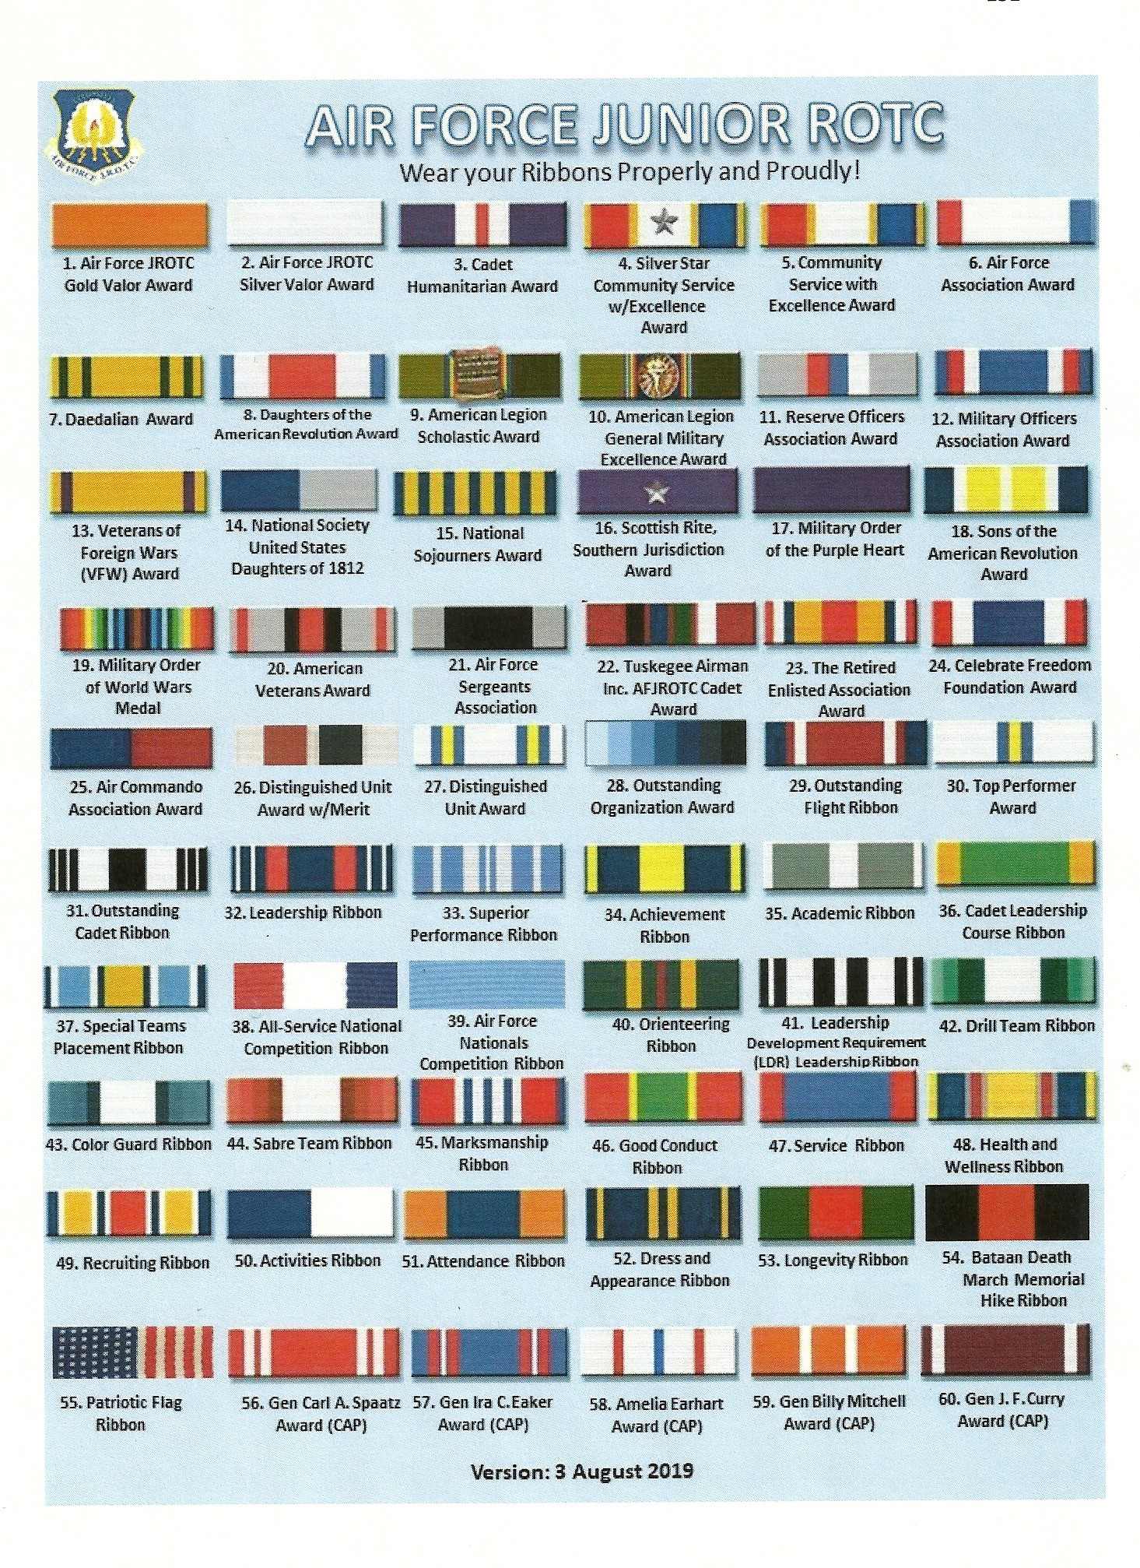
7.8 APPEARANCE AND GROOMING
7.8.1 HAIR – MALE AND FEMALE While in uniform a cadet is responsible for presenting a neat, clean, and professional military image. The standards for wearing the uniform consist of five elements: neatness, cleanliness, safety, uniformity, and military image. There three types of uniform combinations: Class “A” uniform consists of the service coat, short sleeve blue shirt/blouse, pants/slacks/skirt, belt/buckle, tie/neck tab, plain black socks (male), hosiery (female) and low quarters/pumps/slip-on shoes. Class “B” uniform consists of the short sleeve blue shirt/blouse, pants/slacks/skirt, belt/buckle, tie/neck tab, plain black socks (male), hosiery (female) and low quarters/pumps/slip-on shoes. Windbreaker jacket is optional. Class “C” uniform consists of short sleeve blue shirt/blouse, pants/slacks/skirt, belt/buckle, tie/neck tab, plain black socks (male), hosiery (female) and low quarters/pumps/slip-on shoes. Windbreaker jacket is optional. Any time that the skirt is worn, hosiery is mandatory. Refer to paragraph 7.9.3.3 for the proper types of hosiery.
7.8.2 Military low quarters can be worn (optional) with the service dress and services uniforms. Commercially designed low quarters will be black oxford, lace-up style, with a plain rounded toe or a plain rounded capped toe. The sole will not exceed ½ inch in thickness and the heel will not exceed 1 inch in height (measured from the inside front of the heel); however, the sole may have a low wedge heel. They will be plain, clean and serviceable, and without ornamentation such as buckles, bows or straps. The material will be smooth, scotch-grained leather or a manmade material. They may be high-gloss or patent finish.
7.8.3 Pumps will be worn with the formal dress, mess dress, and semi-formal uniforms. Optional with the service dress and service uniforms. Black pumps will be low cut and rounded throat (the top opening) with a raised heel no higher than 2-1/2 inches (measured from the inside sole of the shoe to the end of the heel lift). The tip of the heel cannot be less than ½ inch in diameter or larger than the body of the shoe. Faddish styles will not be worn (e.g. extreme toes, pointed or squared, or extreme heel shapes). They will be plain, clean and serviceable, and without ornamentation such as buckles, bows or straps. The material will be smooth, scotch-grained leather or a manmade material. They may be high-gloss or patent finish.
7.8.4 Slip-on shoes can be worn (optional) with the service dress and services uniforms. Commercially designed step-in shoe where the top of the shoe goes over the top of the foot (not mule-types without backs) with rounded toe or plain rounded capped toe. Faddish styles will not be worn (e.g. extreme toes, pointed or squared, or extreme heel shapes). They will be plain, clean and serviceable, and without ornamentation such as buckles, bows or straps. The material will be smooth, scotch-grained leather or a manmade material. They may be high-gloss or patent finish.
7.8.5 Black Boots/corfams may be issued on an as required basis to the unit Color Guard or Drill Team. This is for restricted use and is not intended for use across unit's entire cadet corps. Black boots/corfams may be reissued to cadets. Spray boots/corfams with disinfectant spray before reissuing. This rule does not apply to standard issue of cadet foot ware. All new cadets enrolling in AFJROTC are to be issued a pair of “NEW” oxford (leather) shoes. Corfams are not to be considered an initial issue of AFJROTC foot ware.
7.9 SPECIAL UNIFORM AND APPEARANCE RULES
7.9.1 JEWELRY You may wear wristwatches and rings, but no more than three rings at time, and no thumb rings.
7.9.2 BRACELETS Ankle bracelets are not authorized. Cadet may wear one bracelet around their wrist. If worn, the bracelet will be conservative (moderate, being within reasonable limits; not excessive or extreme) (which is defined as plain, not drawing attention or faddish) in design, no wider than ½ inch, gold or silver in color, and will not have and inappropriate pictures or writing. Medical alert/identification bracelets are authorized; however, if worn, they will be conservative (moderate, being within reasonable limits; not excessive or extreme) (which is defined as plain, not drawing inappropriate attention or faddish). Bracelets espousing support for cause, philosophy, individual or group are NOT authorized (Exception: Traditional metal POW/MIA/KIA bracelets, which come in colors besides silver, bronze, or gold, remained authorized). Colored/rubber bracelets that support a cause are not allowed to be worn in uniform.
7.9.2.1 Bracelet must not detract from military image, (moderate, being within reasonable limits; not excessive or extreme) (which is defined as plain, not drawing attention or faddish in design) and must not be wider than one-half inch, and must not subject anyone to potential injury.
7.9.2.2 You may not wear ornaments on your head or around your
neck. If you wear a necklace, it cannot be exposed while in uniform.
7.9.2.3 Female cadets in uniform may wear earrings if the earrings are conservative and kept within sensible limits.
7.9.2.4 Female cadets may wear small round or square white diamond, gold, white pearl, or silver earrings. If member has multiple holes, only one set of earrings are authorized to be worn in uniform and will be worn in the lower earlobes. Earrings will match and fit tightly without extending below the earlobe unless the piece extending is the connecting band on clip earrings.
7.9.2.5 Male cadets may not wear earrings while in uniform.
7.9.3 EYEGLASSES OR SUNGLASSES.
7.9.3.1 You may wear conservative sunglasses, (non-mirrored and
conservative color) but not in military formations.
7.9.3.2 If you wear glasses, they must not have any ornaments on the frames or lenses. Eyeglass lenses that are conservative, clear, slightly tinted or have photosensitive lenses may be worn in uniform while indoors or while in military formation.
7.9.3.3 When outdoors and in uniform, sunglasses and eyeglasses must have lenses and frames that are conservative; faddish or mirrored lenses are prohibited. Sunglasses are not allowed while in a military formation.
7.9.3.4 Neither eyeglasses nor sunglasses can be worn around the neck while in uniform.
7.9.4 TATTOOS OR BRANDS
7.9.4.1 Whether you are in or out of uniform, tattoos or brands anywhere on the body are not allowed if they are obscene or if they advocate sexual, racial, ethnic, or religious discrimination. Tattoos or brands that might harm good order and discipline or bring discredit upon the Air Force are also barred, whether you are in or out of uniform.
7.9.4.2 Excessive tattoos or brands, even though they do not violate the prohibitions in the above paragraph, will not be exposed or visible while in uniform.
7.9.4.3 Excessive is defined as any tattoo or brands that exceed one-quarter of the exposed body part, and those above the collar bone and readily visible when wearing an open collar uniform.
7.9.5 BODY PIERCING
7.9.5.1 Cadets in uniform are not allowed to attach or display objects, articles jewelry, or ornamentation to or through the ear (other than authorized in paragraph 7.9.7), nose, tongue, or any exposed body part (including anything that might be visible through the uniform). Cadets may not cover any of these articles with make-up, band-aids, or wearing clear post pins to hide body piercings.

7.10 SPECIFIC FEMALE CADET GROOMING GUIDELINES (FIG 1-1)
7.10.1 HAIR
7.10.1.1 Hair-Female. No minimum hair length to a maximum bulk of 3 ½ inches from scalp and allows proper wear of headgear. Hair will end above the bottom edge of collar and will not extend below an invisible line drawn parallel to the ground, both front to back and side to side. Bangs, or side-swiped hair will not touch either eyebrow, to include an invisible line drawn across eyebrows and parallel to the ground. See Figure 1.2. When in doubt, assess correct length of hair with Airman standing in the position of attention. Exception: While wearing the Physical Training Uniform (PTU), long hair will be secured but may have loose ends and may extend below the bottom edge of the collar.
7.10.1.2 Hair style must be conservative.
7.10.1.2.1 No extreme or faddish styles are allowed.
7.10.1.2.2 Hair weaves are authorized as long as they adhere to the following criteria:
7.10.1.2.2.1 It should look professional and allow you to wear uniform headgear in the proper manner.
7.10.1.2.2.2 Hair must not be too full or too high on the head.
7.10.1.2.2.3 Hair must be able to be placed in a maximum of a three inch bun.
7.10.1.2.3 Wigs and hairpieces must also adhere to subsections
(7.10.1.2.2.1 – 7.10.1.2.2.3).
7.10.1.2.4 All female cadets must adhere to subsections (7.10.1.2.2.1 – 7.10.1.2.2.3).
7.10.1.3 Your hairstyle should not need many grooming aids.
7.10.1.3.1 Hair accessories. If worn, black hair accessories ( e.g. fabric scrunchies, hairpins, combs, clips, headbands, elastic bands and barrettes, etc) are authorized regardless of hair color. Headbands or fabric scrunchies will not exceed one-inch in width. Ornaments are not authorized (i.e. ribbons, beads, jeweled pins). See figure 1-2 (photo of scrunchie).
7.10.1.4 Hair color, highlights, lowlights, and frosting will not be faddish or extreme and will be natural looking hair color, similar to the individual’s hair color (e.g. black, brunette, blond, natural red, and grey).
7.10.1.4.1 Examples of natural looking hair color include: blonde, brunette, natural red, black, and grey.
7.10.1.5 Unauthorized: Shaved heads. Shaved heads are defined as complete removal of all hair to the skin on the head or portions of the head. See figure 1-1.
7.10.1.6 Braids, micro-braids, and cornrows are authorized. (Fig 1-3)
7.10.1.6.1 Must be a natural looking color similar to the individual’s hair color
7.10.1.6.2 A braid is considered three or more portions/strands of interwoven hair.
7.10.1.6.3 When worn, multiple braids shall be of uniform dimension, small in diameter, show no more than ¼ inch of scalp between the braids, and must be tightly interwoven to present a neat, professional, and well-groomed appearance.
7.10.1.6.3 Locs, braids, twists, micro-braids, french braids, dutch braids and cornrows are authorized. Locs are defined as portions of hair that have been intentionally or unintentionally fused together to form a loc or locs. A braid or twist is two or more portions of interwoven hair. If adding additional hair, it must be a natural-looking color, similar to the individual's hair color. It must be conservative (moderate, being within reasonable limits; not excessive or extreme) and not present a faddish appearance. Hair must not exceed bulk and length standards and must not extend below the bottom of the collar. Headgear must fit properly.
7.10.1.6.4 All locs, braids, and twists, when worn will be of uniform dimension, no wider than one inch, with natural spacing between the locs, braids, or twists and must be tightly interwoven to present a neat, professional and well-groomed appearance. When worn, multiple locs, braids, or twists shall be of uniform dimension, small in diameter (approx. ¼ inches), show no more than ¼ inch of scalp between the locs, braids or twists and must be tightly fused/interwoven to present a neat, professional appearance. A loc, or braid must continue to the end of the hair without design and following the contour of the head, and may be worn loose or in a secured style within hair standards in paragraph 7.10.1.1 above. [Exception: Micro-braids or twists are not required to continue to the end of the hair.]
7.10.1.7 Dreadlocks, defined as portions of hair that have been intentionally or unintentionally fused to form a loc or locs, shaved head, flat tops, and military high and tight cuts are not authorized hairstyles for female cadets.
7.10.1.8 Unauthorized: Mohawk, mullet or etched design.

7.10.2 FINGERNAILS
7.10.2.1 Fingernail polish, if worn by female cadets, will be a single color that does not directly contrast with the female cadet’s complexion, detract from the uniform, or be extreme colors. Some examples of extreme colors are included, but are not limited to, purple, gold, blue, black, bright (fire engine) red and florescent colors. Do not apply designs to nails or apply two-tone or multi-tone colors. However, white-tip French manicures are authorized. Fingernails must not exceed ¼ inch in length beyond the tip of the finger and must be clean and well groomed. Some examples of extreme colors include but are not limited to, purple, gold, blue, black, bright (fire engine) red, and florescent colors.

7.10.3 SKIRTS
7.10.3.1 The skirt will be no shorter than the top of the kneecap and no longer than the bottom of the kneecap when standing at attention.
7.10.3.2 The skirt should fit smoothly, should hang naturally, and must not be excessively tight.
7.10.3.3 Female cadets must wear hosiery with the skirt. Anytime hosiery is worn it will be plain commercial, sheer, nylon in neutral, dark brown, black or off-black, or dark blue shades that complement the uniform and the cadet’s skin tone. Patterned hosiery is not authorized to be worn with any uniform.
7.11 SPECIFIC MALE CADET GROOMING GUIDELINES (FIG 2-1)
7.11.1 Hair will have tapered appearance on both sides and the back of the head, both with and without headgear. A tapered appearance is one that when viewed from any angle outlines the member’s hair so that it conforms to the shape of the head, curving inward to the natural point without directional flow, twists, spiking or ducktails. A block-cut is permitted with tapered appearance. Hair will not exceed 1¼ inch in bulk, regardless of length and ¼ inch at natural termination point; allowing only closely cut or shaved hair on the back of the neck to touch the collar. Hair will not touch the ears or protrude under the front band of headgear. Cleanly shaven heads, military high-and-tight or flat-top cuts are authorized. Prohibited examples (not all inclusive) are Mohawk, mullet, cornrows, dreadlocks or etched design. Men are not authorized hair extensions. See figure 2-1 for sideburns and mustaches and for graphic examples of male hair standards.
7.11.1.1 Sideburns. If worn, sideburns will be straight and even width (not
(flared), and will not extend below the bottom of the orifice of the ear
opening. Sideburns will end in a clean-shaven horizontal line. See figure 2- 1, orifice of the ear opening is at reference point A.
7.11.1.2 Mustaches. Male cadets may have mustaches; however they will be conservative (moderate, being within reasonable limits; not excessive or extreme) and will not extend downward beyond the lip line of the upper lip or extend sideways beyond a vertical line drawn upward from both corners of the mouth . See figure 2-1, reference points B, C, and D.
7.11.1.2 Keep your hair clean, neat, and trimmed. It must not contain large amounts of grooming aids such as: greasy creams, oils, and sprays that remain visible in the hair.
7.11.1.2 When your hair is groomed, it should not touch your ears or eyebrows, and only the closely cut or shaved hair on the back of your neck should touch the collar.
7.11.1.3 Your hair should not exceed 1 ¼ inch in bulk regardless of length. The bulk and length of your hair must not interfere with wearing any Air Force headgear properly, and it must not protrude below the font band of the headgear.
7.11.1.5 Your hair may not contain or have attached to it any visible foreign items.
7.11.1.6 If you dye your hair, it should look natural. You may not dye your hair an
unusual color or one that contrasts with your natural coloring.

FIGURE 1-1 FEMALE CADET GROOMING GUIDELINES

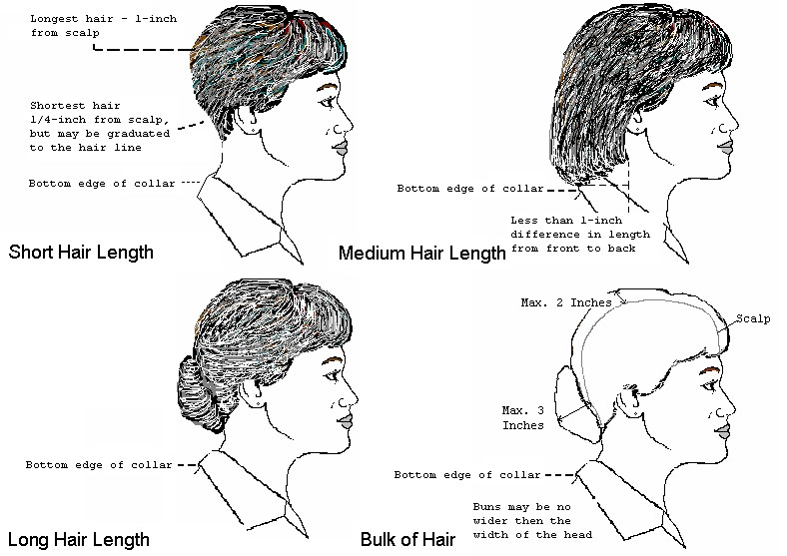

FIGURE 1-2 FEMALE HAIR STANDARDS
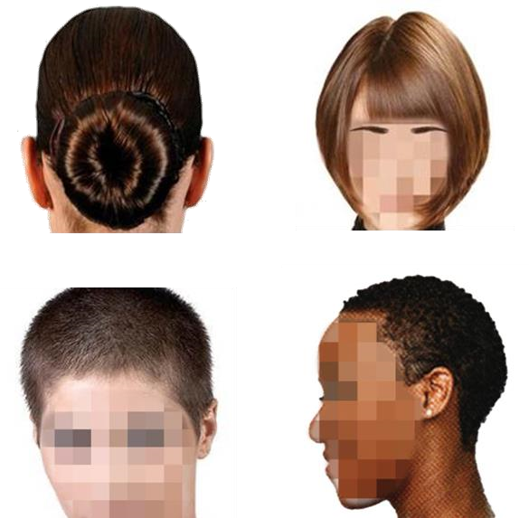

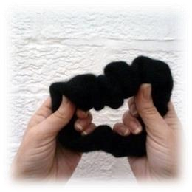

EXAMPLE AUTHORIZED SCRUNCHIE

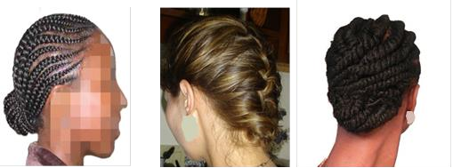
FIGURE 1-3

AUTHORIZED BRAIDS

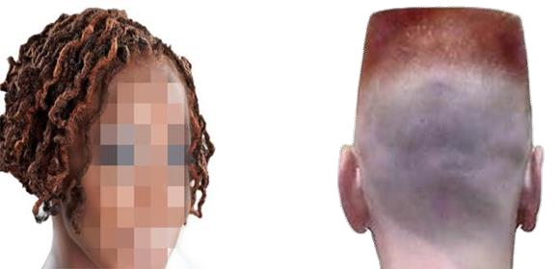

UNAUTHORIZED FEMALE HAIRSTYLES

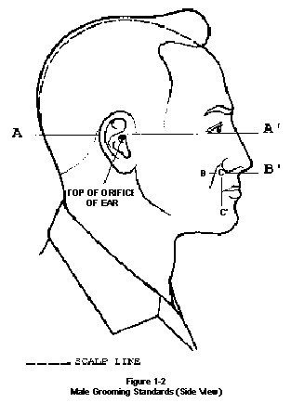
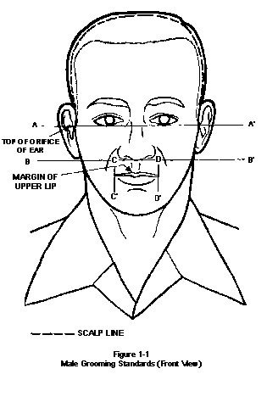
FIGURE 2-1 MALE CADET GROOMING GUIDELINES

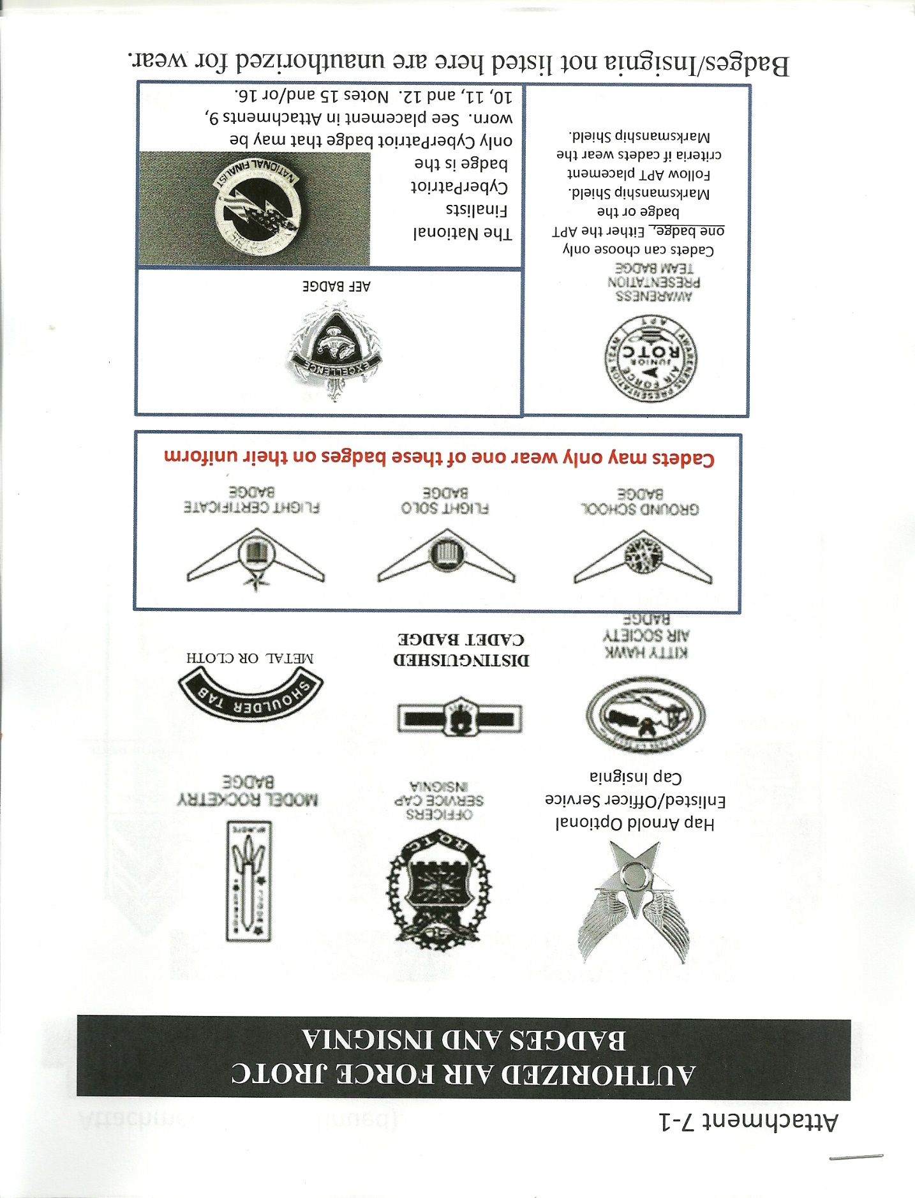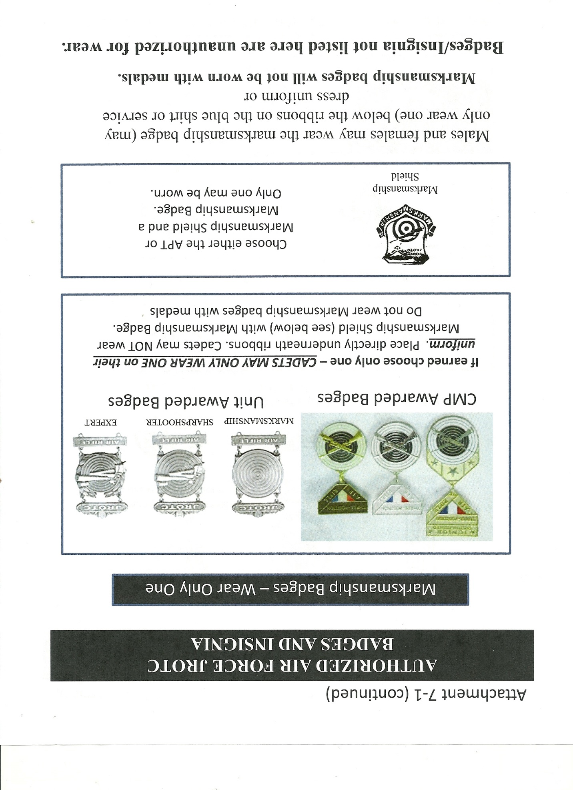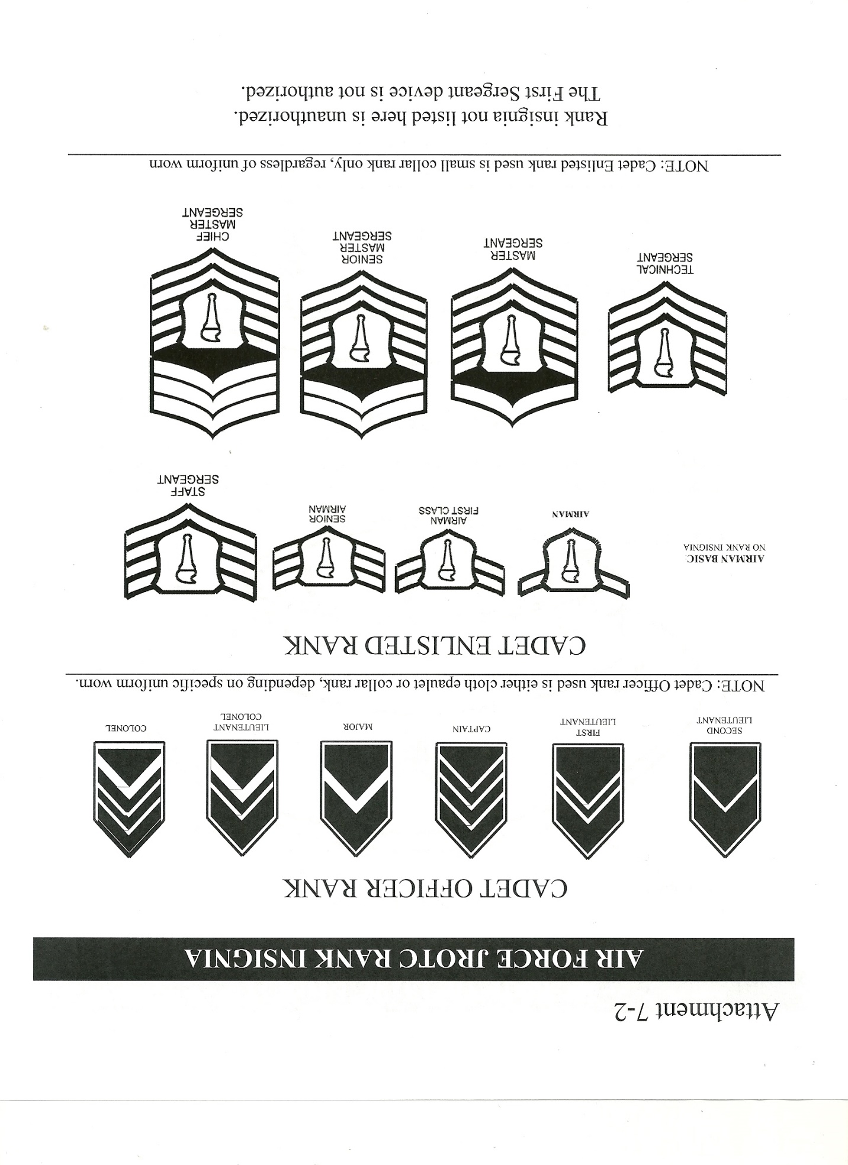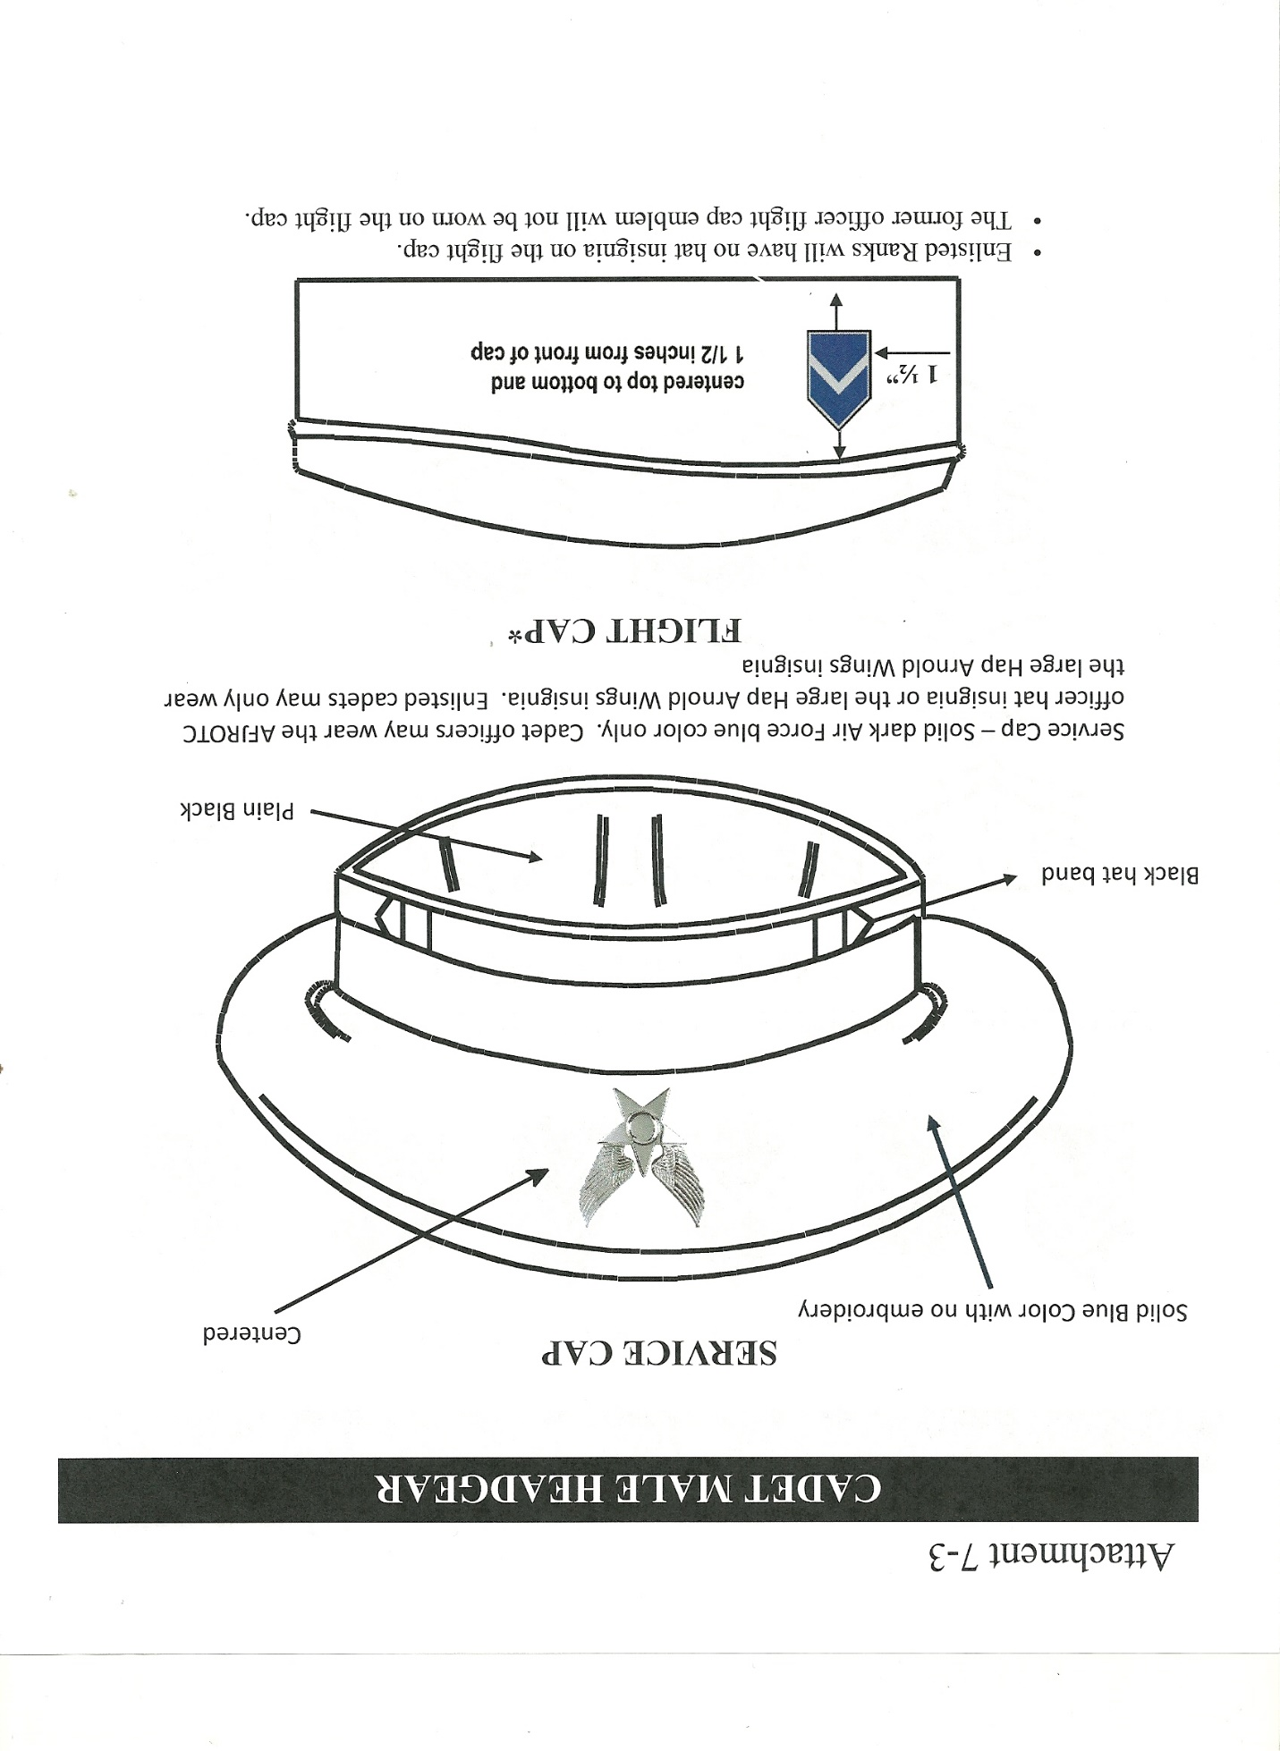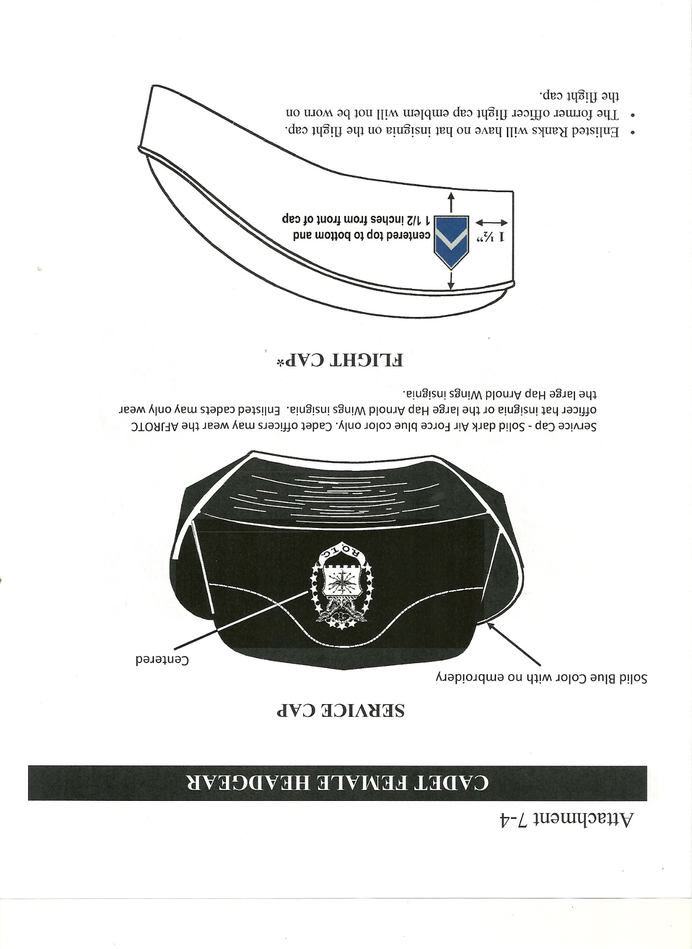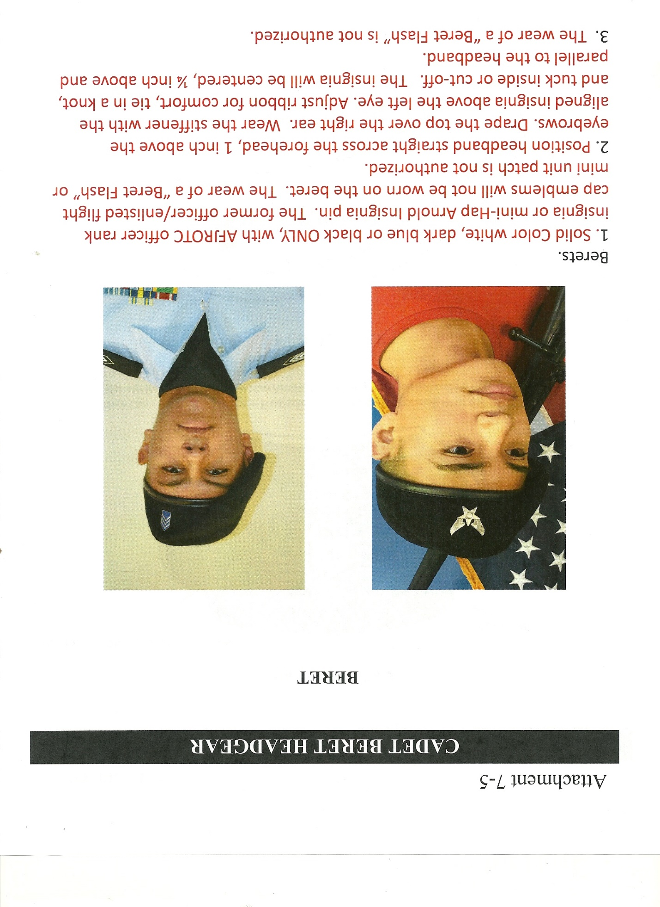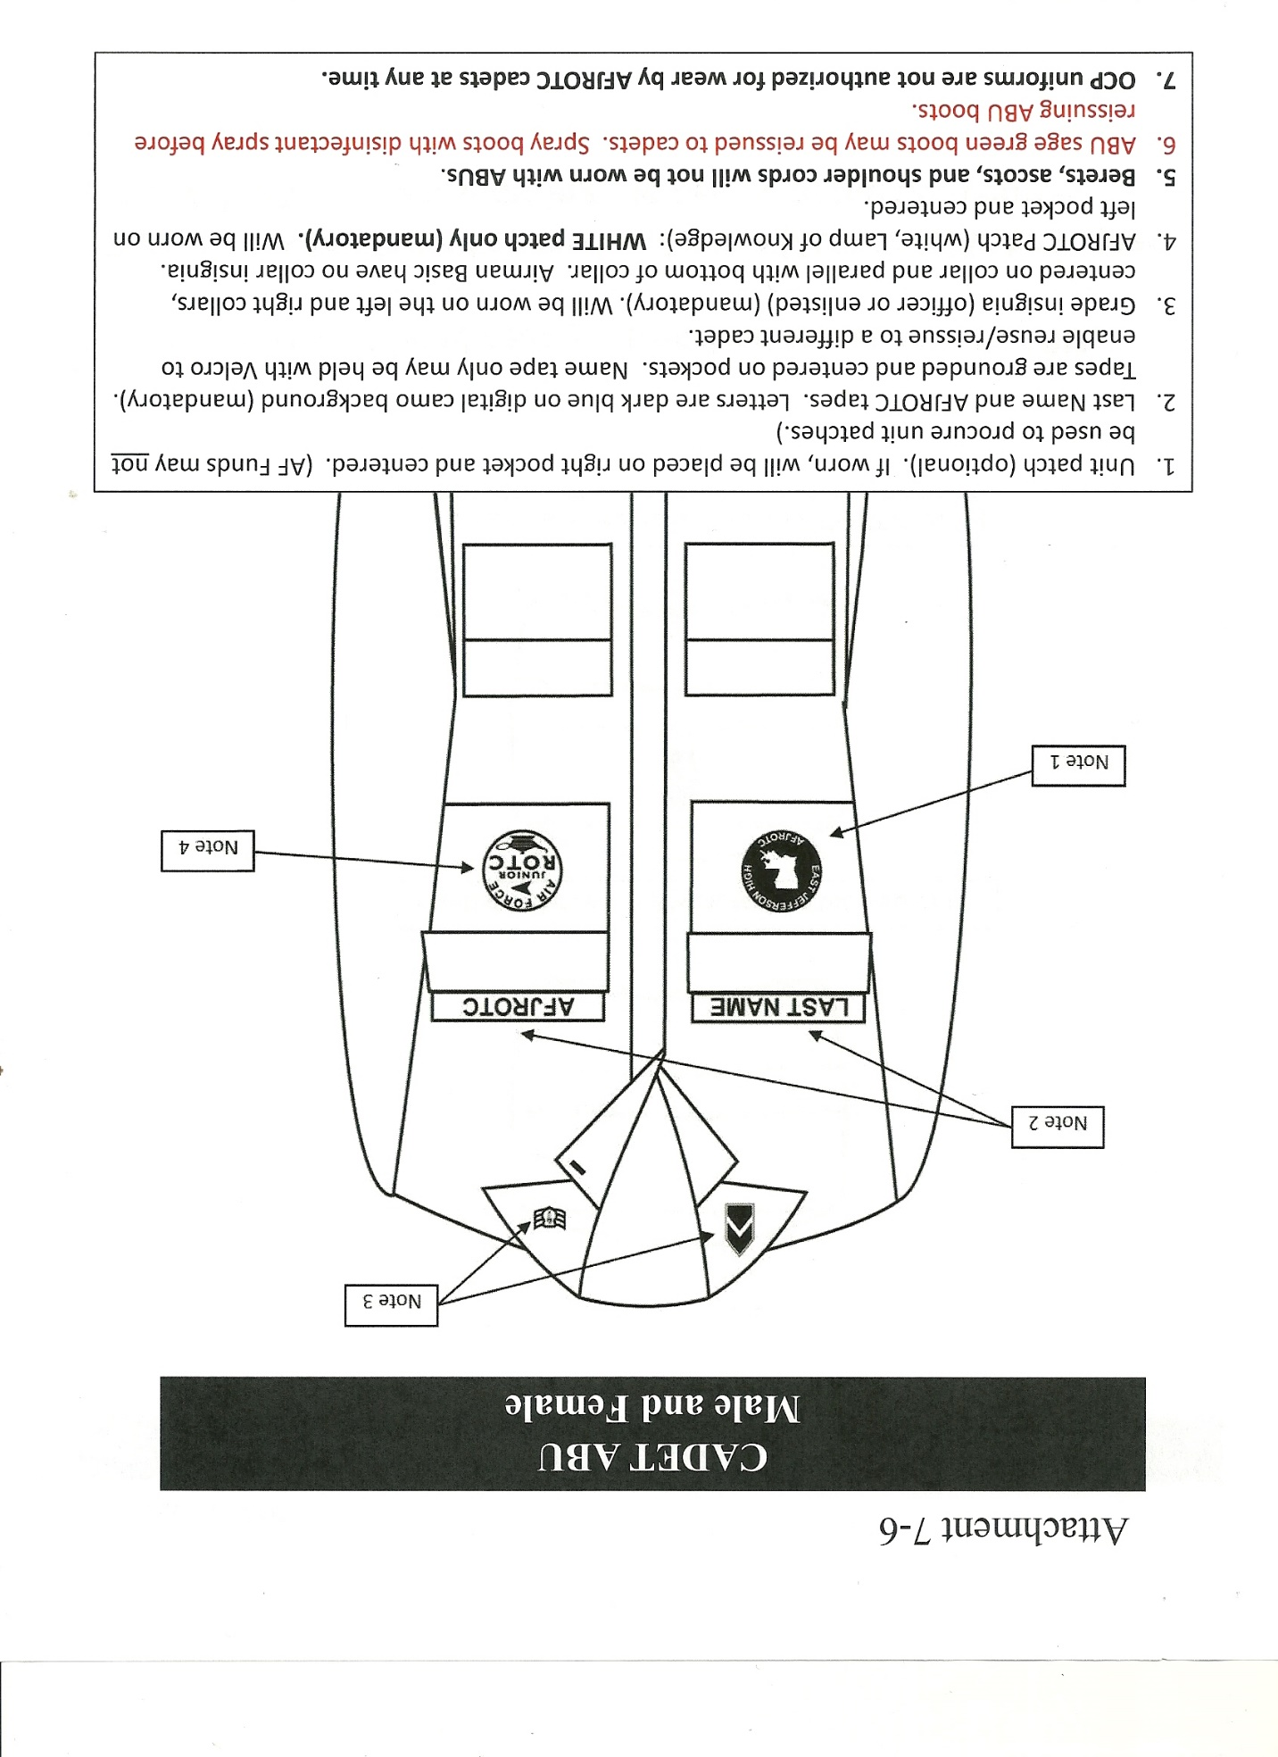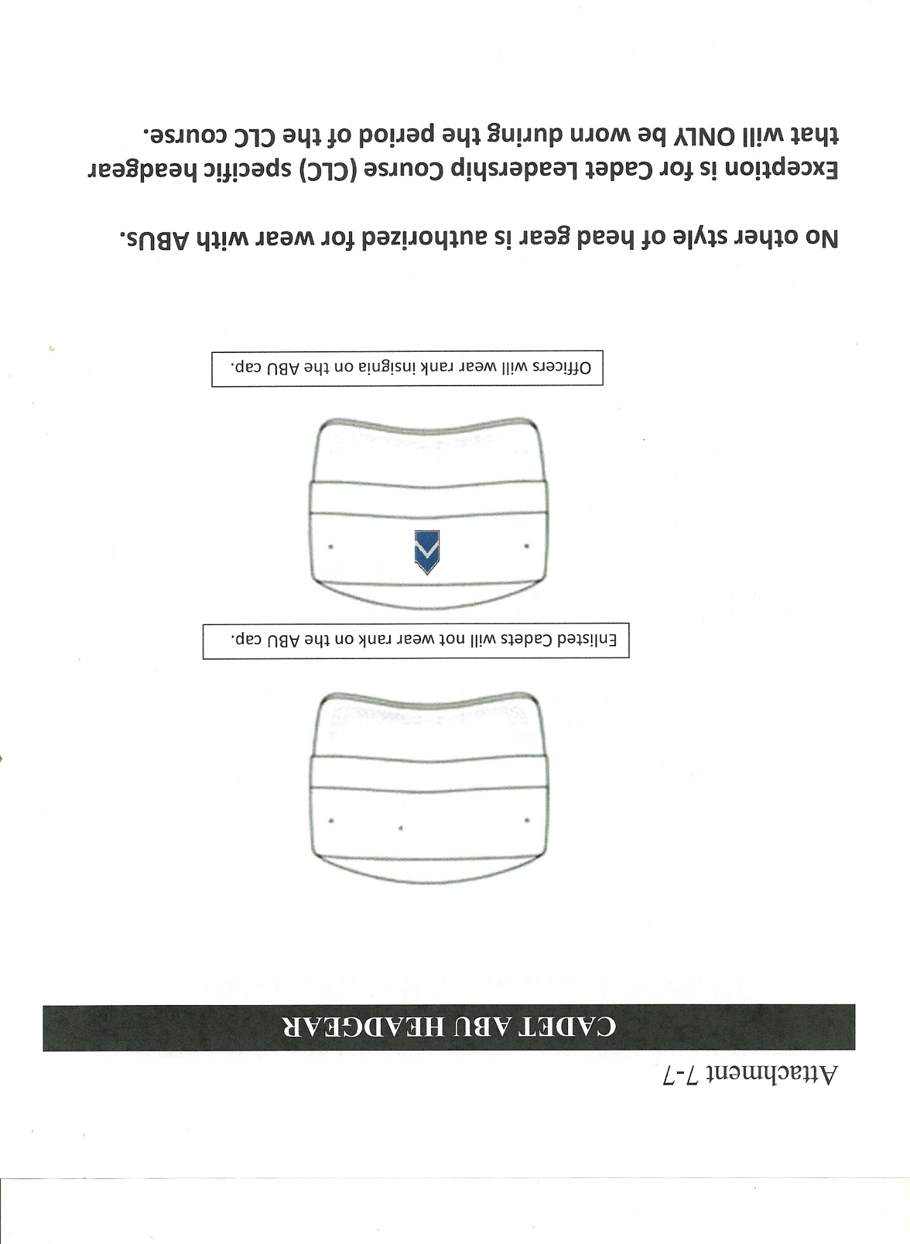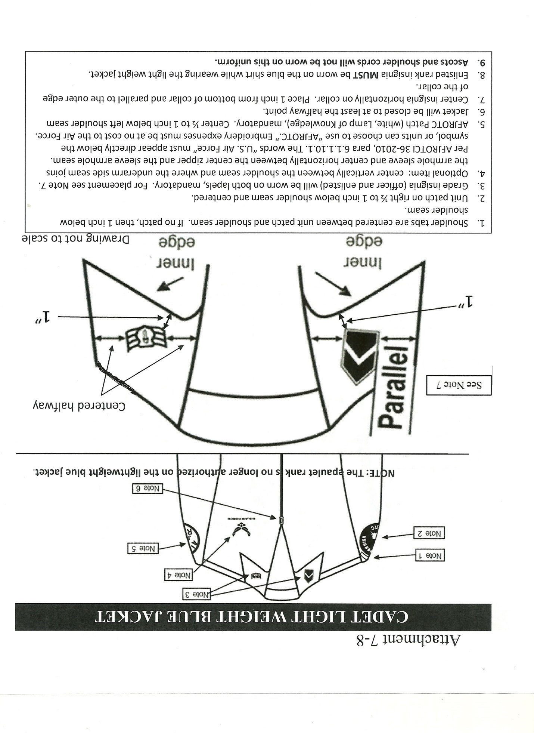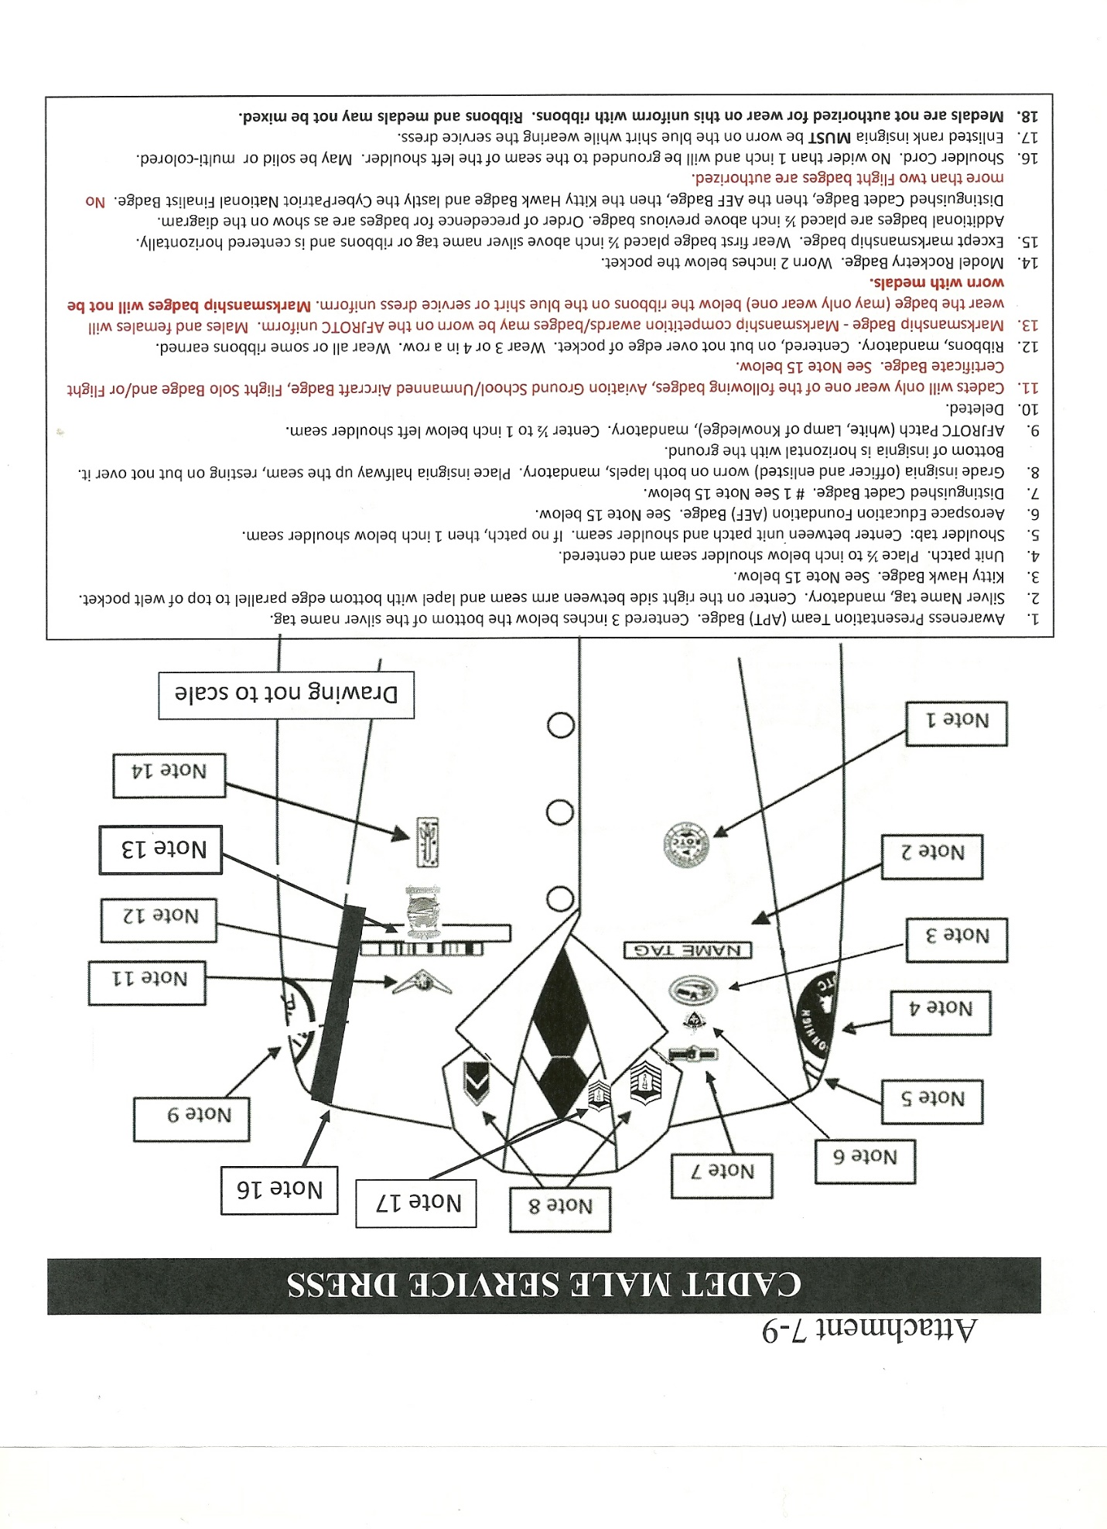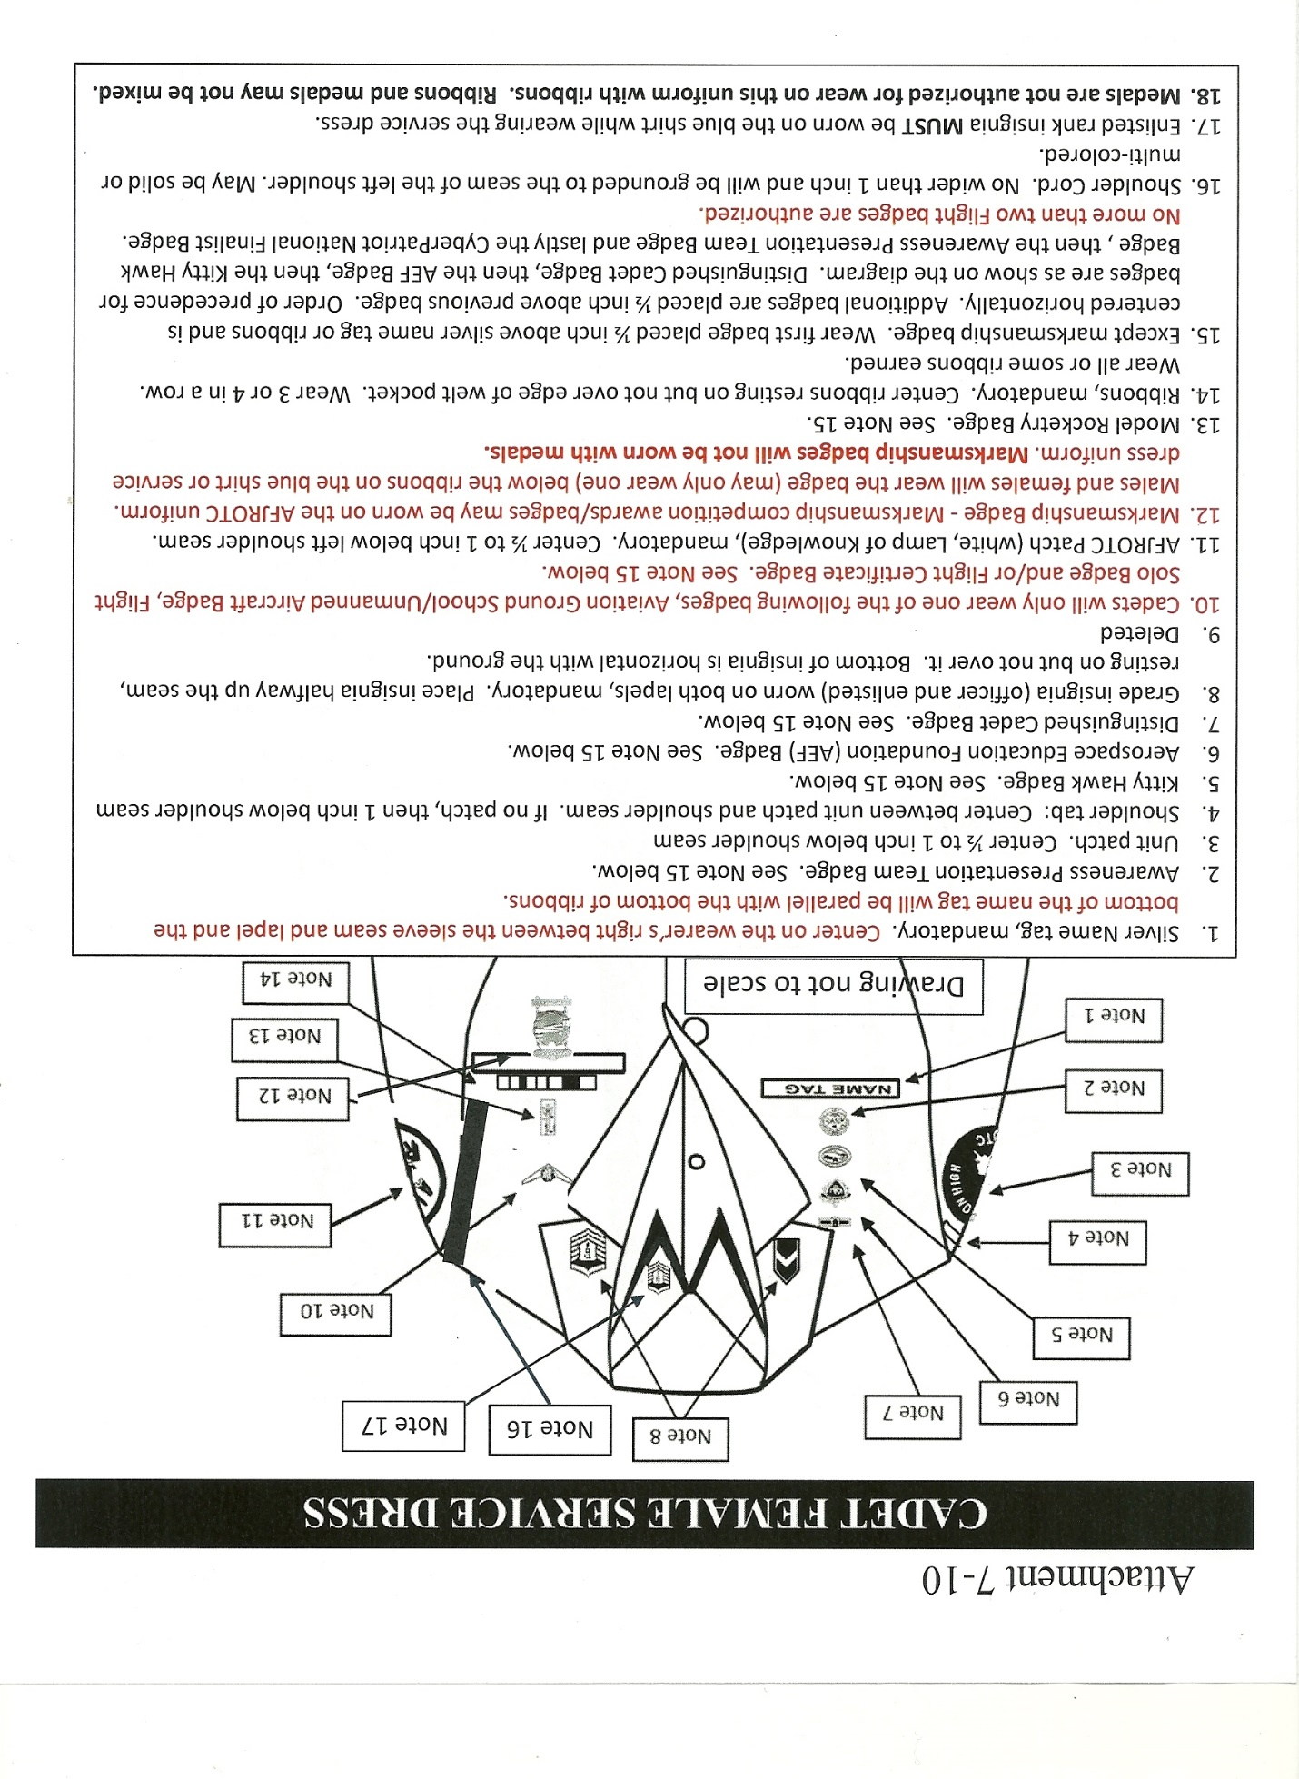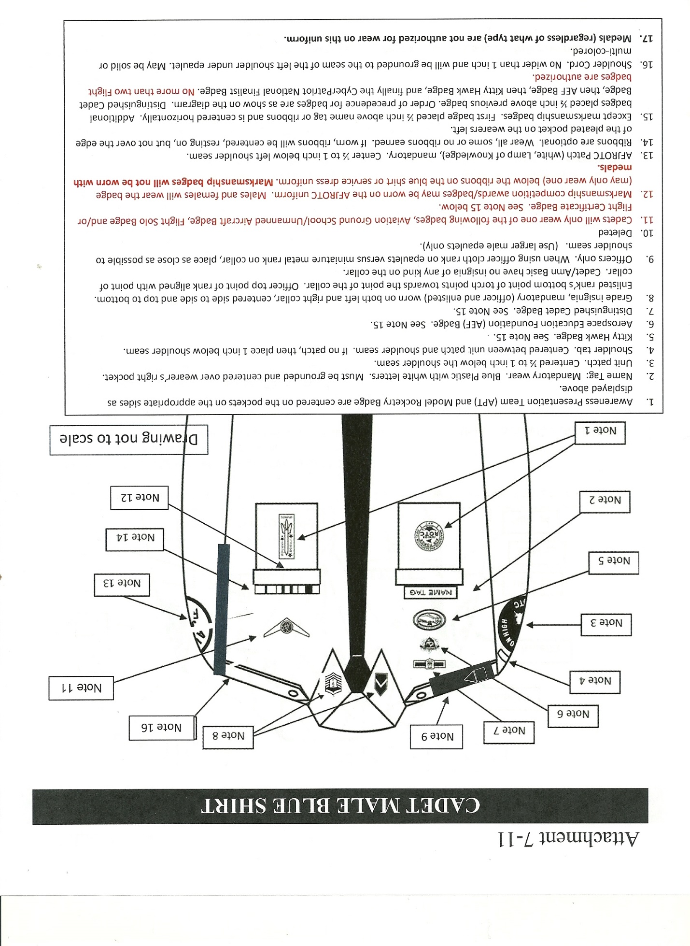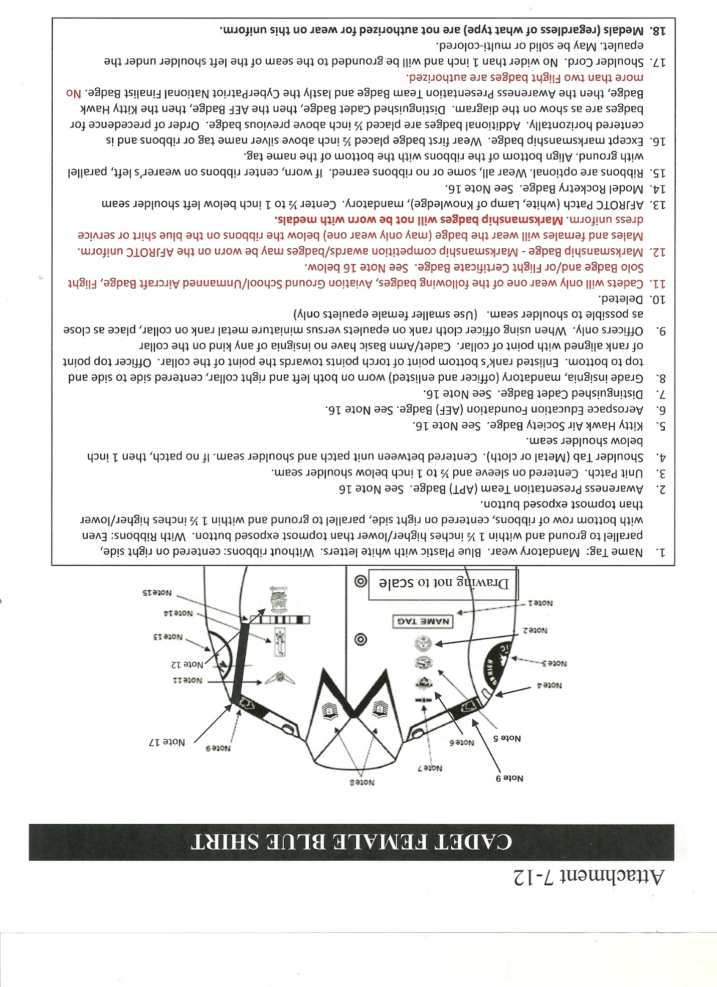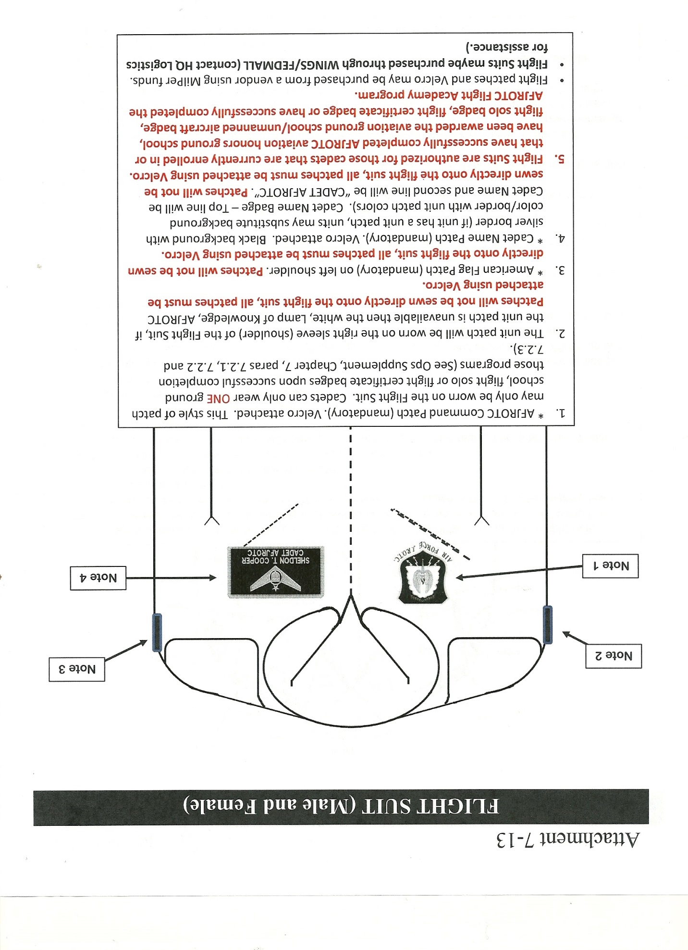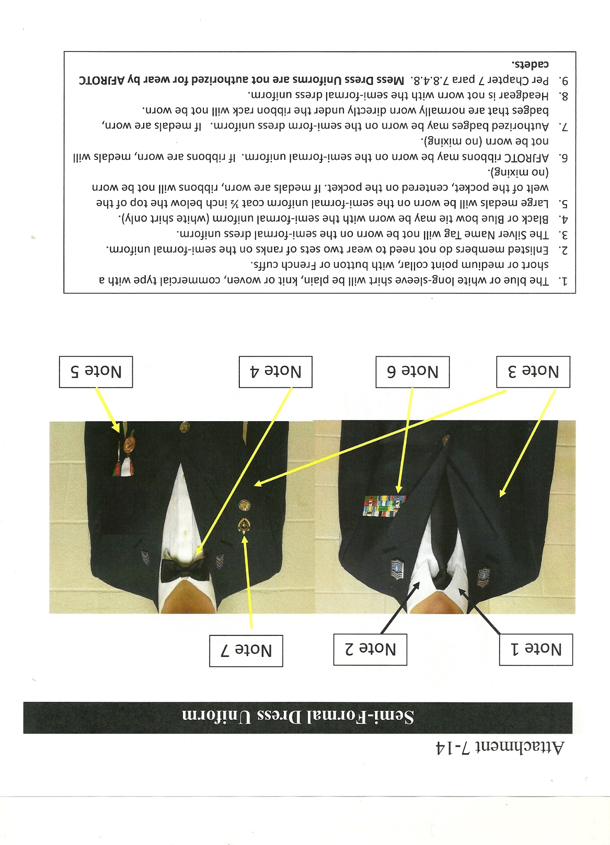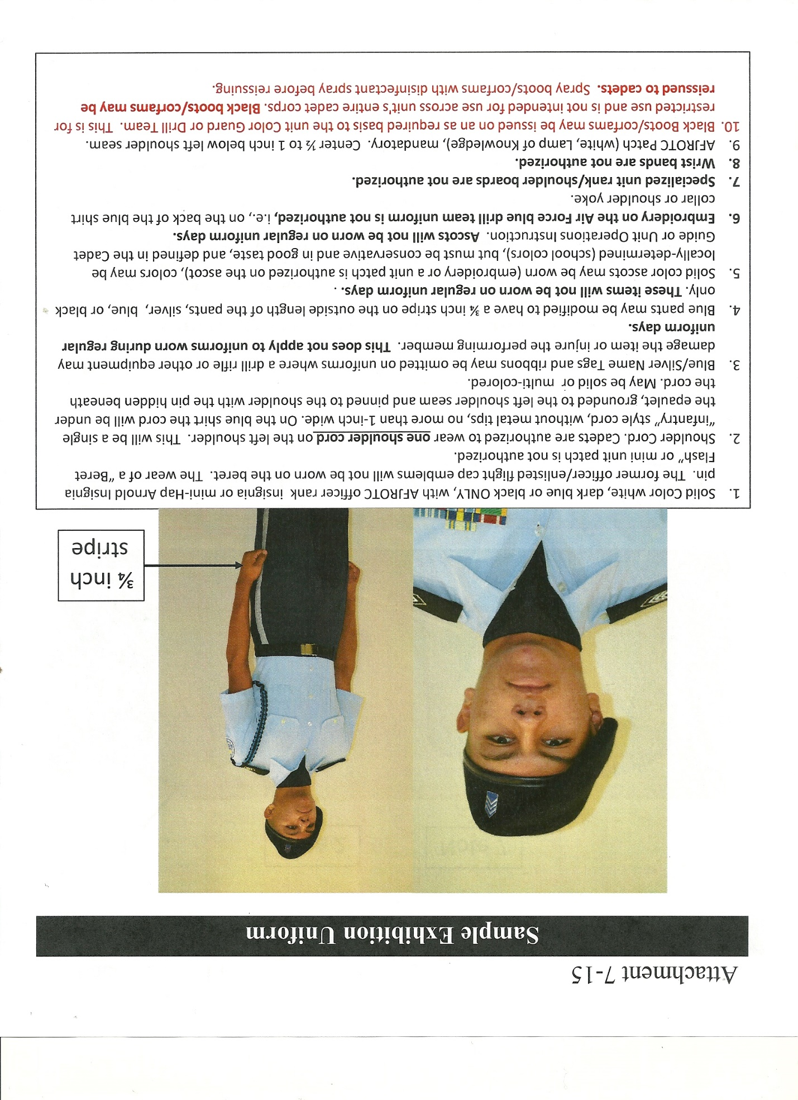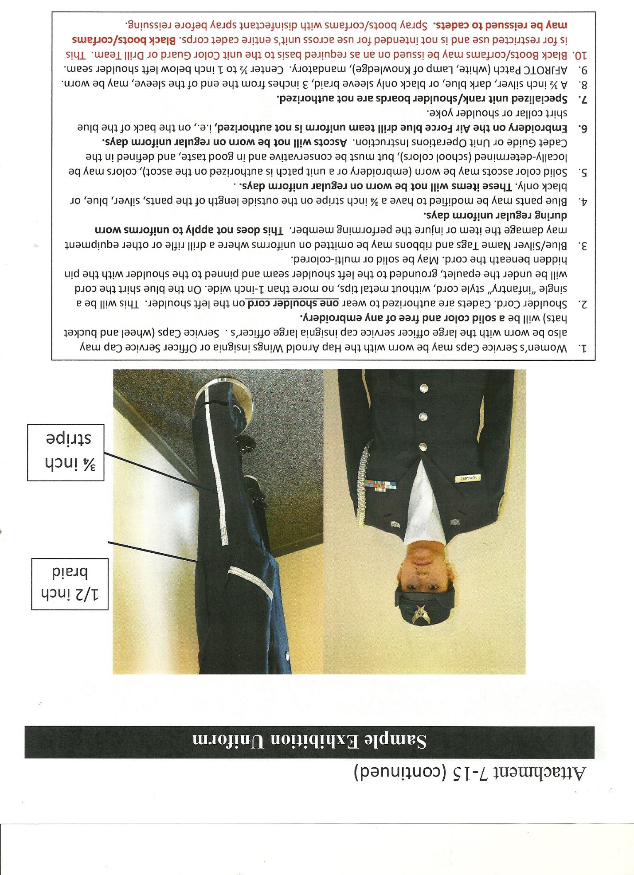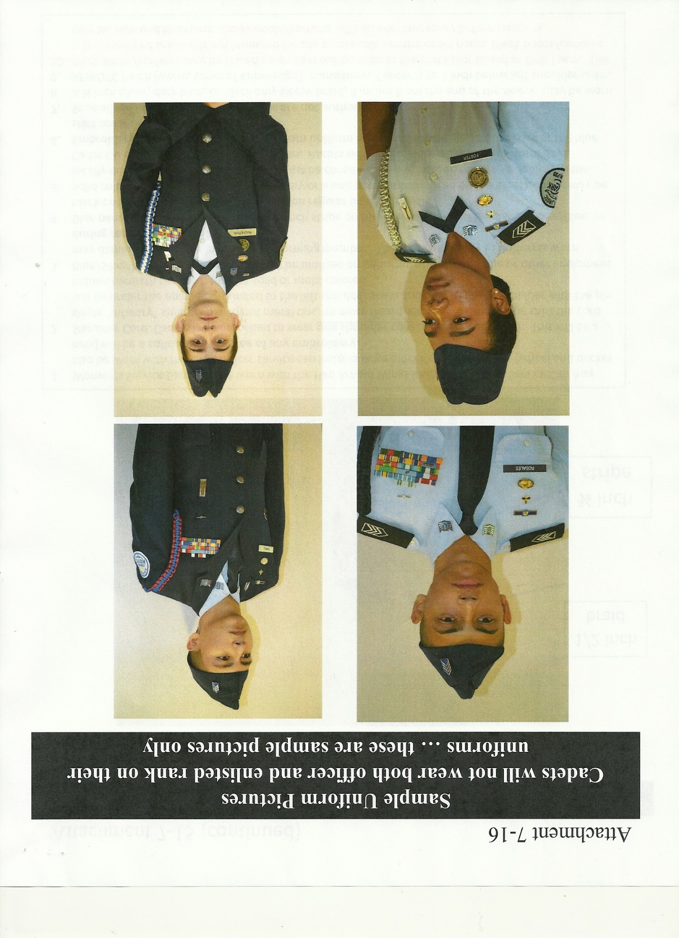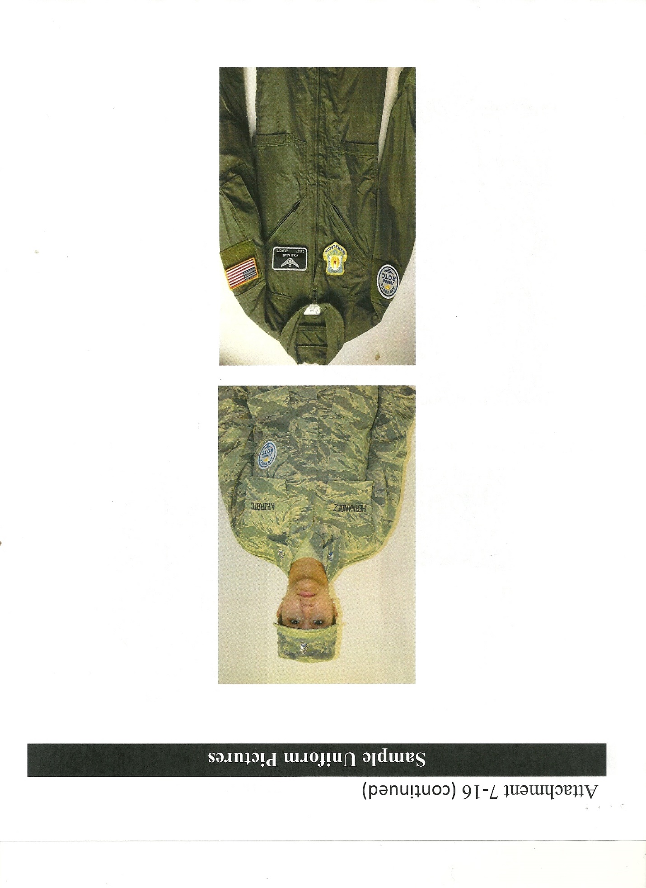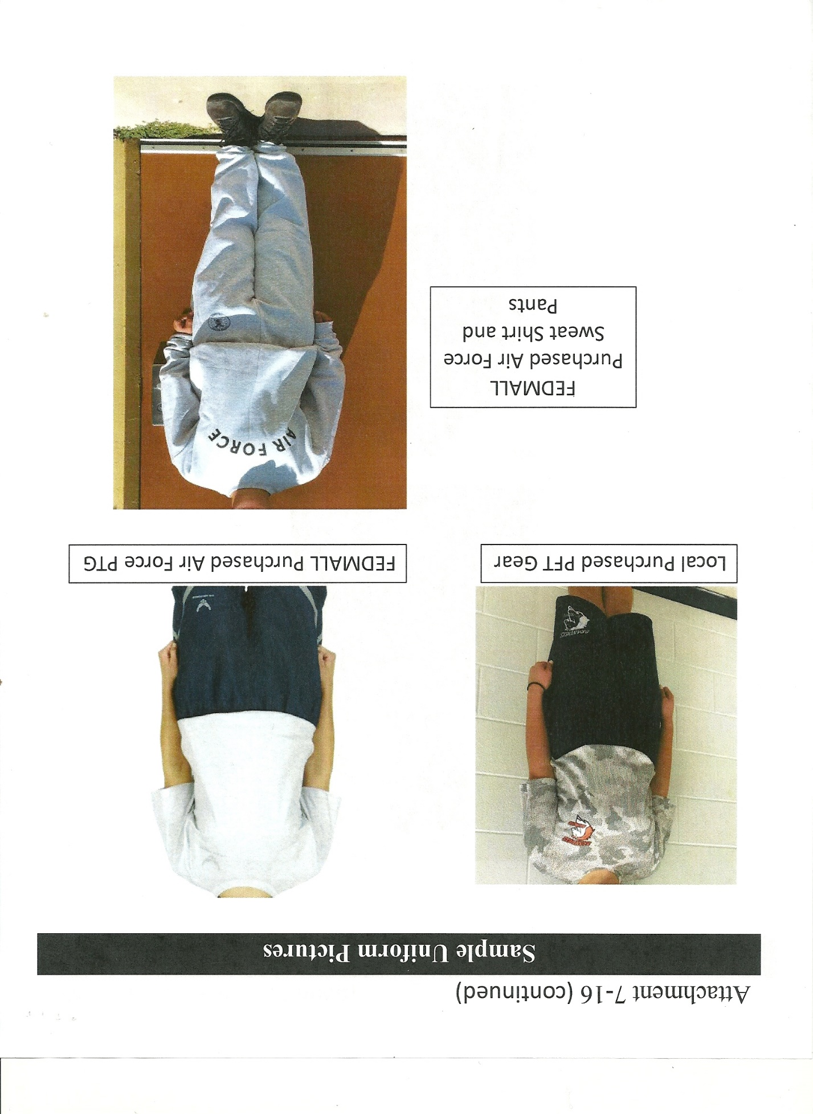


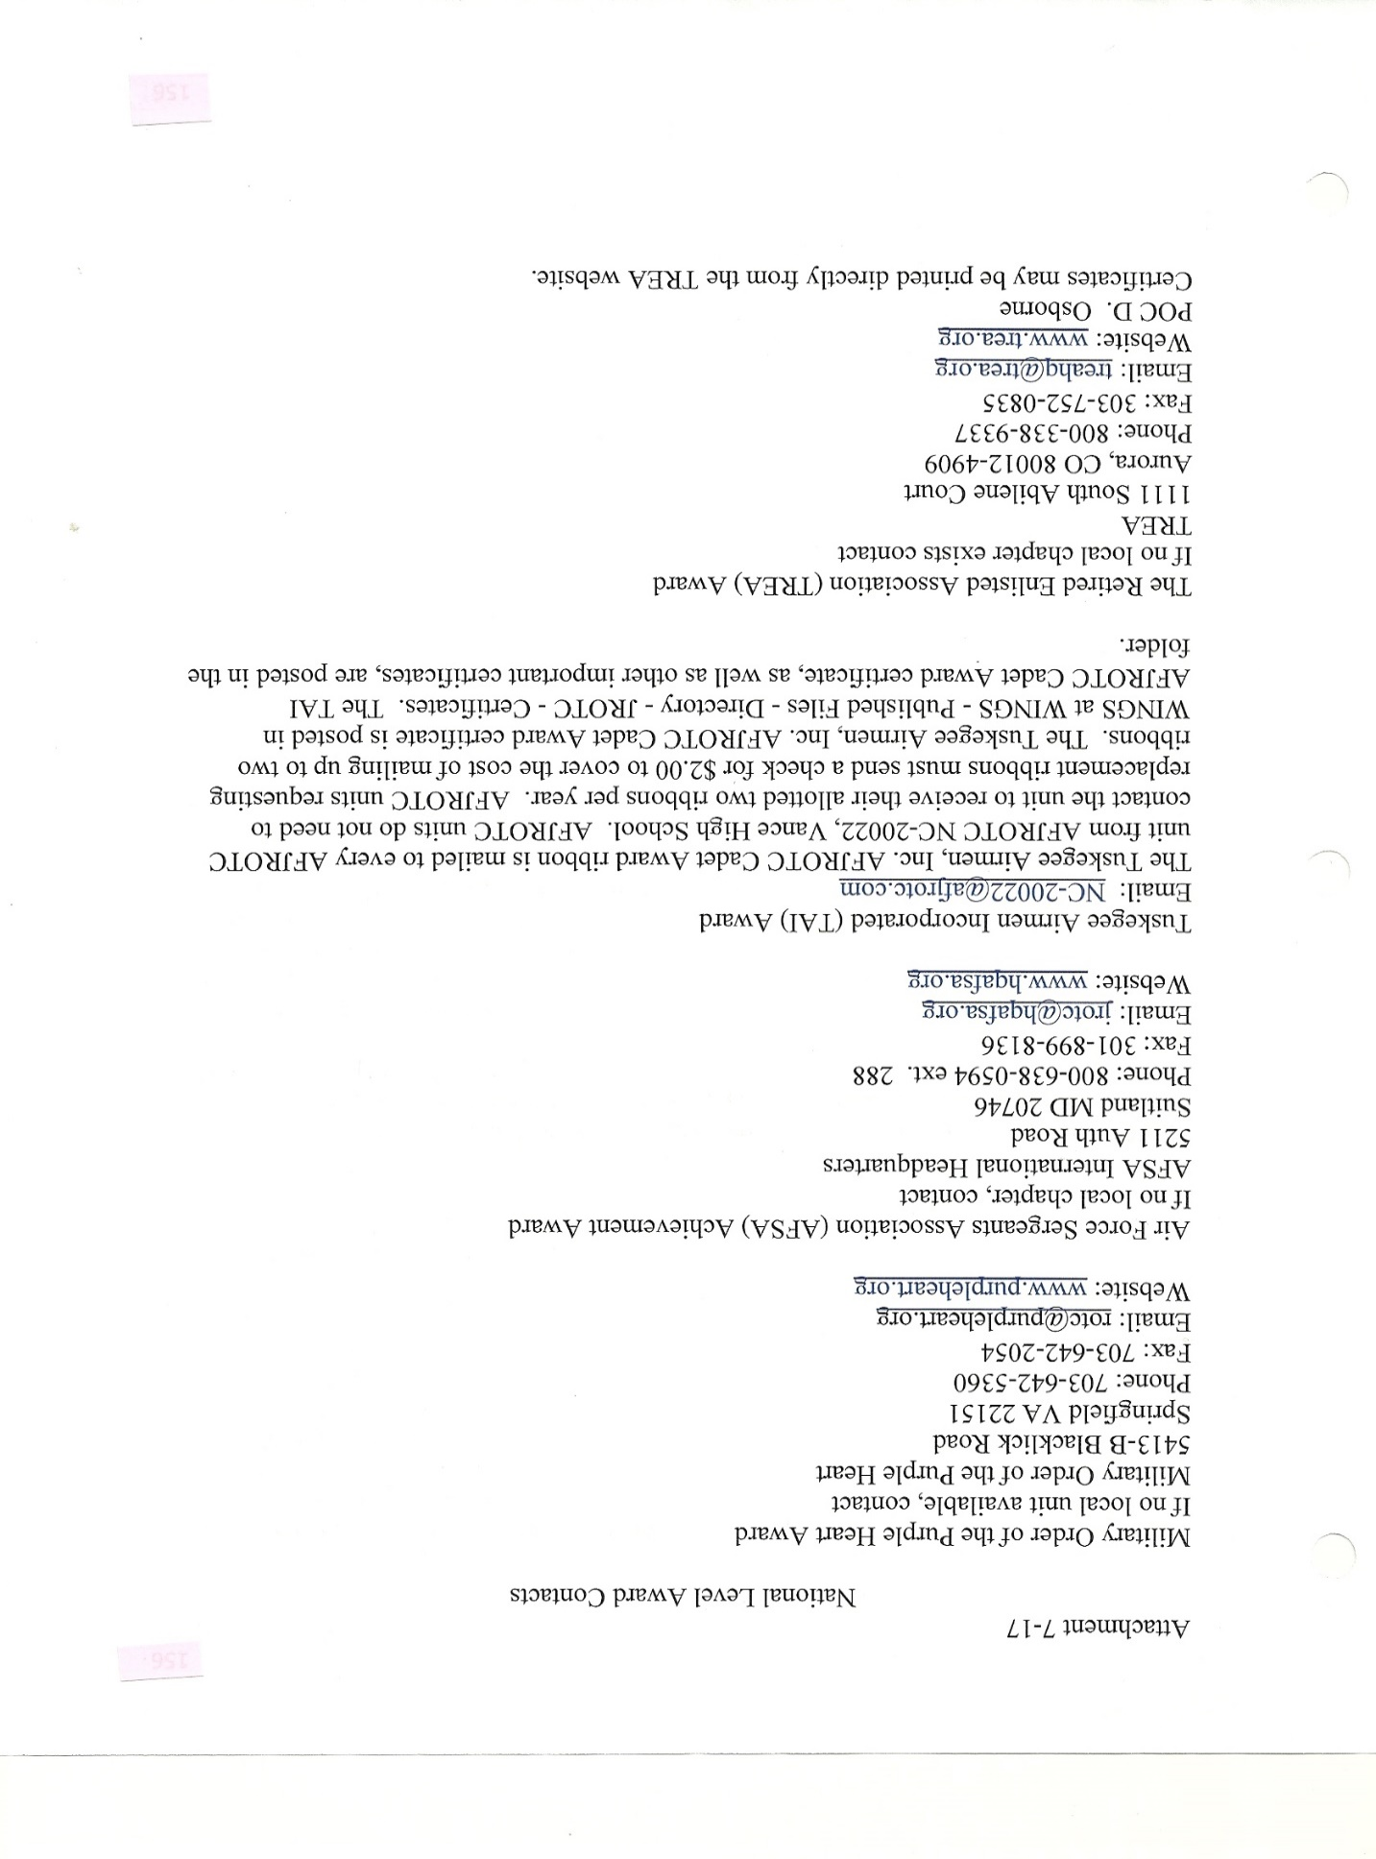

ATTACHMENT 8-1

THE PHONETIC ALPHABET

ALPHA
BRAVO
CHARLIE
DELTA
ECHO
FOXTROT
GOLF
HOTEL
INDIA
JULIETTE
KILO
LIMA
MIKE
NOVEMBER
OSCAR
PAPA
QUEBEC
ROMEO
SIERRA
TANGO
UNIFORM
VICTOR
WHISKEY
X-RAY
YANKEE
ZULU

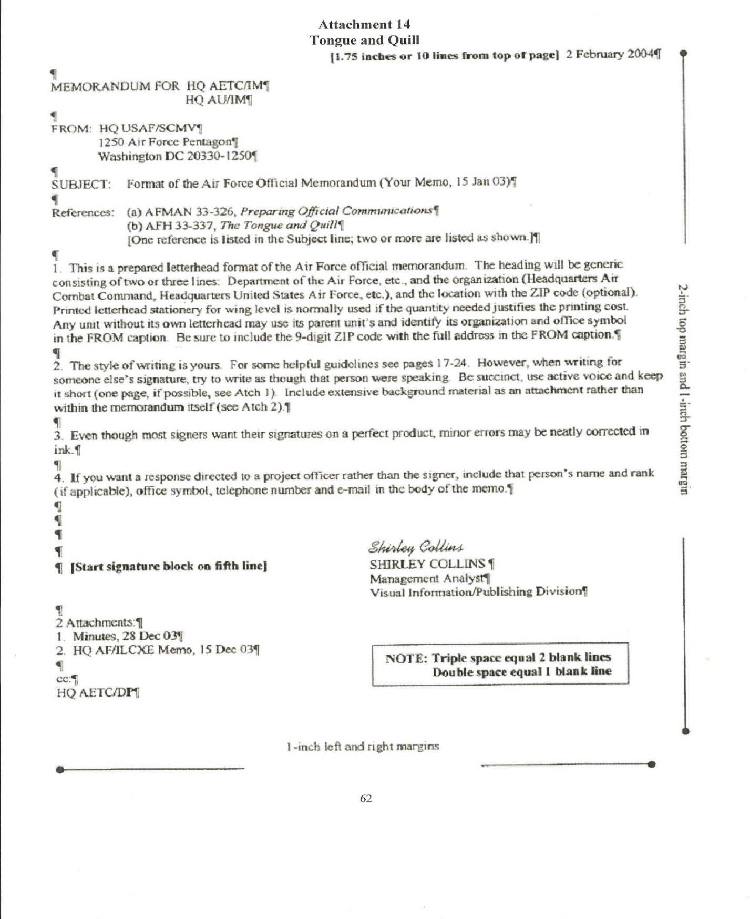
ATTACHMENT 9-1
ATTACHMENT 10-1 MILITARY TIME
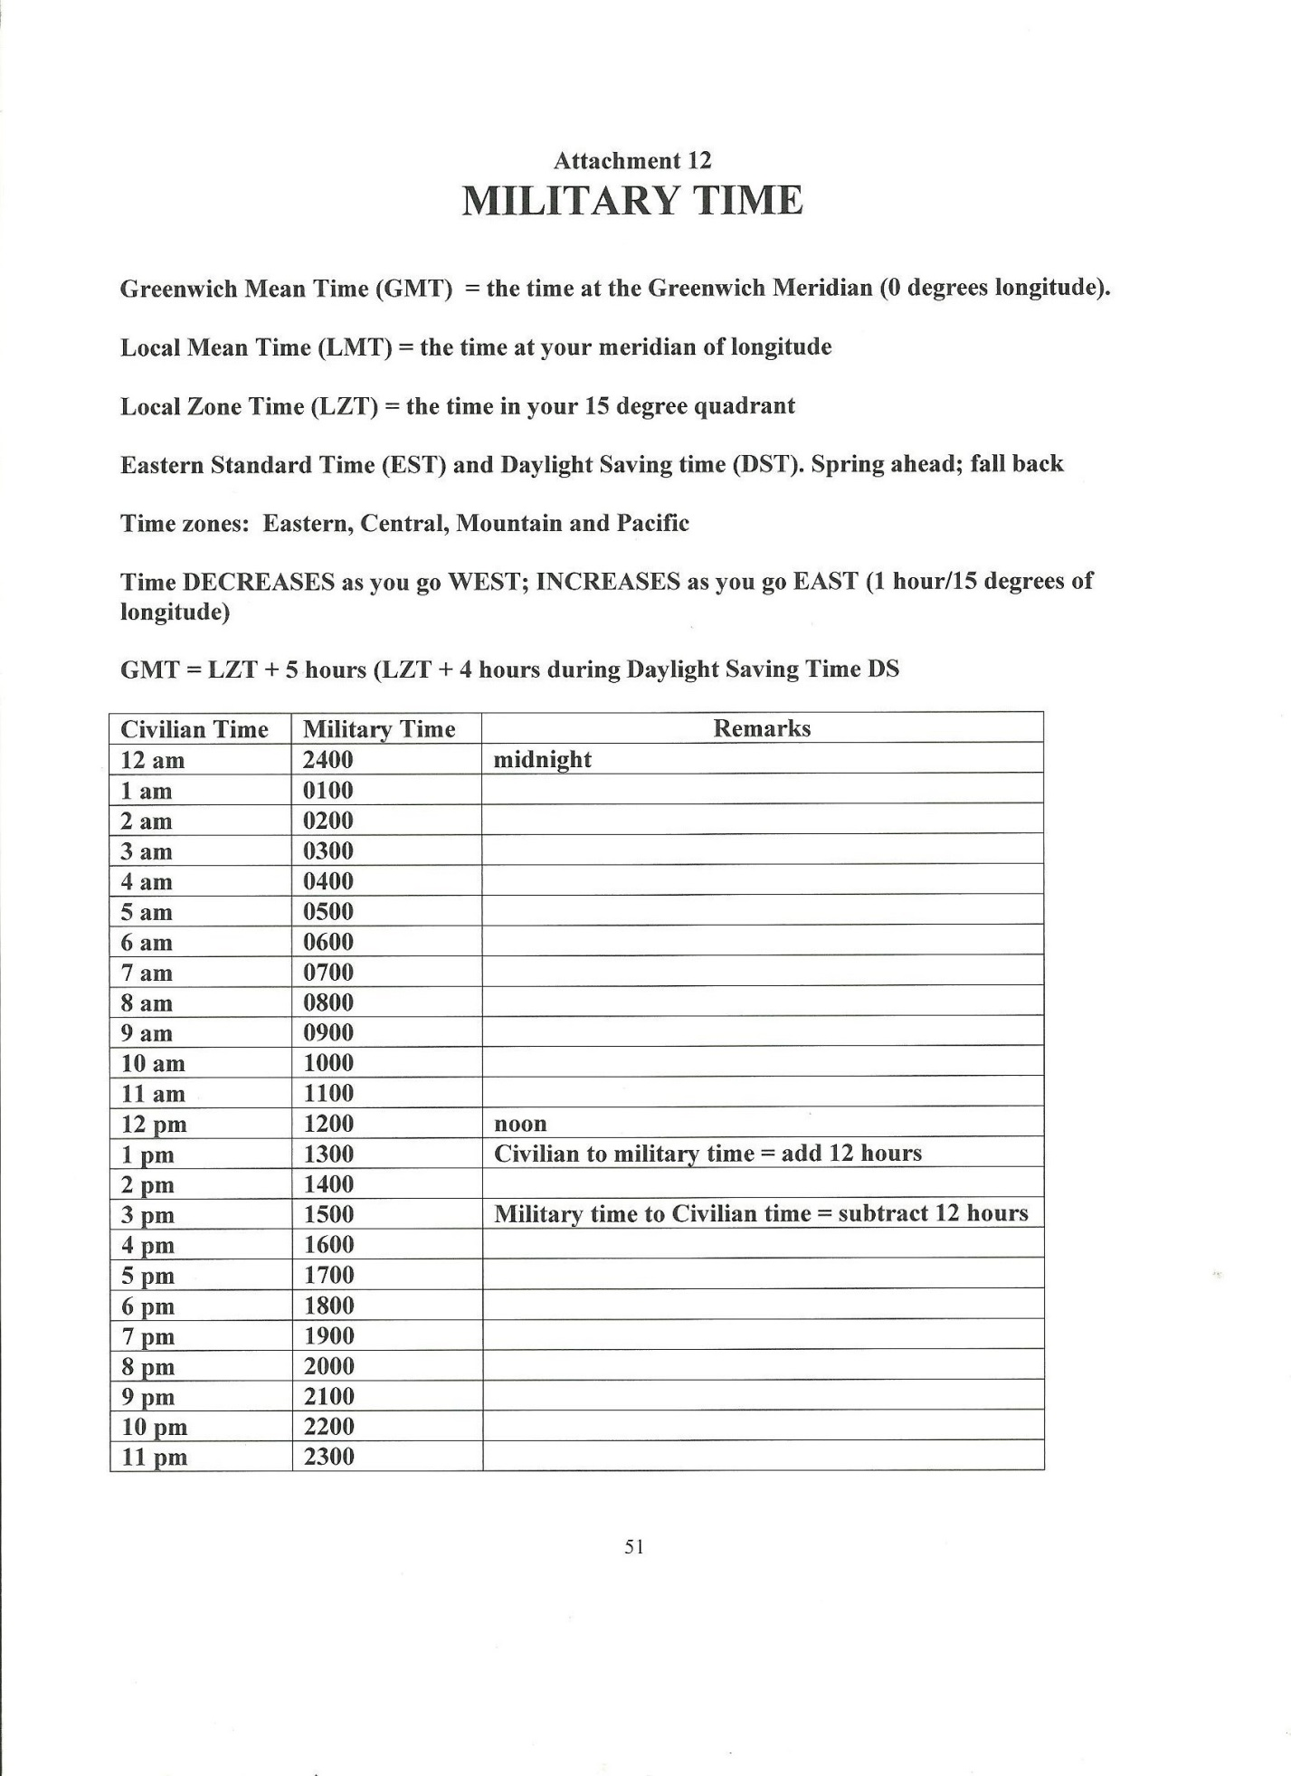

ATTACHMENT 11-1
SUMMARY OF CHANGES (2019)

PAGE 5 - PARA 1.1.1 - SENTENCE 4 THRU 7
PAGE 21 – PARA 2.5.20.2
PAGE 21 - PARA 2.6.15, - SENTENCE 3 THRU 7
PAGE 22 – PARA 2.6.24.1
PAGE 23 - PARA 2.6.25, 2.6.25.1, 2.6.26, 2.6.31
PAGE 24 - PARA 2.6.34.6, 2.6.34.7, 2.6.35.2, 2.6.35.2, 2.6.35.4
PAGE 25 - PARA 2.6.36.7
PAGE 28 - PARA 2.7 THRU 2.7.2.4
PAGE 31 - PARA 3.3.2, 3.3.2.2, 3.3.2.3
PAGE 32 - PARA 3.3.2.4, 3.3.2.6
PAGE 38 - PARA 4.1.9, 4.2.8, 4.3.4, 4.3.5, 4.3.6, 4.3.7, 4.3.8, 4.3.9
PAGE 39 - PARA 4.7.3, 4.7.5
PAGE 40 - PARA 4.8.3, 4.8.6, 4.10.5
PAGE 41 - PARA 4.11.2, 4.11.3
PAGE 43 - PARA 4.18.6
PAGE 44 - PARA 4.20.4, 4.21.3
PAGE 45 - PARA 4.27.7
PAGE 46 - PARA 4.28.6, 4.28.6, 4.29.1, 4.29.3, 4.29.4, 4.29.5, 4.29.6
PAGE 49 - (ADDED) TOTAL QUALITY NCO, SECURITY NCO, SAFETY NCO, DIRECTOR, SPECIAL OPERATIONS, DIRECTOR, DRILL COMPETITION, DIRECTOR, VOLUNTEER ACTIVITIES
PAGE 50 - (ADDED) EQUIPMENT OFFICER, SUPPLY OFFICER
PAGE 51 - (ADDED) AWARDS OFFICER, ACCESSIONS OFFICER
PAGE 52 - (ADDED) COMPUTER OFFICER, DIRECTOR, CONTINUING EDUCATION, DIRECTOR, PROFESSIONAL MILITARY EDUCATION, GROUP HISTORIAN, GROUP PHOTOGRAPHER, DIRECTOR, RECOGNITION MANAGEMENT
PAGE 56 - PARA 4.40.8
PAGE 58 - ADMINISTRATIVE DEMOTIONS/SUSPENDED REDUCTIONS
PAGE 58 - PROMOTION TO CADET OFFICER, LINE 13
PAGE 63 - PARA 7-1, 7.2.1, 7.2.2.1, 7.2.3.1
PAGE 64 - PARA 7.2.4.1
PAGE 65 - PARA 7.2.10.1, THRU 7.2.10.9
PAGE 66 - PARA 7.2.10.10, 7.4
PAGE 67 - PARA 7.6.1, 7.6.1.1, 7.6.1.2
PAGE 68 - PARA 7.6.1.6, 7.6.1.9.1
PAGE 69 - PARA 7.6.1.9.3, 7.6.1.9.4, 7.6.1.9.5,
PAGE 69 - LINE 7.6.1.9.5, 7.6.2.2.2 THRU 7.6.2.2.5
PAGE 70 - LINE 7.6.2.2.6 THRU 7.6.2.2.15
PAGE 71 - PARA 7.7.1.2
PAGE 72 - PARA 7.7.2.2
PAGE 74 - PARA 7.7.8.1, 7.7.8.2
PAGE 74 - LINE 7.7.8.2.1, THRU 7.7.8.2.5
PAGE 76 - PARA 7.7.15
PAGE 76 - PARA 7.7.16
PAGE 77 - PARA 7.7.17
PAGE 78 - PARA 7.7.18
PAGE 81 - PARA 7.7.26
PAGE 82 - PARA 7.7.32
PAGE 84 - PARA 7.7.41
PAGE 85 - PARA 7.7.46, 7.7.48
PAGE 87 - AFJROTC RIBBON CHART
PAGE 89 - PARA 7.8.5
PAGE 90 - PARA 7.10.1
PAGE 91 - PARA 7.10.1 (CONT’D)
PAGE 92 - PARA 7.10.1.63, 7.10.1.6.4,
PAGE 92 - LINE 7.10.1.8
PAGE 99 - ATTTACHMENT 7-1
PAGE 100 – ATTACHMENT 7-1 (CONT’D)
PAGE 102 – ATTACHMENT 7-3
PAGE 103 – ATTACHMENT 7-4
PAGE 104 – ATTACHMENT 7-5
PAGE 105 – ATTACHMENT 7-6
PAGE 106 – ATTACHMENT 7-7
PAGE 107 – ATTACHMENT 7-8
PAGE 108 – ATTACHMENT 7-9
PAGE 109 – ATTACHMENT 7-10
PAGE 110 – ATTACHMENT 7-11
PAGE 111 – ATTACHMENT 7-12
PAGE 112 – ATTACHMENT 7-13
PAGE 113 – ATTACHMENT 7-14
PAGE 114 – ATTACHMENT 7-15
PAGE 115 – ATTACHMENT 7-15 (CONT’D)
PAGE 116 – ATTACHMENT 7-16
PAGE 117 – ATTACHMENT 7-16 (CONT’D)
PAGE 118 – ATTACHMENT 7-16 (CONT’D)

